 | Hilbre Island

Task description

Pupils determine the optimum time to visit Hilbre Island, taking account of given considerations.

Suitability National Curriculum levels 4 to 7

Time 30 minutes to 1 hour

Resources Paper and calculator

Key Processes involved

- Representing: Understand the problem and consider the constraints given.
- Analysing: Work logically taking account of the constraints.
- Communicating and reflecting: Communicate their findings throughout and summarise their outcomes.

Teacher guidance

To help pupils understand the task, you might choose to introduce it with a short video http://www.bbc.co.uk/wales/nature/mediaexplorer/?theme_group=places_to_go&theme=north_east&set=hilbre_island , with comments:

- Hilbre Island is a small island in the Dee estuary, near Liverpool. It is very important for the birds that migrate and nest there. People can only reach it by foot for a few hours a day, when the tide is out, so they must plan carefully when to walk across.

- You are given all the information you need to decide when to start your journey to Hilbre with friends; plan it to have as much time as possible to enjoy the island, but also make sure you can get back safely and do not get stuck there overnight!

The task requires calculations involving time.

During the task, the following probing questions may be helpful:
- What do you need to consider in making your choice? What are the key points?
- Are any of the three dates not possible? Why?
- Why have you chosen this date rather than one of the other dates?
- Will Jon and Lu understand your reasoning?

Further notes for teachers in the Annex.

Hilbre Island

You can walk to Hilbre Island only if the tide is out. At high tide the footpath is under water.
You are planning to walk to the island with your friends. Here is an email from them and information you need to plan your visit.
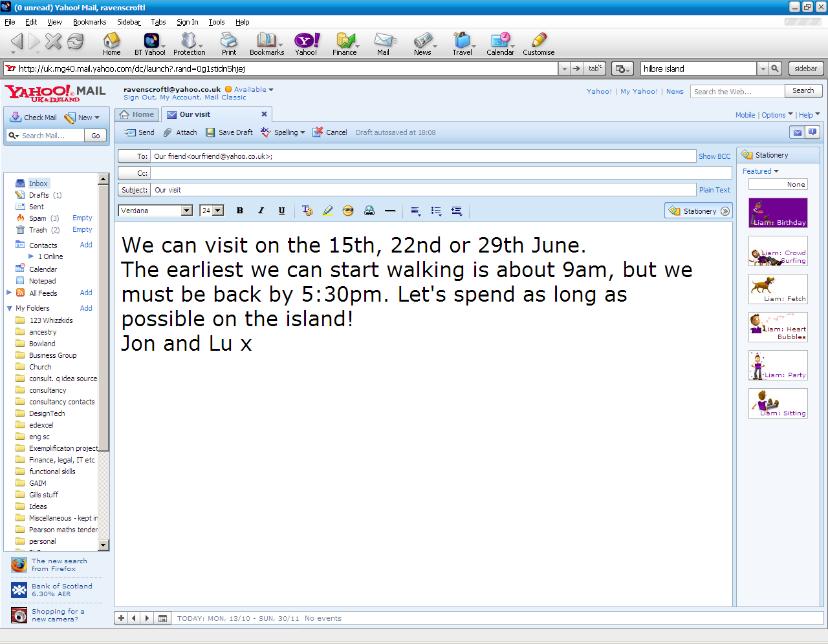

WARNING!
Do not walk between
3 hours before and 3 hours after
high tide

Allow one hour
to walk to the island, and
one hour to
walk back
Times of high tide
15t^{h J}une: 14:00

22n^{d J}une: 09:04

29t^{h J}une: 12:57

Reply to your friends, telling them which date is best for your visit and explaining why some dates are better than others.

You can use this chart to plan your answer.
9am
11am
Midday
10am
1pm
2pm
3pm
4pm
5pm
6pm
8am

15th

22nd
29th

Assessment guidance

Progression in Key Processes

Representing | Analysing | Communicating and reflecting
Understanding the problem | Logical working; constraints dealt with | Findings communicated and outcomes summarised
Shows evidence of using at least one constraint, eg shows 9am and 10am (arriving at the island) and an hour interval for the return journey  PROGRE  S  S  I  ON | Calculates a time interval of more than one hour correctly.  Converts correctly between the 12- and 24-clock  Pupil A | States only some of the information required for their journey, eg date, start time and arrival time on the island
Shows evidence of understanding the constraints for high tide, eg starts walking on the 22nd June at 12:04 (or 12:00)  Pupil A | Calculates the elapsed time interval(s), eg for 22nd maximum time spent on the island is 3 hours 26 minutes (or 3½ hours)  Pupil B | Clearly states their preferred date, starting time and time spent on the island, and also their time of return (even if there are errors)  Pupil A
Uses all the constraints for at least one of the days  Pupil B | Shows that on the 29th the maximum time spent on the island is 6 hours 27 minutes (or 6½ hours) | Gives a clear and accurate explanation for the 22nd or 29th showing working that allows for their reasoning to be easily followed  Pupil B
Uses all the constraints for all the days, even if implicitly  Pupil C | Explains why the 15th is not possible  Finds correct time intervals for the 22nd and the 29th then recommends the 29th  Pupil C | Throughout, presents clear, logical and accurate arguments  Pupil C

Sample responses

Pupil A
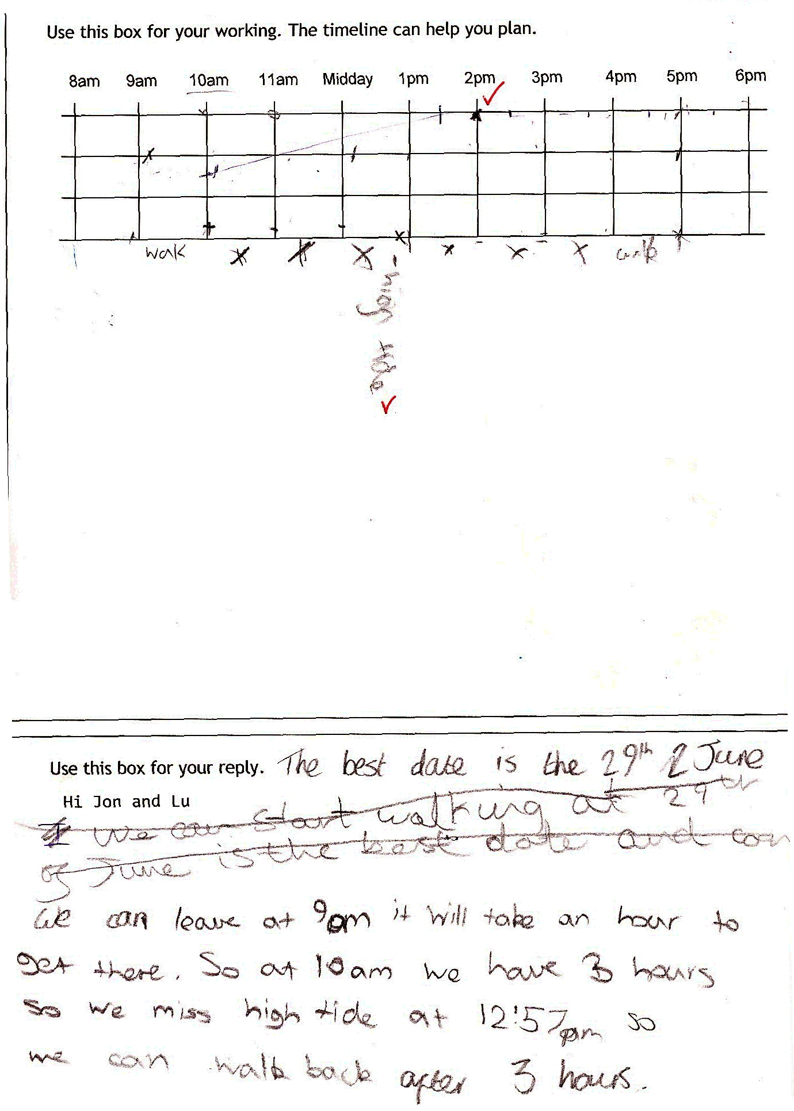

Comments
Pupil A’s timeline shows understanding of constraints. On the first line (15th), high tide is shown at 2pm; the marks at 10am and 11am show the departure and arrival time on the island. Little information given for the 22nd. The 29th shows a start time of just before 9am and the times when walking is not possible; but she seems to think that walking back must start 3 hours after high tide, hence return of 4pm to 5pm. Limited explanation, but the email summary gives an explanation for her answer.

Probing questions and feedback

- Think about communication: how could you have used the timeline more effectively, for example, so that Jon and Lu could understand your thinking?

Pupil A would benefit from examples of how to present her work better, for example, by getting another ‘e-mail’ from Jon and Lu saying that they now think they can leave the Island later on the 29th than she is suggesting, and asking her to explain her reasoning on a timeline. She could then present this graphically, perhaps using a spreadsheet.

Pupil B
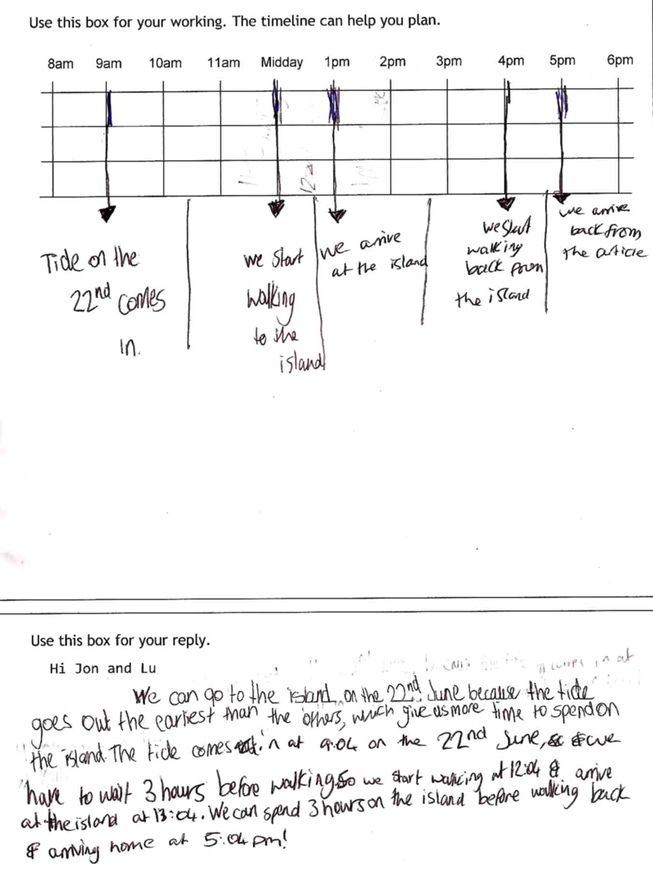

Comments

Pupil B uses the timeline effectively and gives clear and complete information in the ‘email’. The arrival time back on the mainland is just after 5pm, otherwise there is a complete and correct summary of information for the 22nd, including the amount of time that can be spent on the island. The logic in selecting the 22nd is clear but incorrect - ‘the tide goes out the earliest than the others which gives us more time to spend on the island – but his communication skills are good allowing his reasoning to be followed.

Probing questions and feedback

- When solving a problem, think about all the information – check you haven’t missed anything important – and be careful not to make assumptions without checking them out first …

Further work on multi-step tasks with interpretation of information would help him. The Bowland case You Reckon would give a good opportunity for him to develop these skills.

Pupil C

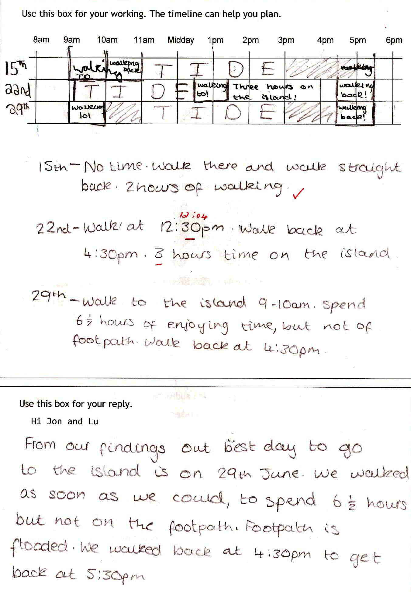

Comments

Pupil C uses the timeline clearly and effectively with all information shown. Why she chose 12:30 as the start time on the 22nd is unclear - she may think that they can only leave on the hour or half hour. The written summary supports the communication and reasoning, although as stand-alone communication, the email is less clear with the start time omitted. But the task as a whole shows high levels of reasoning, planning and communication skills.

Probing questions and feedback

- ‘When summarising information, be careful not to omit anything important … and make sure you state all your assumptions.’

The pupil may benefit from doing an extended case study that requires her to present her reasoning and solutions. Reducing Road Accidents or Product Wars would each be appropriate.

Annex: Notes for teachers

Taking account of the constraints, the following diagram may be helpful.

W denotes the best times for walking. H denotes high tide. Shading denotes no walking is possible because of high tide.
9am
11am
Midday
10am
1pm
2pm
3pm
4pm
5pm
6pm
8am
W
W
W
W
15th
22nd

29th
H
H
H

15th: Earliest it is possible to leave island is 5pm, so can’t be back by 5:30pm. [Note: could in theory leave at 9am, get to the island at 10am, leave immediately to get back by 11am.]

22nd: Start at 12:04, arrive 13:04, leave 16:30, back 17:30
Time on island 3 hours 26 minutes

29th: If they start at 08:57 (ie. just before 09.00), arrive 09:57 (just before 10.00), leave 16:30, back 17:30.
Time on island 6 hours 27 minutes (about 6½ hours)

