 | Golden Rectangles

Task description

Pupils work out how adventurers can maximise the area in which they can dig for gold within a fixed perimeter.
Suitability National Curriculum levels 4 to 6 (can be extended up to level 8)

Time 30 minutes to 1 hour

Resources Ruler, pencil, calculator and 1 cm squared paper. It may also be helpful to make available some graph paper.

Key Processes involved

- Representing: Draw various rectangles with a given perimeters.
- Analysing: Find areas of rectangles.
- Interpreting and evaluating: Consider different rectangles while trying to maximise the area. Find that a square is the best. Go on to find that, if the adventurers work together, they can get a bigger area each.
- Communicating: Explain how they know this is the best arrangement and that working together is best.

Teacher guidance

Check that pupils understand the context, for example with questions such as:
- How do you think the adventurers would mark out their plot of land?
- How should they share a plot that two of them had marked out?
- The adventurers need to understand your thinking, so show your findings in an organised way.

Pupils can tackle this task in different ways, but they might be expected to:
- draw rectangles and find their areas
- collect results in a table or ordered list
- find a pattern in their data

The work could be extended to:
- finding patterns in their results and finding an n^{th} term
- drawing a graph to clarify their results
- finding the areas of other shapes

This would take the content to National Curriculum levels 6 - 8

Golden Rectangles

In the 19th century, many adventurers travelled to North America to search for gold  Dan Jackson owned land where gold had been found.  He rented plots of land to the adventurers.  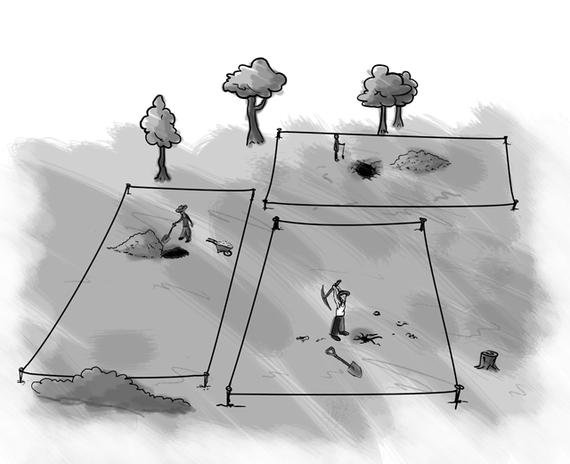 | 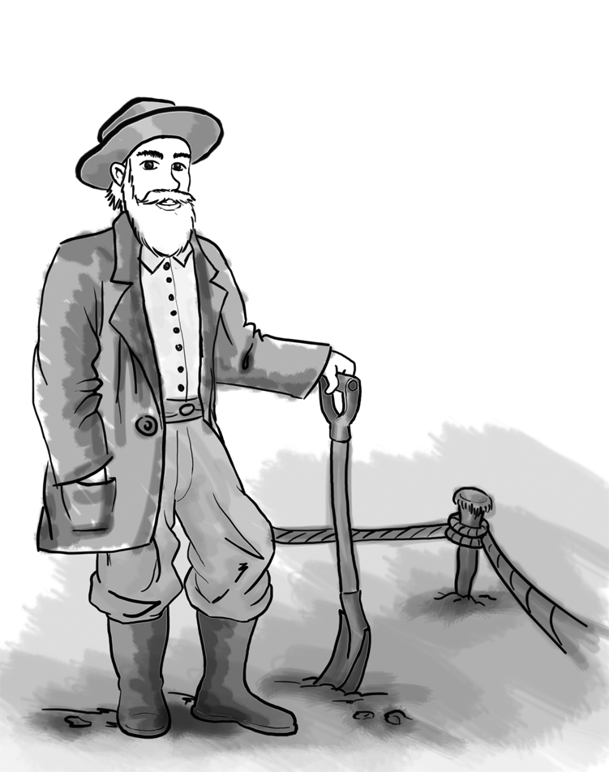  Dan gave each adventurer four stakes and a rope 100 metres long  Each adventurer had to use the stakes and the rope to mark off a rectangular plot of land.

- How should an adventurer place his stakes to mark out the biggest plot he could?
Explain your answer.

One adventurer had an idea:

“Tie the ropes together! We can get more land each if we work together and share than if we work separately.”

- Is he right if two adventurers work together, but still using only four stakes?

- Is he right if more than two work together? Explain your answer.

Assessment guidance

Progression in Key Processes

Representing | Analysing | Interpreting and evaluating | Communicating
Choice of drawings to get started on the problem; choice of ways to record data | Calculations of areas and finding patterns | Quality of conclusions and their justifications | Clarity and completeness of written work
Draws one or two rectangles.  PROGRE  S  S  I  ON  Pupil A | Works out the areas of some rectangles.  Pupil A | Draws a few rectangles but not a square; the justification is incorrect or omitted.  Pupil A | Communicates the work adequately, but with gaps and/or omissions.  Pupil A
Draws several rectangles.  Pupil B | Calculates the areas of their rectangles and attempts to find a generalisation.  Pupil B | Realises that different shapes have different areas but comes to incorrect or incomplete conclusions. | Communicates the work clearly and the reasoning can be followed.
Draws several, correct rectangles for one adventurer and for 2 working together. (May draw too many rectangles.) | Calculates the areas correctly and finds that a square is best for one adventurer and that 2 working together do better than one alone.  Pupil C | Attempts to give some explanation for their findings.  Pupil B | Communicates the work clearly and the reasoning can be followed easily.  Pupils B and C
Uses a sensible number of rectangles and collects the data in an organised way.  Pupils C and D | Calculates the correct areas, finds that a square is best for one adventurer and that 2 working together do better than one alone. Finds a rule or pattern in the results.  Pupil D | Gives reasoned explanations for their findings.  Pupils C and D | Explains work clearly; considers other shapes.  Pupil D

Sample responses

Pupil A
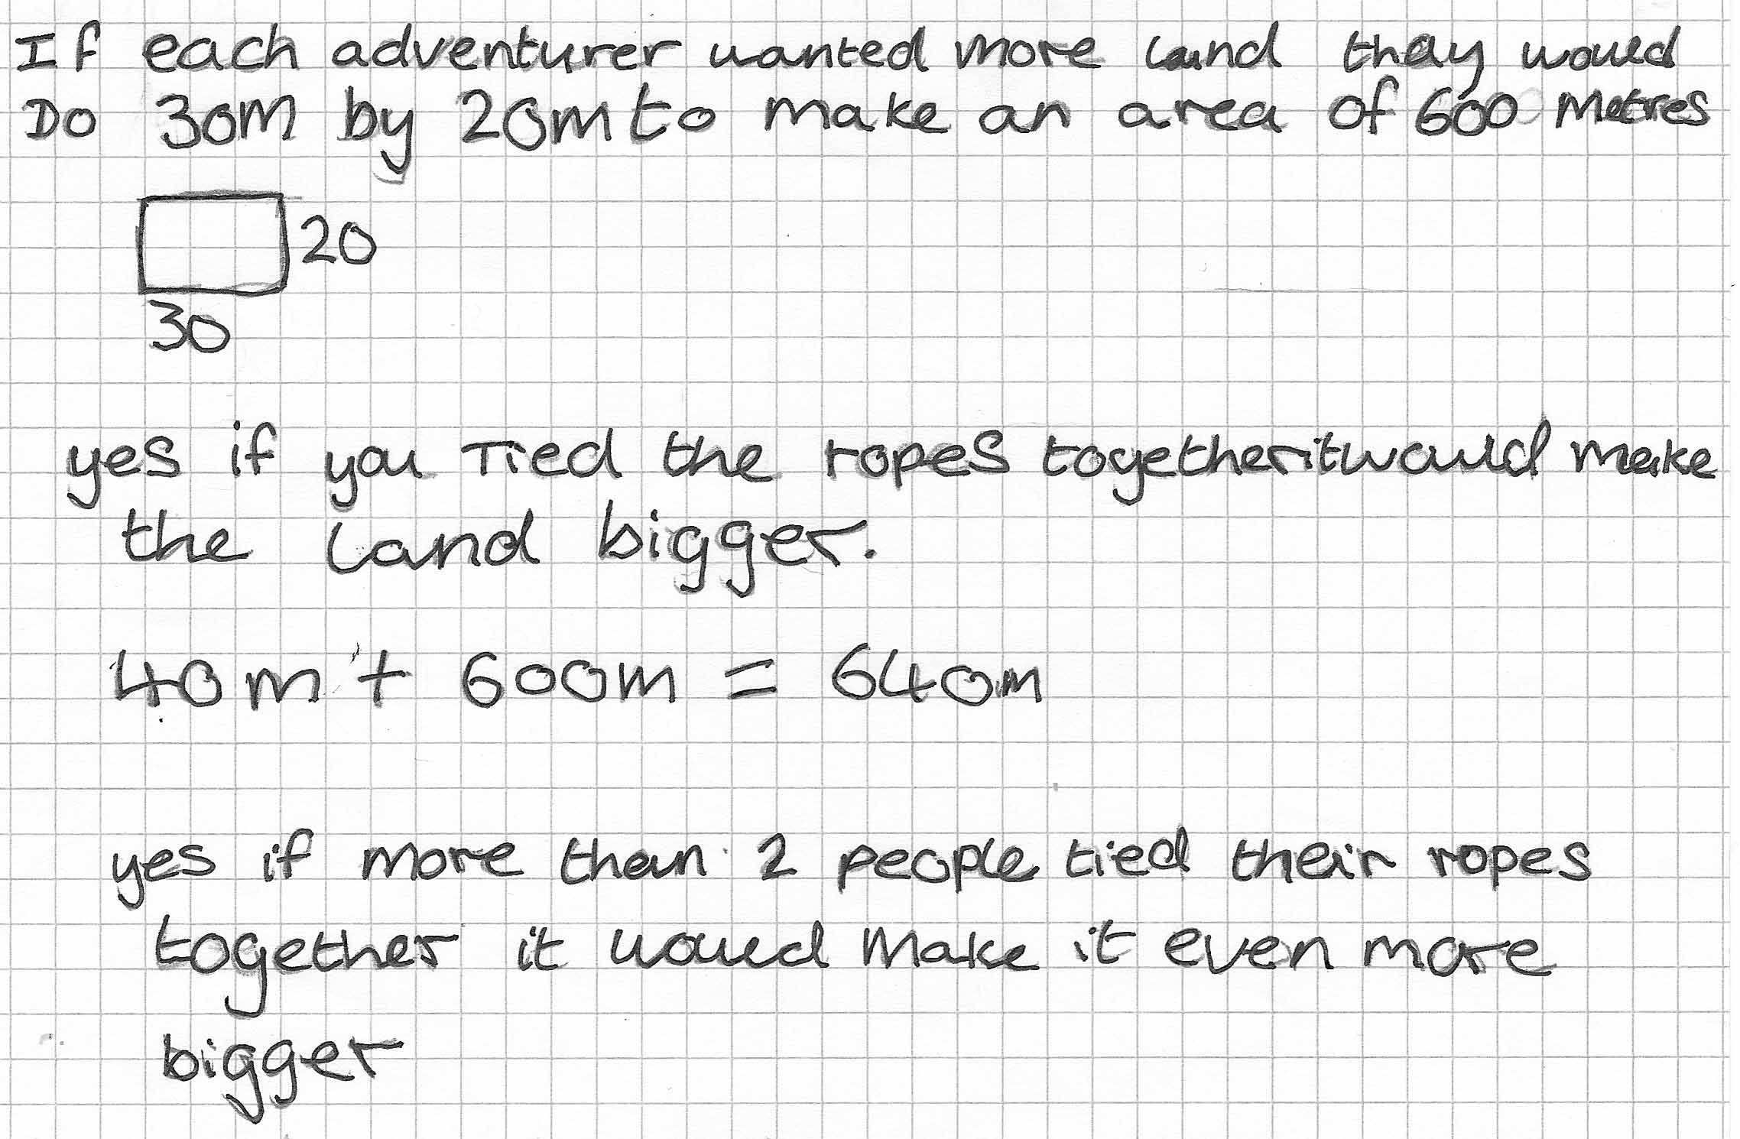

Comments

Pupil A draws a rectangle with the correct perimeter and finds its area, but she does not try any other rectangles to see if their areas are different. She also says that twice the rope will give a bigger area but her calculation is wrong and she does not think about the area for each adventurer.

Probing questions and feedback

- Is a 20 by 30 metre rectangle the only one the adventurer could have made?
Are there other rectangles with the same perimeter?
- Can you explain where “40 + 600” came from?
- If you tie two ropes together how long will the rope be?

Pupil B
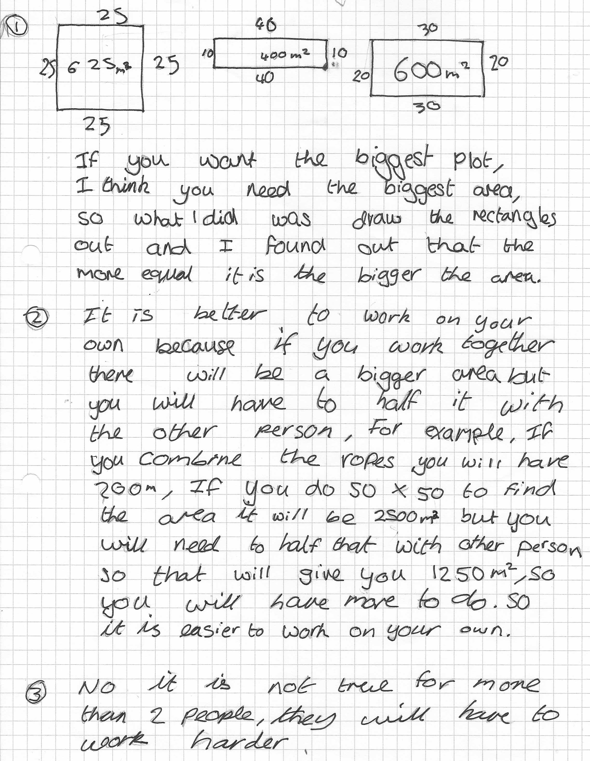
Comments

Pupil B drew three rectangles, including the square. He correctly concluded that ‘the more equal it is the bigger the area’ but does not say that a square is biggest. In the second part, his reasoning is fine, but draws the wrong conclusion based on keeping the adventurers’ work down rather than giving them a bigger plot.

Probing questions and feedback

- Which shape do you think gives the biggest area?
- Can you find out if two adventurers would get more land each by tying the ropes together?
- Why do you think it will not be true for more than two people?

Pupil C
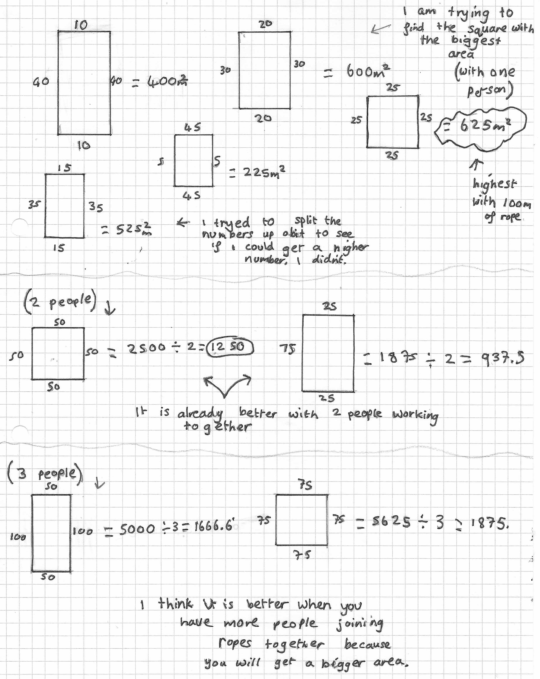
Comments

Pupil C has drawn three rectangles, including the square and concluded that the biggest area is the square. She then tried to be sure by drawing two more rectangles. She tried two rectangles, including a square, for two and three people and remembered to work out how much land each would have. Her final conclusion is correct.

Probing questions and feedback

- The square is best but can you see a pattern in the rectangles that shows why this is best?
Could you put the rectangles in some sort of order?
- Please explain why it is better to join the ropes together? Why does joining them make a bigger area each?

Pupil D
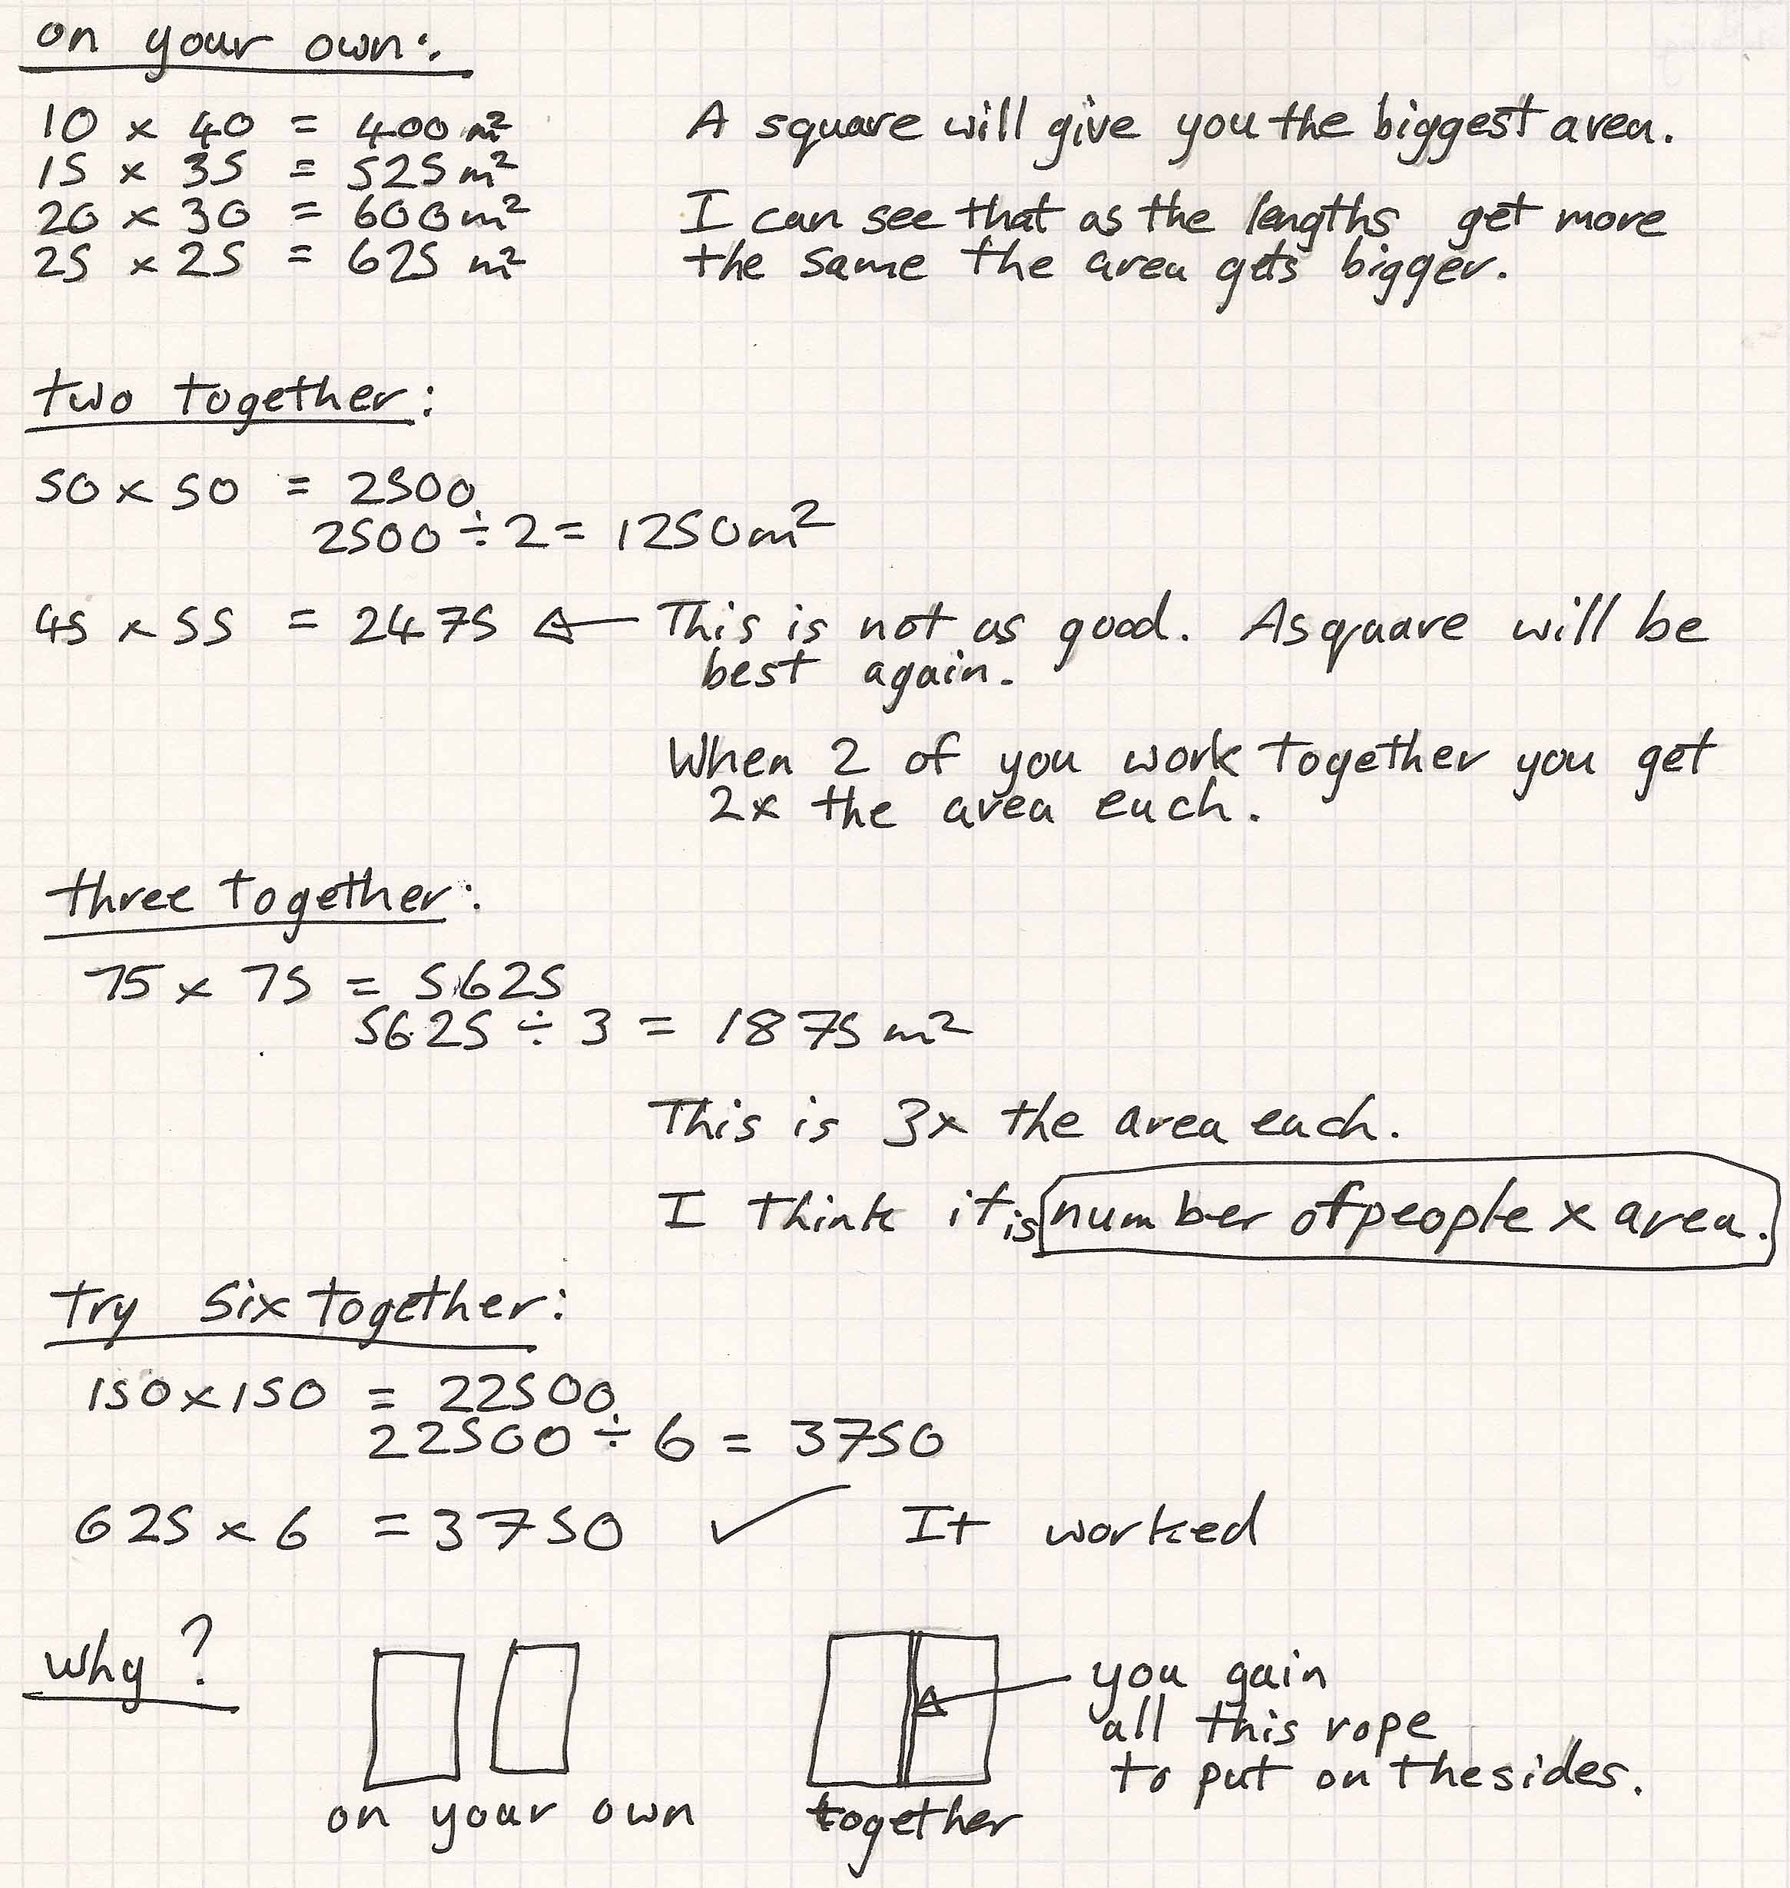
Comments

Pupil D used rectangles with the difference in side lengths getting progressively less. He noted that the areas increase and concluded that the square gives the biggest area. He finds the areas for two and three ropes and sees a pattern in the increasing areas which he checks using six ropes. He considers why the areas increase and gives a reason.

Probing questions and feedback

- Can you write your rule in algebra?
- Could the adventurers use any shape other than rectangles and squares?
Are there any other shapes you could investigate?

