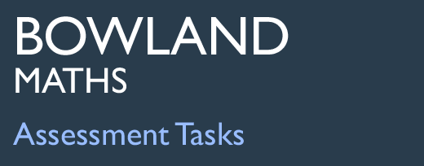 | German or English?

Task description

Pupils use pie charts to decide whether a code is more likely to be in German or English.

Suitability National Curriculum levels 4 to 7

Time About 45 minutes

Resources Paper and calculator; pupils might also ask for an angle measurer and a pair of compasses.

Key Processes involved

- Representing: Decide how to present the information in a form that enables comparison between the two languages.
- Analysing: Compare the unknown text against the pie charts.
- Interpreting and evaluating: Form an argument for one (or both) of the languages.
- Communicating and reflecting: Present arguments and reflect on the validity of their results.

Teacher guidance

You might set the scene by showing the task on a whiteboard and commenting:
- There are two pie charts, one with information relating to German and one for English. There is also a text with the words missing.
- Use the pie charts to decide whether the text is more likely to be German or English
- Look at everything you have been given and think about your reasons carefully. Show your reasons: even code-breakers have to explain how they break codes!

Pupils need to devise a strategy for analysing the ‘unknown’ text, make their comparisons and decide which language is most likely. More able pupils should recognise that there are arguments for both languages and that their ability to make a definitive choice is limited by the small number of words in the unknown text. The Annex has values shown for teachers.

The task requires an understanding of proportionality and interpretation of pie charts.

During the work, the following probing questions may be helpful:

- What are the differences between text in English and in German?
- How did you work out the percentages / angles / values in the pie charts?
- You decided that the language is English (German). What are your reasons for your decision?
- How confident are you that your answer is correct? 100%? 0%? 50%? Why?
- What would make you more certain?

German or English?

The pie charts show information about the length of words in a text in English and
the same text in German.
German text
1 to 3
letters
4 to 6
letters
more than
7 letters
more than
7 letters
4 to 6
letters
1 to 3
letters
English text

Here is a different short text, but the letters are missing.

_ _ _ _ _ _ _ / _ _ _ _ _ _ / _ _ _ / _ _ _ _ / _ _ / _ _ _ / _ _ /
_ _ _ _ / _ _ _ _ _ _ _ _ / _ _ _ / _ _ _ _ / _ _ _ / _ _ _ _ _ _ _ _ _ _ _ _ _ _

_ _ _ / _ _ _ _ / _ _ / _ _ _ _ _ / _ _ _ _ / _ _ _ .

Which language is this text is more likely to be − German or English?

Why do you think that?

Assessment guidance

Progression in Key Processes

Representing | Analysing | Interpreting and Evaluating | Communicating and reflecting
Understanding of the problem and data represented in a form that enables comparison  PROGRE  S  S  I  ON | Comparisons | Good reason(s); arguments drawn together | Arguments presented clearly; reflections on the validity of the results
Counts the number of letters per word in the unknown text and presents information systematically, even if there are errors | Compares more than one category shown on the pie charts,  eg ‘English has smaller words, German has longer words’ | Uses a simple reason that is supported,  eg ‘English, because (nearly) half of the letters are 1 to 3’  Pupils A + B | Identifies key points, even if repetitious  Pupils A + B
Summarises the data from the unknown text, eg using a tally or frequency chart  Pupils A + B | Makes a simple comparison of their data against one of the pie charts,  eg ‘Almost half of the new text has 1 to 3 letters which is like English’  Pupils A + B | Uses more than one of the three categories shown on the pie charts to form an argument for one of the languages | Presents a coherent argument and recognises that that different texts could give different answers  Pupils C + D
Summarises the data, converting it to a form that enables comparison, even if % or angles are estimated | Makes a simple comparison of their converted data against one or both of the pie charts | Uses their converted data to give arguments about both languages, even if simplistic | Presents a coherent argument and recognises that the sample size is too small to be a reliable indicator  Pupil E
Summarises the data accurately, in an immediately comparable form  Pupils C + D and E | Uses all their converted data to make insightful comparisons against both pie charts  Pupil E | Uses all their converted data to provide thorough and reasoned arguments about both languages  Pupil E | Presents a coherent and insightful argument that makes explicit the assumptions that are implicit, eg that all the texts are typical of the language

Sample responses

Pupils A and B

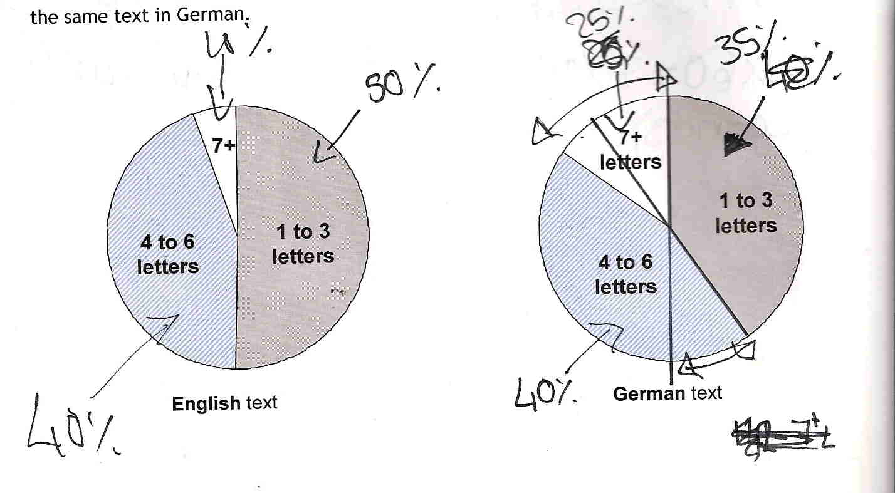

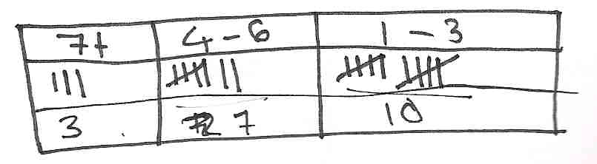

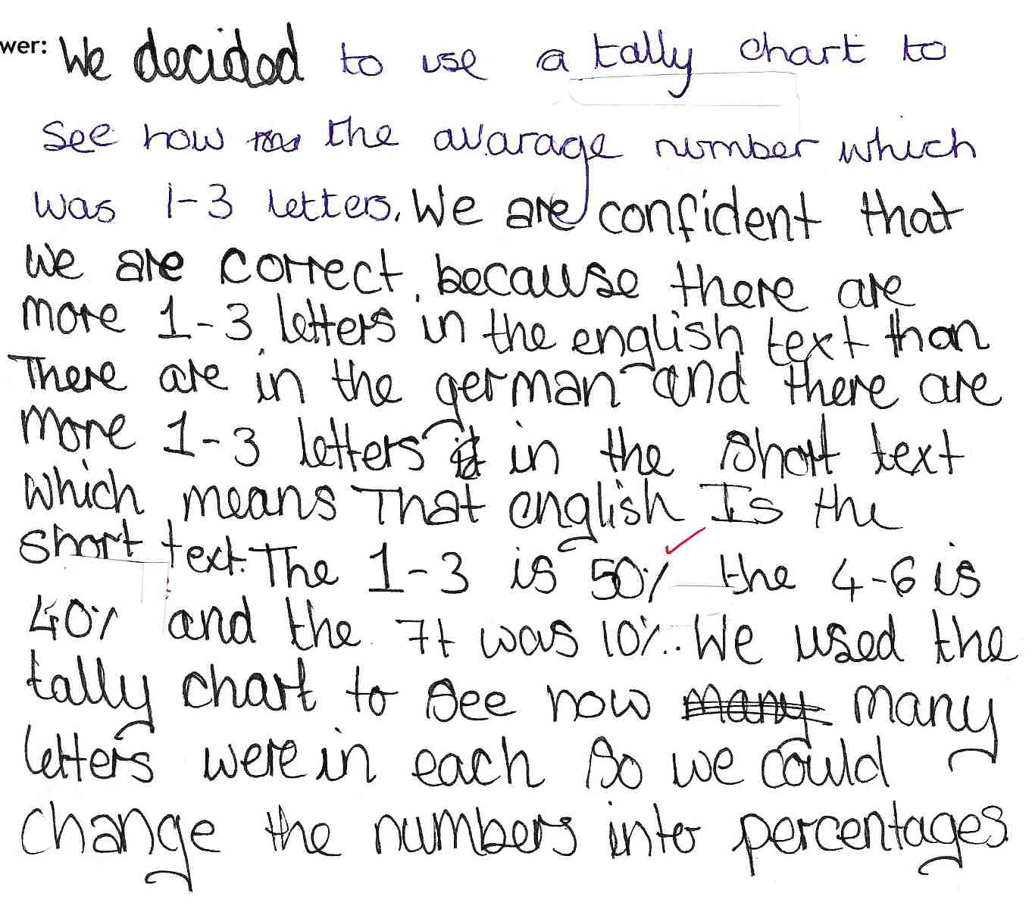

Comments

Pupils A and B give estimates of the percentages on the pie charts – but 25% is given for a sector that is clearly less than a quarter. The text suggests that they recognised the need to use percentages to compare, but there is no evidence that this conversion occurred. The information for the unknown text has been summarised and presented efficiently, although 20 rather than 19 words is given as the total. The text flows well, but there is little rationale to support their choice of English.

Probing questions and feedback

- Think about how to find reasons that will really persuade the reader that you are right. Try to use all the information rather than only some of it; make sure you show all your working. Remember, the reader only knows what you tell them, so make sure you write it all down.

These pupils would benefit from more practice at interpreting pie charts and communicating their findings. They should also be encouraged to reflect on their work and their findings through feedback to the teacher, or to the class - perhaps through the medium of a poster.
Pupils C and D
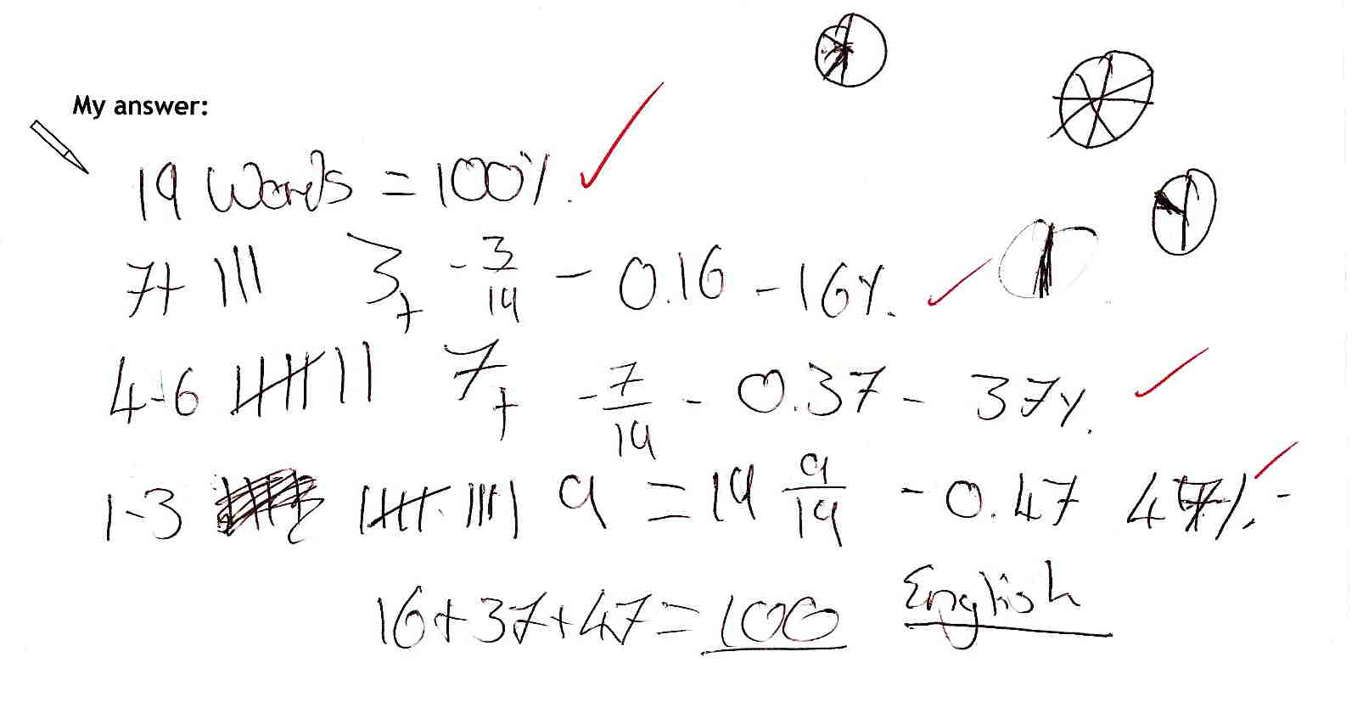

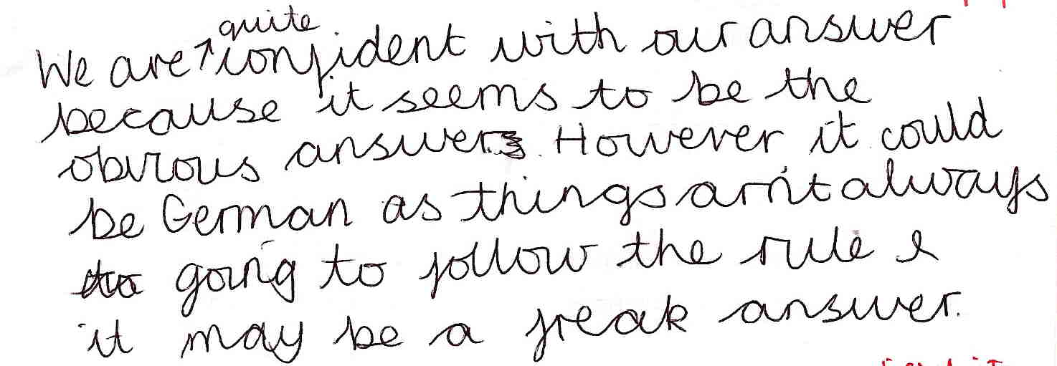

Comments

Pupils C and D appear to show good insight into the task by selecting the appropriate mathematics and they show confidence with fractions, percentages and rounding, but they do not show the percentages from the pie charts (theirs appear to be ‘thinking tools’.) It is not clear whether they understand why conversion to percentages is appropriate – and they do not extend this to an interpretation of the pie charts. They give no justification from the percentages for the ‘unknown’ text lead for their choice of English as the language. Their written explanation shows some insight into the variability of data.

Probing questions and feedback

- Facts and figures need interpretation for someone to understand them − think about newspapers or television, where things are usually explained clearly. Explain what you are doing and why. For example, after you worked out the percentages for the unknown text, how did you decide on English? Is this clear to the reader?

These pupils would benefit from working on further multi-stepped activities, particularly those that require explanation. A Bowland case study such as Save a Baby Kangaroo should provide a positive way forward.
Pupil E

Comments

Pupil E approaches the task with confidence and provides a clear argument that considers both sides before making a decision. He develops a strategy for analysing the unknown text, coverts the data into percentages to enable comparisons and uses all relevant information. He shows insight into the need for further data. He completes his response by reflecting on his lack of certainty, given the small size of the sample text – although he could have extended this to consider whether all the texts are typical of the two languages.

Probing questions and feedback

- When thinking about the information given (in this case, the pie charts), what assumptions can you make about the source of that information and how might you decide if those assumptions are sensible?

To encourage him to understand the relevance of uncovering assumptions, this pupil may benefit from being asked to evaluate statistical information presented in real-life situations, eg newspaper articles. This could also provide a good basis for cross-curricular work.

Annex for teachers

Percentages and angles may vary depending on accuracy of measurements and approach to rounding

The pie charts

 | English text in pie chart |  | German text in pie chart
 | Percentage | Angle | Percentage | Angle
1 to 3 letters | 50% | 180° | 40% | 145°
4 to 6 letters | 43% | 156° | 45% | 161°
7+ letters | 7% | 24° | 15% | 54°

Summary of unknown text

 | Frequency  (Total 19) | Percentage | Angle
1 to 3 letters | 9 | 47% | 171° (or 170°)
4 to 6 letters | 7 | 37% | 133°
7+ letters | 3 | 16% | 58° (or 57°)

