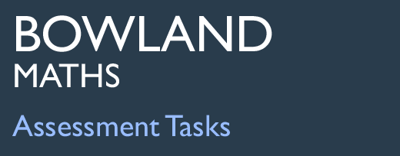 | Fruit pies

Task description

Pupils use their knowledge of area of circles and rectangles to solve a problem.
Suitability National Curriculum levels 6 to 8

Time About 1 hour

Resources Calculator, paper (may request squared, graph or plain), pair of compasses, a ruler

Key Processes involved

- Representing: Break the problem down into smaller steps.
- Analysing: Use logical reasoning, and make calculations.
- Interpreting and evaluating: Consider appropriateness and accuracy.
- Communicating and reflecting: Communicate their findings effectively.

Teacher guidance
You might set the scene by showing the slides on a whiteboard. If asked, clarify that the thickness of the pastry when re-rolled should be the same as originally; don’t volunteer this information since it can form part of the assessment.
- This task looks at a practical issue – the making of pies. You are asked to calculate the maximum number of pies Anna can make from a rectangle of pastry; note she has to cut whole circles for the pies.
- You are given the dimensions of the pastry and are told Anna can roll the pastry, then re-roll the left over once only.

The task assesses geometric understanding, with a focus on circles.

During the task, the following probing questions may be helpful:
- Can Anna use all of the pastry in the first rolling? Why not?
- She wants to make as many pies as possible. What should she think about when rolling out the leftovers?
- When Anna uses the leftover pastry, what size rectangle should she make? Why?
- How certain are you that the number you have found is the maximum possible?

The following values may be helpful; they are given to two decimal places to help check pupils’ rounding skills.

Total area per pie = (25π = 78.54 cm²) + (9π = 28.27 cm²) = (34π = 106.81 cm²)
Assuming 12 pies cut from fist rectangle, remaining area = 518.23 cm²
Theoretical maximum number of pies: 16 (1800 ÷ 34π = 16.85)
Actual maximum number of pies: 15

Fruit pies

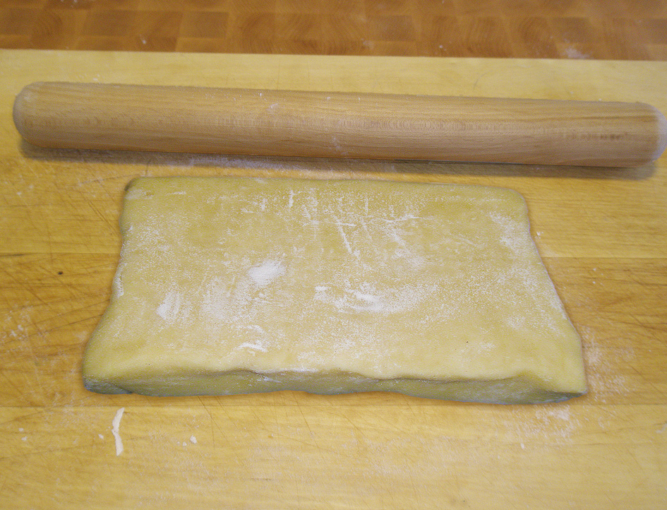
Anna is making fruit pies.

She has a rectangular sheet of pastry that is 60cm by 30cm.

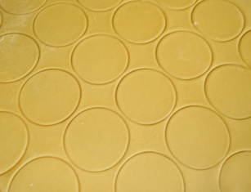

Each pie needs two pastry circles,
one of diameter 10cm, one of diameter 6cm.
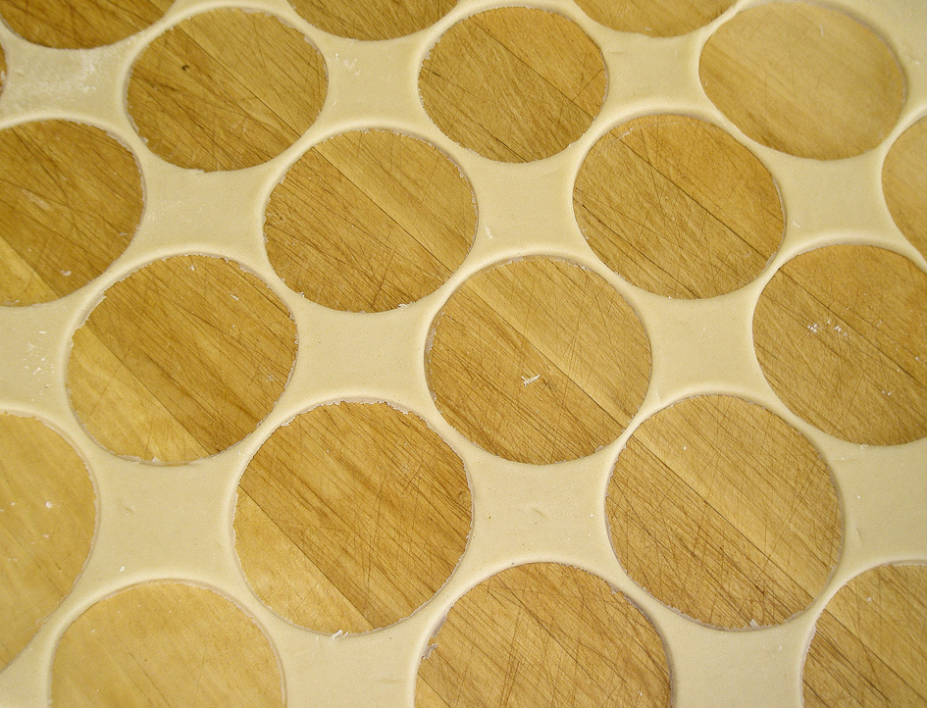

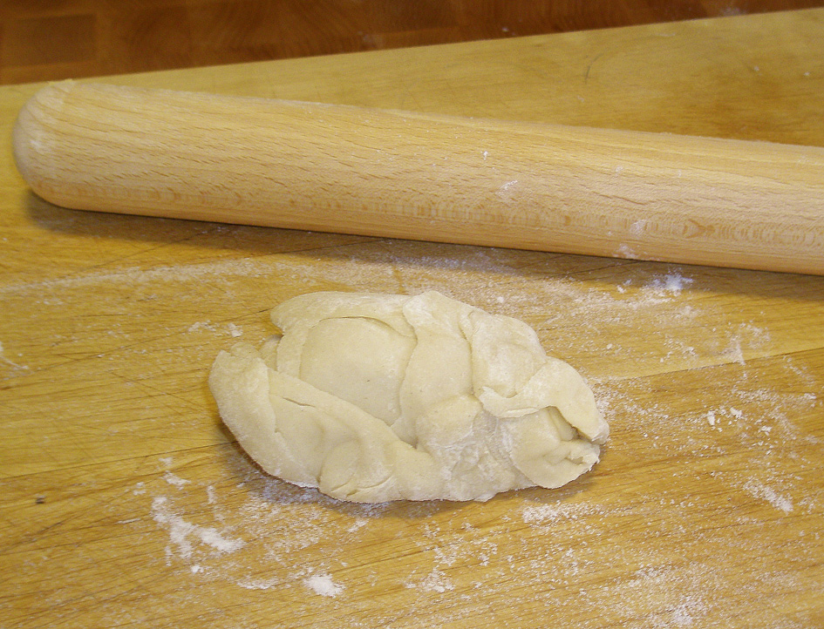

Anna will use the leftover pastry to roll a smaller rectangle,
but she will only use the leftover pastry in this way once.

What is the largest number of fruit pies Anna can make?

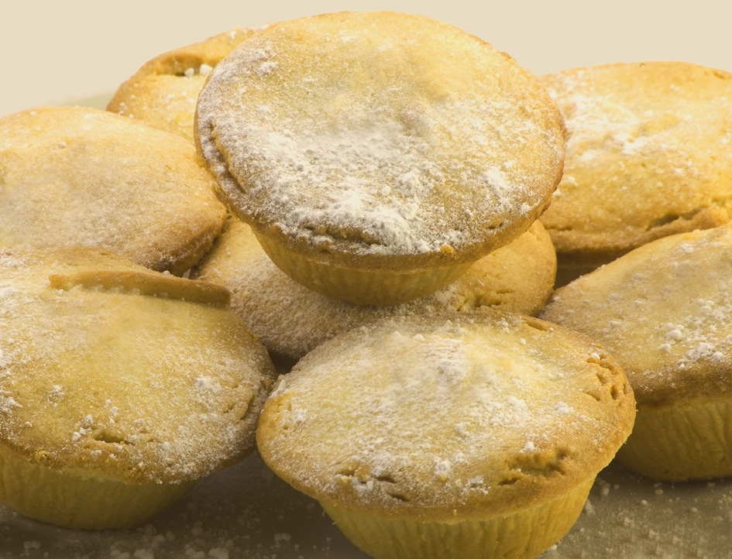

Assessment guidance

Progression in Key Processes

Representing | Analysing | Interpreting and Evaluating | Communicating and reflecting
Understanding of the problem, approaches to problem solving | Use of reasoning, and calculations | Appropriateness and accuracy of the work | Clarity and logic of presentation throughout the task
Uses a scale drawing or clear sketch to show how pies can be cut and/ or uses squares to represent circles  PROGRE  S  S  I  ON  Pupil A | Recognises that the first rectangle can give 12 complete pies  Pupil A | Shows evidence of rounding down their number of pies, to the nearest integer | Shows their methods, using some correct units, so that someone else can follow their reasoning
Attempts to find the total area of pastry used during the first rolling | Correctly calculates the area of a large or a small circle | Any circle areas used are rounded up or are correct to at least 3 significant figures  Pupil B | Explains their methods using appropriate units, diagrams, symbols and text
Attempts to find the total area of pastry left after the first rolling  Pupil B | Divides area of first rectangle by combined areas of large and small circles to find the theoretical maximum number of complete pies  Pupil B | Shows insight, eg recognises that the depth of pastry should be kept the same for the second as for the first rolling  Pupil C | Gives a clear and concise explanation of their methods, even if their solution is incomplete  Pupils A, B and C
Attempts to use the leftover pastry to form a rectangle from which more pies are cut  Pupil C | Shows the size of the second rectangle to be rolled, with one dimension a multiple of 6 or of 10 or both  Pupil C | Investigates if rolling second rectangle in a different way changes the number of pies that can be made | Gives a clear, concise and thorough explanation of their methods, including the second rolling

Sample responses

Pupil A
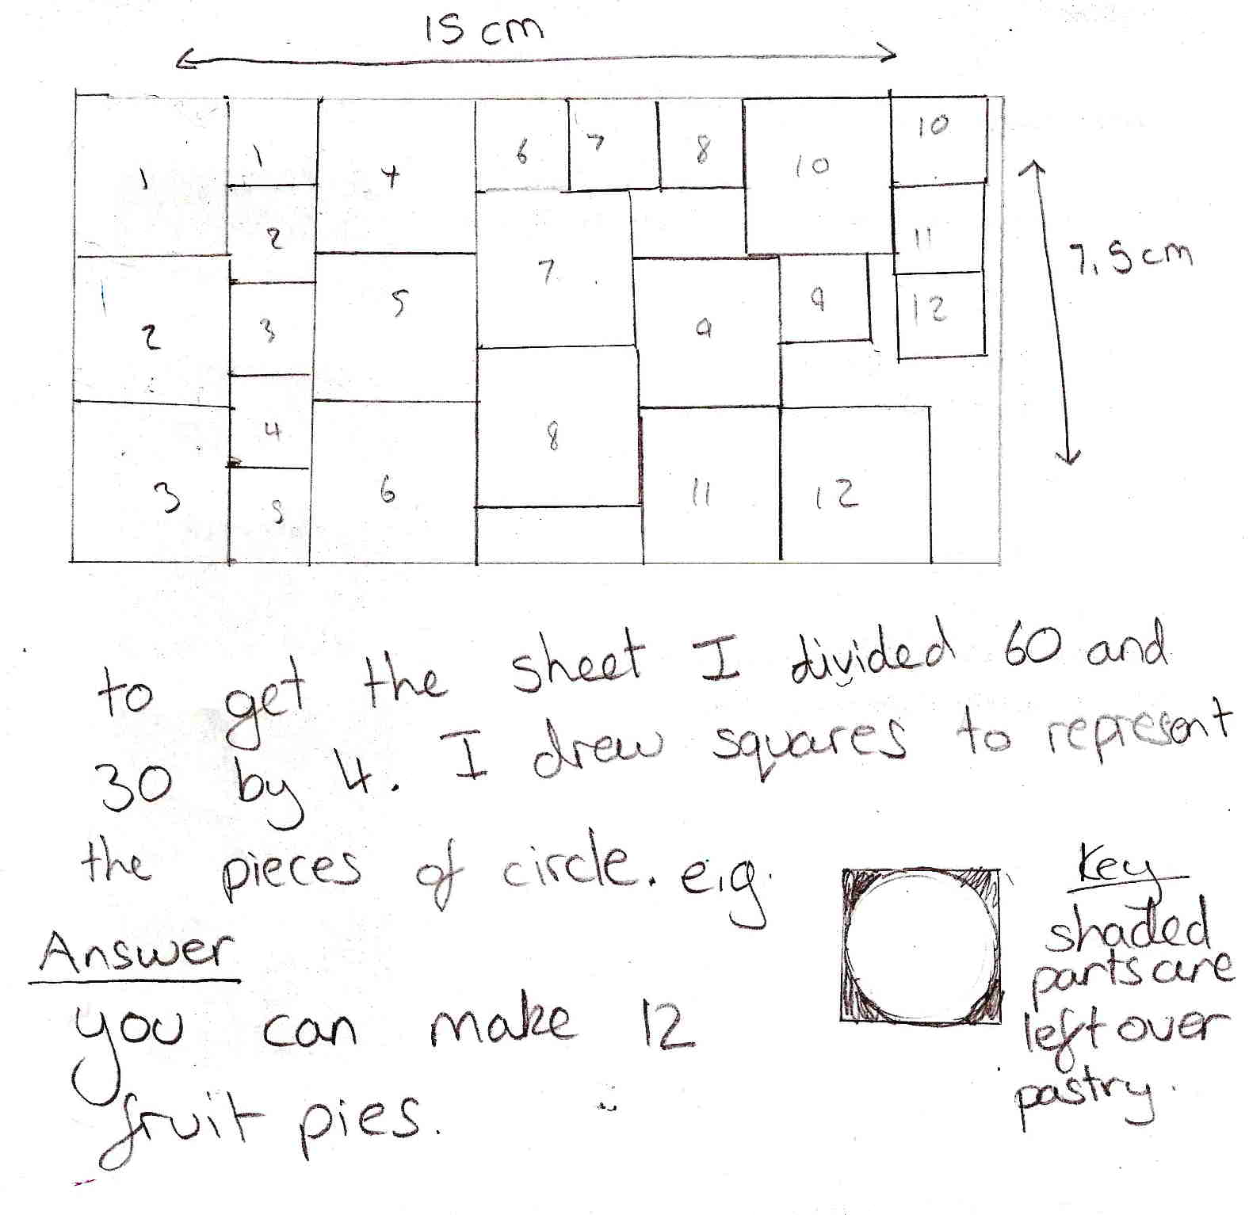

Comment

Pupil A has attempted a scale drawing (not shown here full size) but without squared paper. The scale of 1 : 4 is clear, and the rectangle is correct; not all of the squares are accurate, but a correct solution for one rolling is found. No attempt made for the second rolling. The reasoning is clearly expressed; the key showing the leftover pastry is clear.

Probing questions and feedback
- Your key is really good, but you need to know how much pastry is left over from each square – and the rest. Look back at the work you have done on areas of circles - how would that help?

Pupil A would benefit from further multi-step activities that require knowledge of circles within practical contexts.

Pupil B

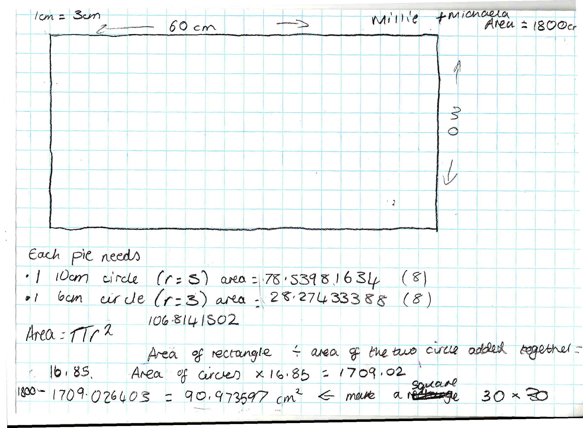

Comment

Pupil B has used areas of circles to calculate the total area for each pie. She correctly worked out the theoretical maximum number of pies, which she rounded to 16.85, but does not analyse whether this is achievable. To calculate the pastry used, she uses a correct method, but makes an error. She subtracts this to find the remaining area, but then makes an error with the square root. Perhaps she ran out of time as this left over pastry is not used. Her reasoning is clearly and logically expressed and neatly presented.

Probing questions and feedback
- How can you be sure that you have calculated the amount of left over pastry correctly?
- What do you intend to do with the left over pastry?
- ‘Next time you work on a complex problem, spend some time at the beginning planning your methods so that you can use your time more effectively. That way each step can be clearer; towards the end of your work it all gets a bit muddled.’

Further multi-step problems that require the pupil to assess the reasonableness of her solution would be valuable. A Bowland case study such as Reducing Road Accidents would be appropriate and engaging for her.

Pupil C

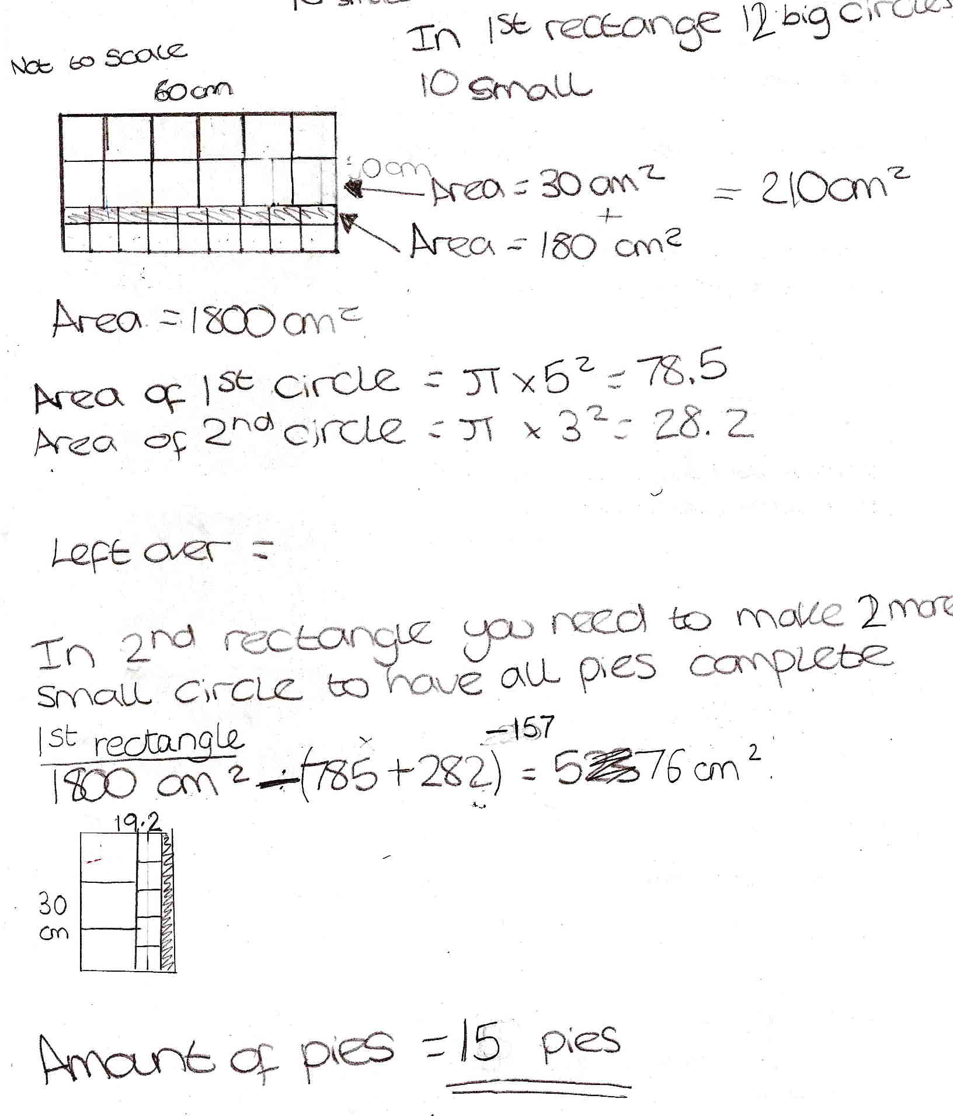

Comment:
This pupil has started by using squares to represent rectangles. The diagram is not accurate (9 small circles are shown rather than 10) and the area calculations also seem to be inaccurate. However, these values are not used in the working that follows.

The pupil subtracts the areas of 12 large and 10 small circles from the total area of the rectangle to find the area of pastry available for the second rolling. Areas of circles have been rounded down.

The dimensions of the second rectangle have been chosen wisely since this allows for 3 more large and 5 more small circles, giving a total of 15 pies.

Comment

Pupil C started by using squares to represent circles. The diagram is not accurate, but the numbers of squares are stated correctly. He does not use his (inaccurate) area calculations. He subtracts the areas of 10 large circles (it should have been 12) and 10 small circles from the total area to find the area available for the second rolling. Areas of circles have been rounded down. He chose the dimensions of the second rectangle wisely since this allows for 3 more large and 5 more small circles, giving a total of 15 pies.

Probing questions and feedback
- ‘Think about your communication. Aim to be clear and concise but thorough so that someone else understands each step of your working – what you are doing and why and how you know your solution is as good as possible.’

Creating situations in which the pupil needs to explain his work, eg presenting his work to others, will help develop his understanding of effective communication.

