 | Fish Dish

Task description

Pupils plan when they should start preparing a meal in order to have it ready by a stated time.
Suitability National Curriculum levels 5 to 6

Time 30 minutes to 1 hour

Resources Ruler, pencil and paper; scissors available but provided only on request.

Key Processes involved

- Representing: Select a way of representing the sequence of jobs using a table or diagram showing times, constraints and which jobs may be done in parallel.
- Analysing: Work logically towards a result, sequencing the jobs using the constraints given on the job cards; explore the effects of varying the order.
- Interpreting and evaluating: Relate findings to the original context: they look at the organisation of jobs, recognise which jobs may be done in parallel and deduce the latest time they can start preparing the meal.
- Communicating and reflecting: Communicate reasoning clearly, showing the order in which jobs can be done and which may be done in parallel.

Teacher guidance

Check that Pupils fully understand the context, for example with questions such as:
- How long does it take to boil a potato? How about frying a piece of fish?
- Would you start them both at the same time? Or which would you start first? Why?
- Show your working so that I can understand your reasoning – don’t just write down the answer!

This task requires pupils to demonstrate their proficiency in the Key Processes using fairly elementary mathematical techniques. They might be expected to:

- create and interpret graphs and diagrams and draw conclusions

Fish Dish
A chef is preparing a fish meal.
These are the jobs he has to do, but they are not in order.
Job A
Heat and stir the sauce
Takes 3 minutes
Must be completed just before the fish is served
Job B
Make the sauce
Takes 7 minutes
Must be done before heating the sauce
Job C
Prepare the vegetables
Takes 4 minutes
Must be done before making the sauce and before cooking the vegetables
Job D
Skin and bone the fish
Takes 5 minutes
Must be done before cooking the fish
Job E
Cook the vegetables
Takes 10 minutes
Must be completed just before the fish is served

Job F
Serve up the meal
Takes 2 minutes

Job G
Cook the fish
Takes 5 minutes

The chef is on his own and can only do one thing at once.

The fish and the vegetables can be left to cook in the oven while he does something else.

- What is the order in which the chef should do the jobs? Use the letters A to G.

- The customer wants the chef to serve the fish dish at 6.00pm. What is the latest time the chef can start preparing it?

The chef needs to see how you did the calculations

Assessment guidance

Progression in Key Processes

Representing | Analysing | Interpreting and evaluating | Communicating and reflecting
Choice of representation to engage with the problem  PROGRE  S  S  I  ON | Placing of jobs in order, taking the constraints into account | Conclusions about the time the dish will take and relating back to original context | Clarity of order of tasks, calculation methods and reasoning
Makes a simple list of jobs but with no indication of times of jobs, constraints or which jobs could be done in parallel.  Pupil A | Makes an attempt to order the jobs, meeting some of the constraints, but with no evidence of checking.  Pupil A | Proposes a sequence of jobs that is nonsensical or unreasonable. Does not progress to a calculation of time though a time may be presented. | Communicates some of the ordering but with little explanation  Pupil A
Makes a simple diagram or table of jobs, but with no indication of timings or which jobs can be completed in parallel  Pupil B | Makes attempts to order jobs, meeting many ordering requirements of jobs. (3 or more, D before G, C before E, B before A, C before B)  Pupil B | Begins to consider the time required, but does not take into account that some jobs can be done in parallel  Pupils A and B | Communicates ordering and some calculation of time but lacks adequate explanation.  Pupil B
Chooses a representation that includes indications of times and whether jobs can be completed in parallel. | Orders the jobs so that they meet the explicit constraints, but not in the optimal way.  Pupil C | Gives a plausible order of jobs and shows recognition of jobs that can be done in parallel. Calculates a start time consistent with the sequence of jobs shown.  Pupil C | Presents the work clearly enough for the reader to deduce which jobs were done in parallel and how the time was calculated.  Pupil C
Chooses a representation that includes indications of times and whether jobs can be completed in parallel  Pupils C and D | Places the jobs in an order which meets the constraints and minimises the time.  Pupil D | Reflects the original context by using jobs that can be completed in parallel; recognises the need for some jobs to finish 'just in time'. Correctly finds the optimum start time of 5:39  Pupil D | Explains the work clearly including the impact on timing of completing some tasks in parallel.  Pupil D

Sample responses

Pupil A
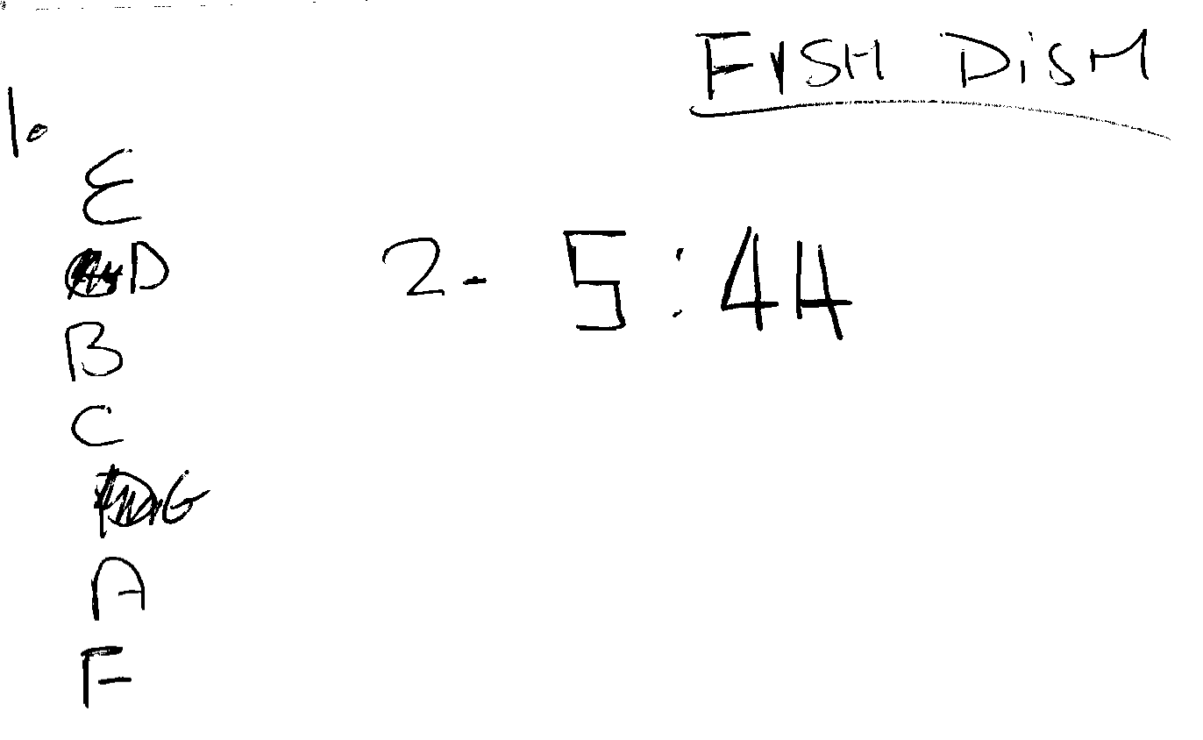
Comments

Pupil A has not communicated his reasoning nor shown any working. He attempts to order the jobs meeting some of the constraints, but the order is wrong. His starting time is incorrect and he gives no reason for it. He may have added the times of C+E+F.

Probing questions and feedback

- How did you decide the order of the jobs? How did you decide when to start?
- What is job E? What is job C? Which do you need to do first?
- How could you present your work, so someone else can see your thinking?

Pupil B
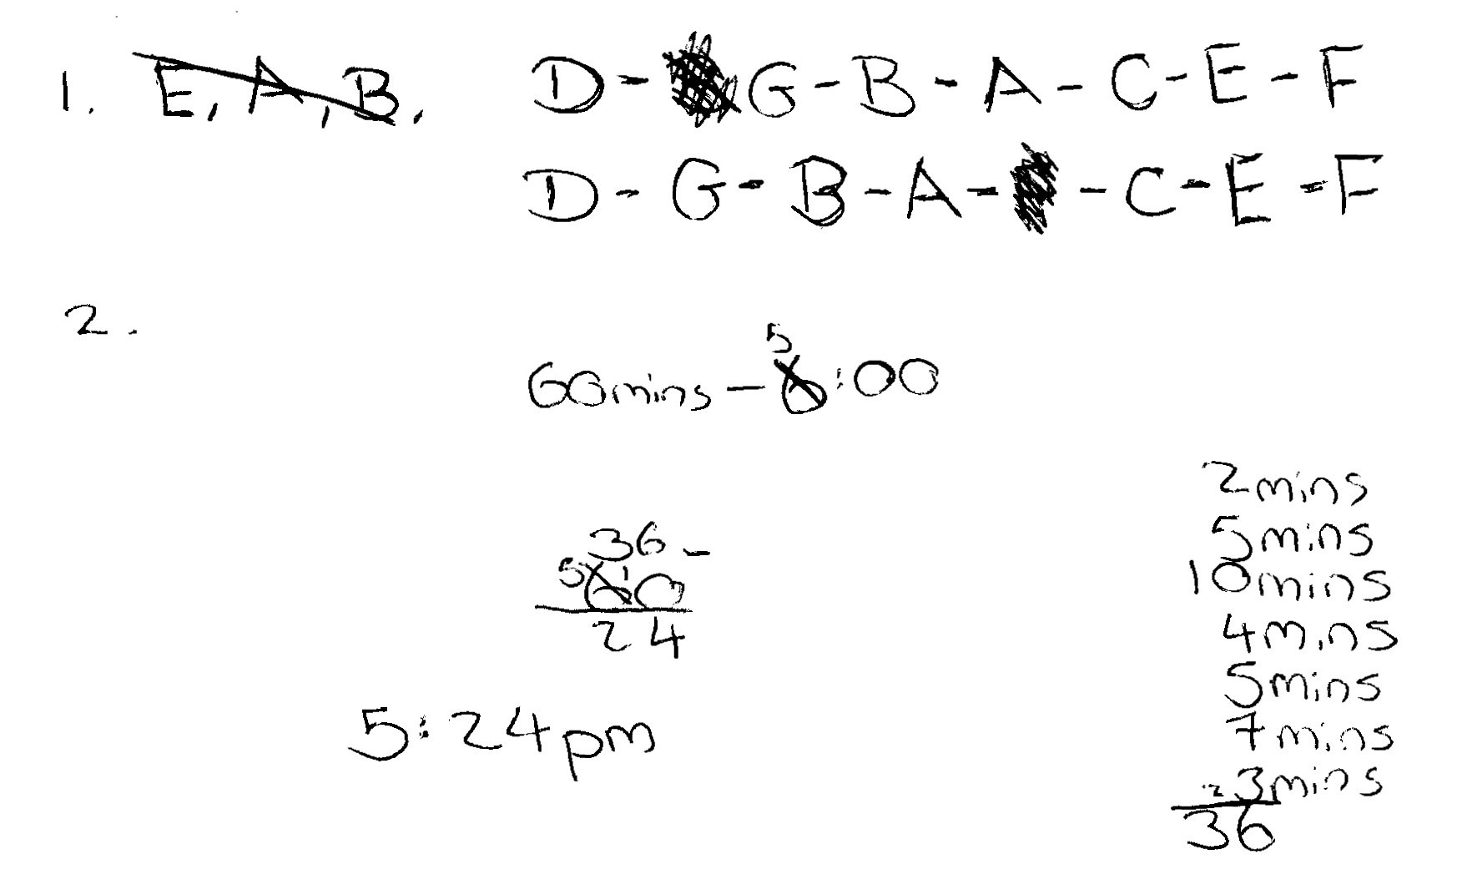
Comments

Pupil B orders the jobs meeting some of the ordering requirements, but not all of them. His order fails to consider the original context (the fish and sauce are left to wait while the vegetables cook). He does not take account of the fact that some of the jobs can be done in parallel. His start time is correctly calculated for his sequence.

Probing questions and feedback

- Are you sure that you followed all the rules on the cards? Can you think of a way of writing them down which would make it easy to check?
- What is the chef doing while the vegetables are cooking?
- What is happening to the fish while the vegetables are cooking?
- Is it possible to do it in less than 36 minutes?

Pupil C
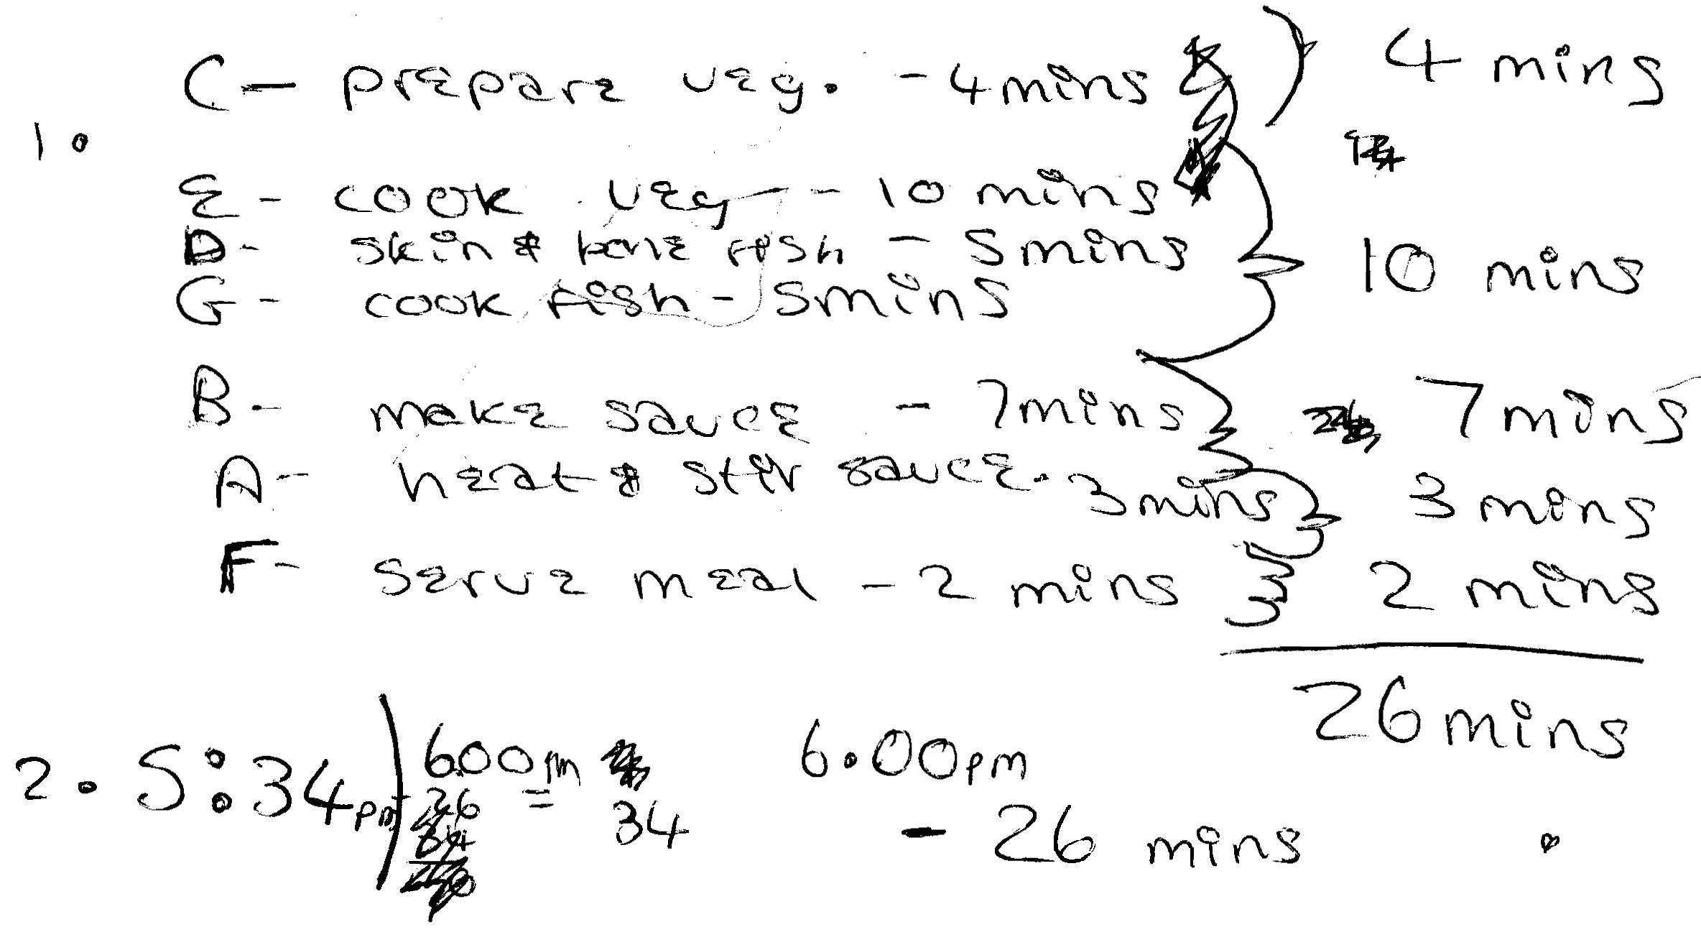
Comments

Pupil C correctly orders the jobs, meeting the key requirements, leading to a calculation of the time required. She has recognised that the chef can do other things while the vegetables are cooking, but has not found the optimum time. The work is sufficient to infer which jobs are to be done in parallel, but this is not well explained.

Probing questions and feedback

- Do you think you have found the quickest way to cook the meal? Can you find a faster way?
- What jobs can be done at the same time? Are there any others?
Which can’t be done at the same time? Why is this?
- Could you modify your diagram to make it clearer, so that the chef could follow your instructions?

Pupil D
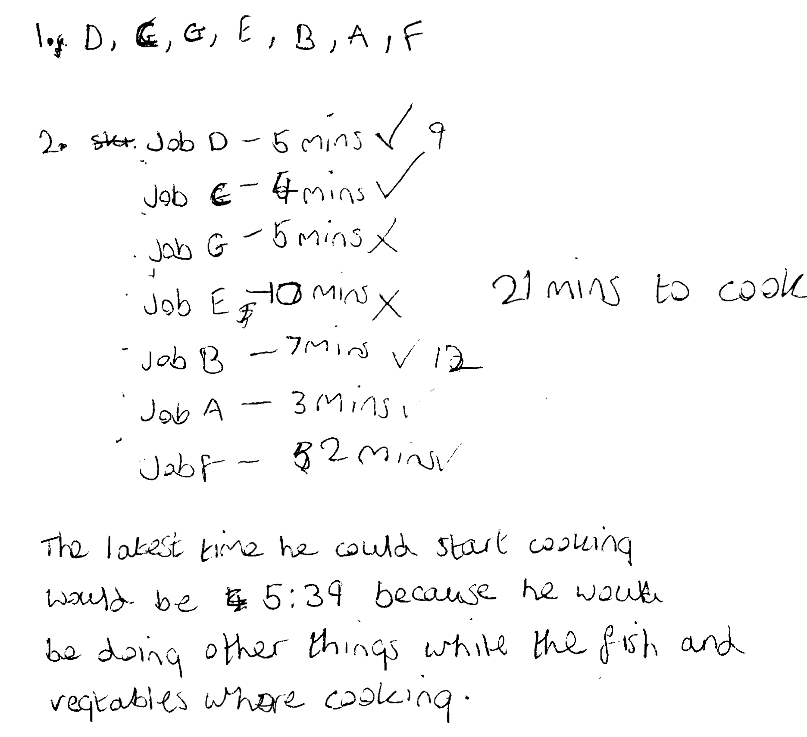
Comments

Pupil D shows all the jobs in a valid order. She indicates that cooking the fish and cooking the vegetables can take place while other jobs are being done, and her calculation of the time required is correct. Then she correctly calculates the starting time. Her work is clear and easy to follow.

Probing questions and feedback

- Could you modify your diagram to make it clearer, so that the chef can follow your instructions?
- What other order of jobs would also work?

