 | Fares not fair

Task description

Pupils determine whether the rates for taxi fares, set by a local council, are fair in relation to the changing cost of fuel.

Suitability National Curriculum levels 6 to 8

Time 45 minutes to 1 hour

Resources Paper and calculator

Key Processes involved

- Analysing: Process the data to find the relationship between fuel cost and taxi fares.
- Interpreting and evaluation: Use findings to justify their recommended fare.
- Communicating and reflecting: Communicate findings effectively and explain recommendation clearly.

Teacher guidance

You might begin by showing the slides on a whiteboard and commenting:

- Even though taxi drivers are usually self employed, the taxi fares they can charge are not set by the drivers, but by their local Council. In 2008, taxi drivers in Surrey complained that the prices they were allowed to charge were not fair as the price of diesel fuel had gone up so much.
- The data shows the cost of fuel and the price of taxi fares over 8 years. Your task is to examine the drivers’ claim and decide on a fair price for them to charge.

The task requires knowledge of proportionality.
During the task, the following probing questions may be helpful
- What method will you use to decide what would make a fair price?
- What does ‘fair’ mean?
- Are there different ways you could use the information to make your decision?
- The taxi drivers focus on the cost of their fuel; should there be other factors in deciding what would be a fair price?

Fares not fair!

Cabbies complain – “Fares are set too low”

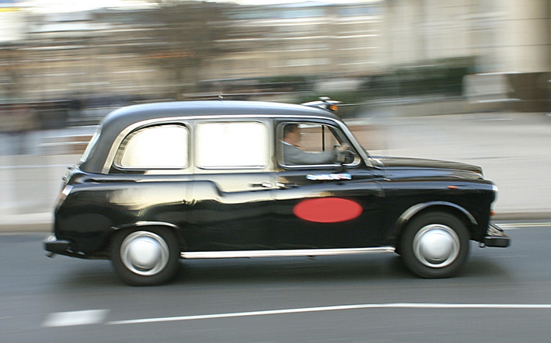

In May 2008, taxi drivers in Surrey complained that they were not allowed to increase their taxi fares although the cost of fuel had risen.

The table shows how costs and prices have changed.

How prices changed
Average cost of one litre of diesel fuel  May 2000 82p  May 2001 79p  May 2002 77p  May 2003 78p  May 2004 83p  May 2005 90p  May 2006 92p  May 2007 97p  May 2008 125p | Taxi fare (2 mile journey)  May 2000 £3.50  May 2001 £3.80  May 2002 £3.90  May 2003 £4.40  May 2004 £5.00  May 2005 £5.00  May 2006 £5.00  Fact:  Taxi fares are set  by the Council  May 2007 £5.20  May 2008 £5.20

As diesel costs have increased so much, it seems reasonable that taxi fares should have been allowed to increase in May 2008.
How much would it have been reasonable to allow fares to increase?

Use the data to make your suggestion for what would be a fairer taxi fare for May 2008; Explain why.

Assessment guidance

Progression in Key Processes

Representing | Analysing | Interpreting and Evaluating | Communicating and reflecting
What is done with the data | The data processed to gain an insight into patterns and exceptions | Findings used to justify their recommended fare | Methods and findings explained throughout; insight into the problem shown
Chooses an additive method to compare changes in costs  PROGRE  S  S  I  ON  Pupil A | Recognises that a rise (or fall) in the cost of diesel is not always matched by a rise (or fall) in fares  Pupil A | Gives a recommended fare | Identifies which years are being considered and explains their simplistic method clearly  Pupil A
Attempts to summarise the outcomes from their additive method,  eg uses averages | Makes simple statements when summarising the data, eg ‘Between 2001 and 2003 diesel costs fell but fares went up’ | Forms a simple argument to justify their recommended fare  Pupils A and B | Identifies which years are being considered and shows the calculations that lead to a solution, thus allowing their working to be checked  Pupil B
Uses a non-additive method, even if simplistic  Pupils B and C + D | Processes the information to gain an insight into the data, eg by using means or percentages  Pupils B and C + D | Forms more complex arguments to justify their recommended fare  Pupils C + D | Shows methods clearly in a solution that ‘flows’; recognises that other factors will be applicable in determining fares  Pupils C + D
Uses a non-additive method based on at least the last four years | Uses a scatter graph or other insightful methods that show the relationship between the costs of diesel and prices of fares | Uses additional mathematical tools to inform their recommended fare, eg draws a line of best fit | As above, but also justifies why the problem is complex, eg ‘fuel is a small proportion of the costs so other costs, (eg labour) need to be considered’

Sample responses

Pupil A

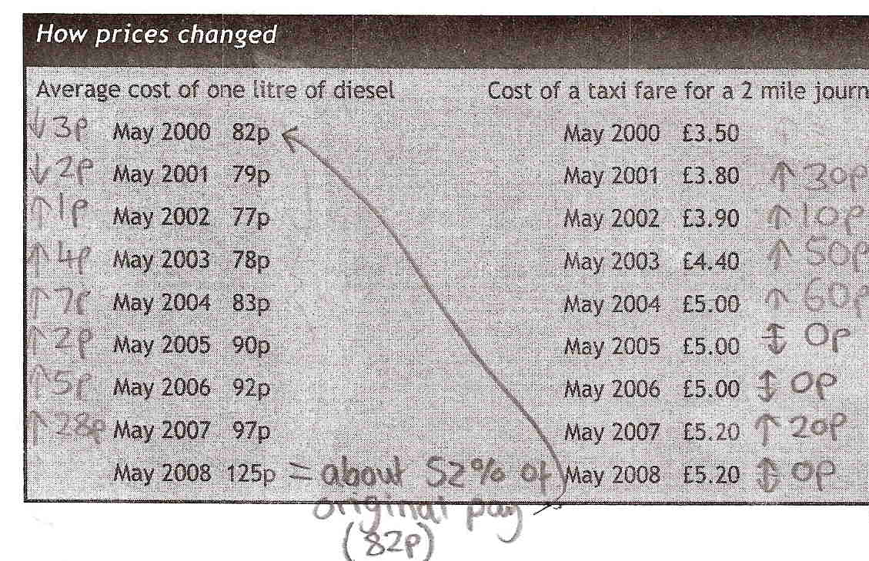

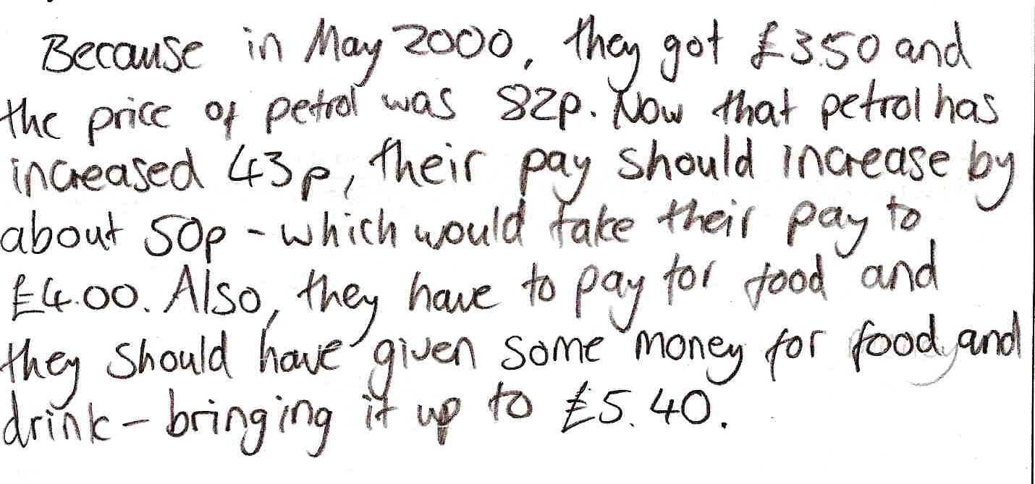

Comments

Pupil A starts with the changes per year in fuel costs and fares, but there is little evidence of insight into the values found. He works out the percentage increase in the fuel costs from 2000 to 2008 – but shows it as 52% not 152%. He does not use this, but reverts to using the cost difference between May 2000 and 2008. He shows an awareness that real life costs are based on more than the price of fuel, but the solution is simplistic and not justified.

Probing questions and feedback

- You worked out a percentage change; your solution would have been better if you had used that, ie by finding 52% of £3.50 and adding the answer to £3.50. You suggest £1.40 for food and drink, but why should that suddenly appear for 2008?

This pupil would benefit from tasks that probe his ability to reason mathematically. Working with another pupil might encourage him to reflect on his methods and his solutions.

Pupil B

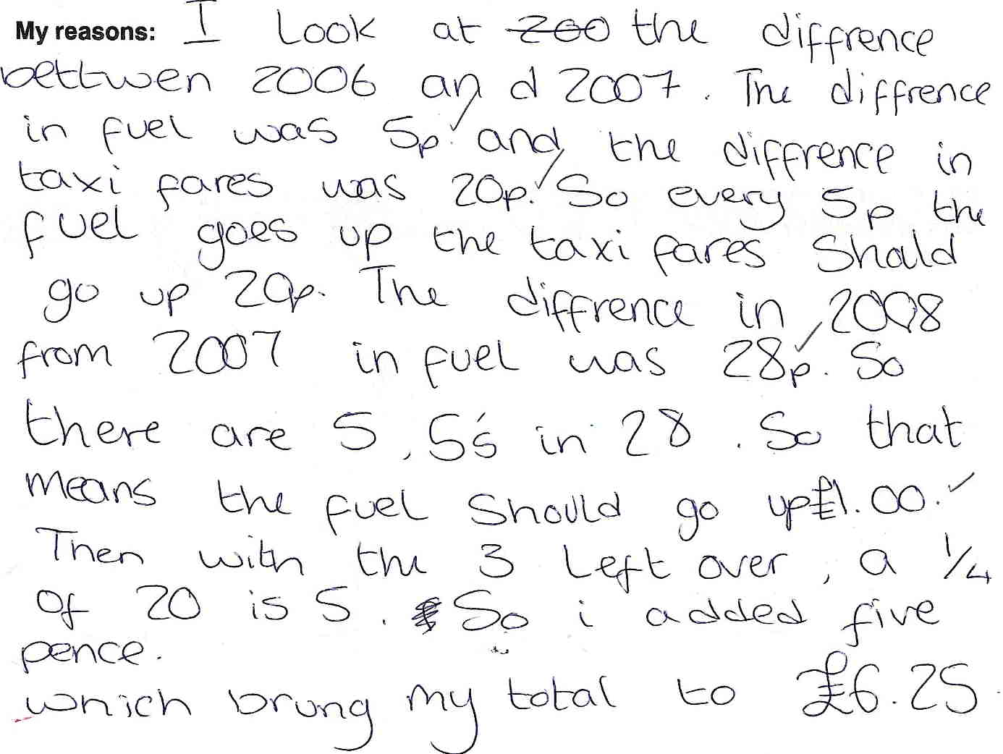

Comments

Pupil B has used the change from 2006 to 2007 to inform his solution for 2008, but with no reference to the period before 2006. He uses proportional reasoning, but his understanding of fractions is insufficient to complete the method since he calculates one quarter of 20p rather than three-fifths of 20p.

Probing questions and feedback

- When solving a complex problem, remember to show evidence for your thinking; for example, why did you choose to work only with 2006, 2007 and 2008; what about earlier years?
- Why did you choose that particular method?

Practice at interpreting data sets would benefit this pupil, as would working with contexts that require an understanding of fractions.

Pupils C and D
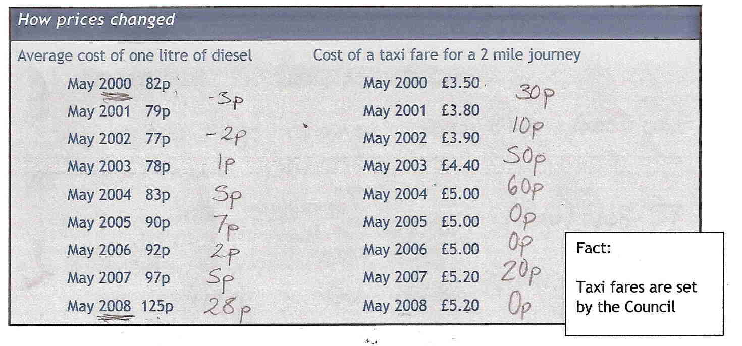

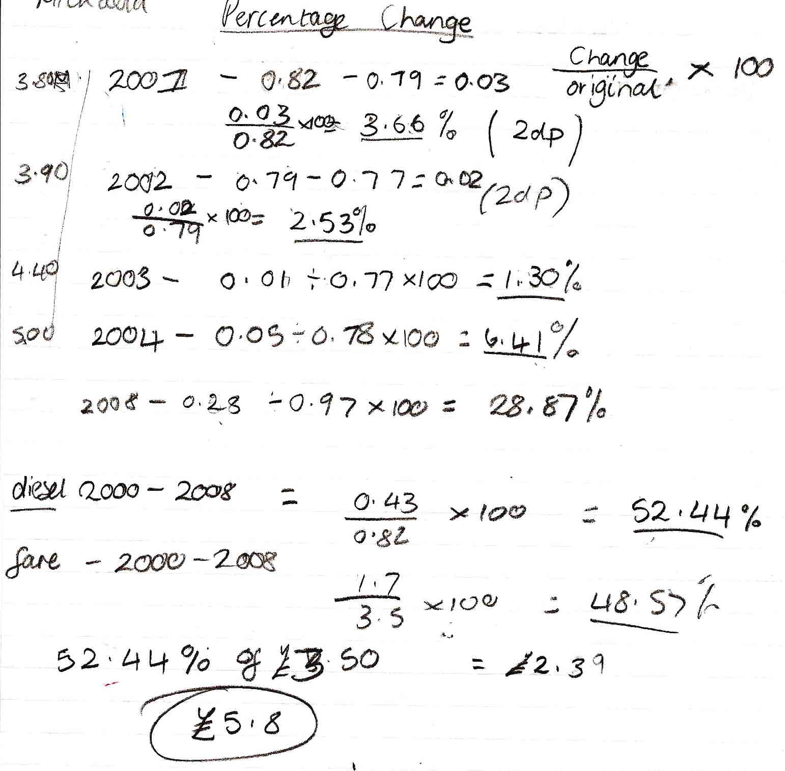

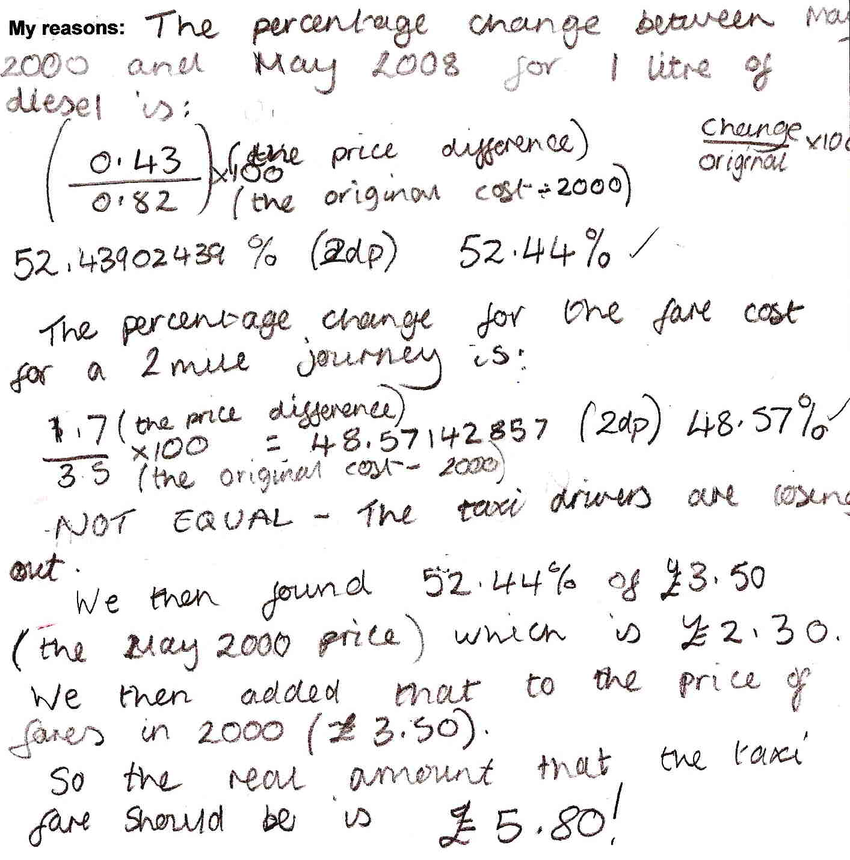
Comments

Pupils C and D start by using differences in costs, but change to percentages. They find the percentage change for several years decide not to continue; their oral explanation was that: ‘there isn’t a pattern in the data, you can’t see anything, so we think if we just work out what is happening from the beginning it will be simpler and clearer’. They then use their multiplicative method to compare how prices have changed from 2000 to 2007 and apply their findings to 2008 to find a justified conclusion. Most calculations are accurate, but not all. Their communication is clear, although there is no evidence of reflection on the task.

Probing questions and feedback

- When working on a complex problem, try to think about how well the mathematical model you are applying fits the real life situation; in this task you could have thought about whether basing the cost of a taxi fare only on the cost of diesel was appropriate.

These pupils enjoyed working on the task, seeing it as an exciting challenge. Providing them with extended open-ended tasks, such as a Bowland case study, would capitalise on this enthusiasm and should enable them to develop their skills further.

