 | Day Out

Task description
Pupils choose the best trip using survey data and then cost it.
Suitability National Curriculum levels 4 to 5

Time 30 minutes to 1 hour

Resources Pencil, calculator and paper

Key Processes involved

- Representing: Simplify the situation, summarise unsorted data, and represent data mathematically.
- Analysing: Calculate costs accurately.
- Interpreting and evaluating: Interpret their tables and deduce the best place for the trip.
- Communicating and reflecting: Clearly describe their decision making process and their methods.

Teacher guidance

Check that pupils understand the context, for example, give out the task sheet and ask general questions such as:
- Which place has the cheapest entrance fee?
- Which place is nearest?
- What are Lucy’s first and second choices?
- How does the bus company charge for the coach?
- How much will teachers have to pay?
- How much will the school pay towards the total cost of the trip?

Pupils can tackle this task in different ways, but they might be expected to know:

- How to collect discrete data
- How to record data using a frequency table

Day Out

Mr. Richards, a teacher at Bosworth School, plans to take 30 pupils on a school trip. Here are the places they could visit.

Growlets Zoo  36 miles from Bosworth  Entrance fee £2.50 per person | Prison Museum  30 miles from Bosworth  Entrance fee £6 per person | Space Science Show  10 miles from Bosworth  Entrance fee £10 per person

The class vote on which place to visit. Here are the results:

Name | First Choice | Second choice |  | Name | First Choice | Second choice
Olivia | Zoo | Space show |  | Jack | Prison museum | Zoo
Grace | Space show | Prison museum |  | Thomas | Zoo | Prison museum
Jessica | Prison museum | Zoo |  | Joshua | Zoo | Prison museum
Ruby | Zoo | Space show |  | Oliver | Space show | Prison museum
Emily | Space show | Prison museum |  | Harry | Prison museum | Zoo
Sophie | Prison museum | Zoo |  | James | Zoo | Space show
Chloe | Prison museum | Space show |  | William | Space show | Space show
Lucy | Prison museum | Space show |  | Samuel | Zoo | Prison museum
Lily | Space show | Prison museum |  | Daniel | Zoo | Space show
Ellie | Space show | Prison museum |  | Charlie | Prison museum | Prison museum
Ella | Zoo | Space show |  | Benjamin | Space show | Zoo
Charlotte | Space show | Prison museum |  | Joseph | Zoo | Prison museum
Katie | Space show | Prison museum |  | Callum | Zoo | Prison museum
Mia | Zoo | Space show |  | George | Prison museum | Space show
Hannah | Zoo | Space show |  | Jake | Space show | Prison museum

- Taking first and second choices into account, where do you think Mr Richards should take them? Explain how you decided.

Here are some more facts about the trip.

The bus company charges £6 per mile. The school fund will pay the first £200 of the trip. Teachers will go free. Each pupil will pay the same amount.

- How much will each pupil need to pay to go on the trip you have chosen?
Explain how you work this out.

Assessment guidance

Progression in Key Processes

Representing | Analysing | Interpreting and evaluating | Communicating and reflecting
Selection of data and choices about summarising data | Analysis of pupils’ first and second choices and calculations | Ensuring that the chosen destination relates to the context | Description of method: clarity and completeness
PROGRE  S  S  I  ON  Selects some of the data given  Pupils A and B | Uses some of the data given for analysis of choice, for example counts only first choices or performs some calculations on the cost of the trip  Pupil A | The result of analysis of some of the data is used to select a destination  Pupil A | Describes the decision, or calculations made but this is incomplete and/or contains errors  Pupil A
 | Uses some of the data given for analysis. Calculates the cost of a trip  Pupil B | The result of analysis of some of the data is used to select a destination  Calculations on the cost of the trip are made, but with some inaccuracies  Pupil B | Describes the decision made and cost of the trip but with some errors  Pupil B
Produces summary data on first and second choices  Pupil C | Takes both first and second choices into account, but does not weight them.  Calculates cost per pupil accurately  Pupil C | Interprets and evaluates the summary data and makes a reasoned decision about which trip, but does not take everything into account  Pupil C | Describes their decision making process and methods but lacks clarity  Pupil C
Produces summary data on first and second choices  Pupil D | Uses a weighting system based upon both first and second choices.  Calculates cost per pupil accurately  Pupil D | Interprets and evaluates the summary data and makes a reasoned decision about which trip; takes everything into account  Pupil D | Clearly describes their decision making process and their methods  Pupil D

Sample responses

Pupil A

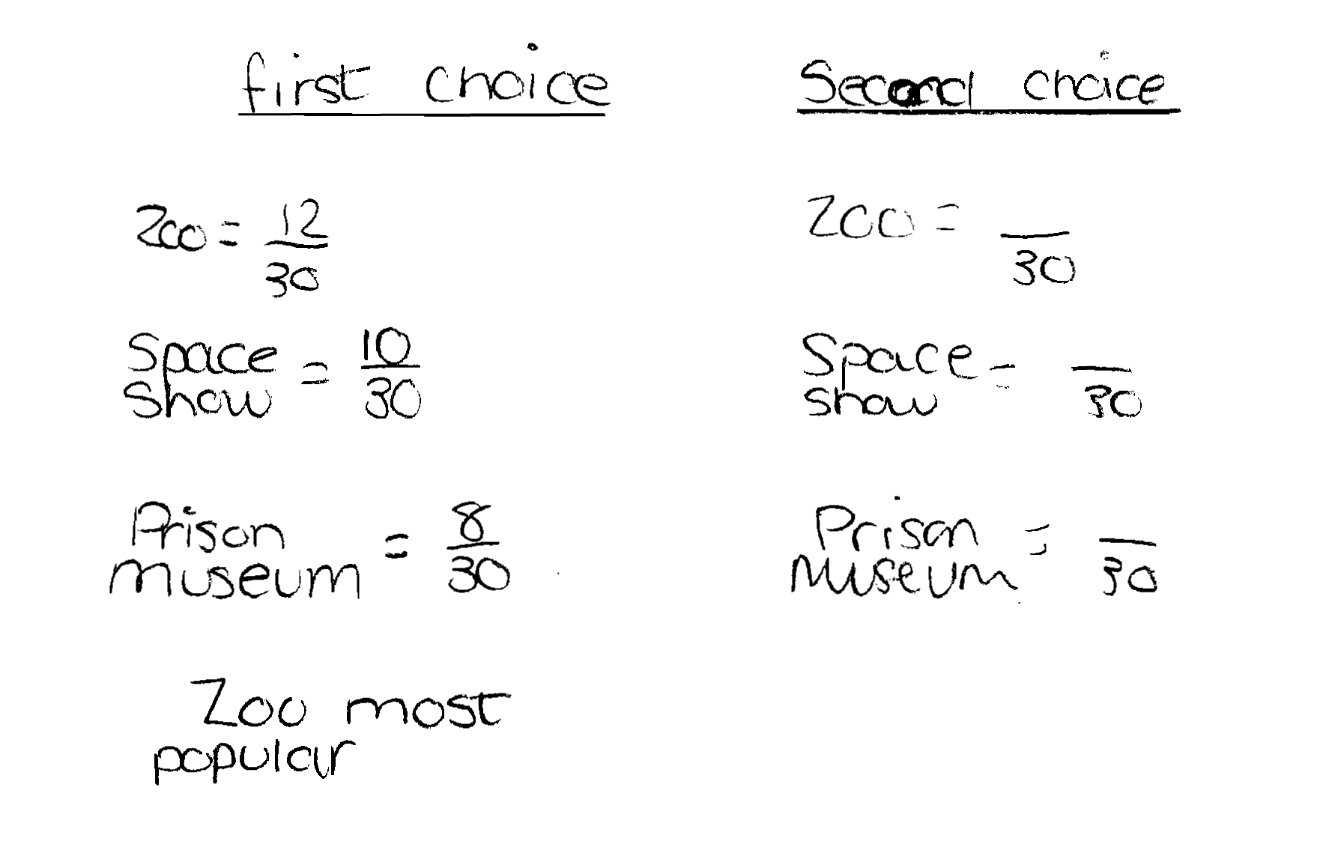
Comments

Pupil A correctly counts the number of first choices for each venue.

Probing questions and feedback

- How might you take into account the second choices?
How would this affect your decision?
- What would be the entrance cost for 30 pupils to go to the zoo?
- Can you calculate the total cost for 30 pupils to go to the zoo – including the coach?
- How does the cost of going to the other places compare with the cost of going to the zoo?

Pupil B

Comments

Pupil B correctly calculates the total cost of the entrance fee and travel for the three venues, but calculates the cost per person incorrectly. She selects the Space Science based on her calculations.

Probing questions and feedback

- Please explain how you worked out the cost of visiting the zoo?
- About how much per person will this be?
- How popular is the Space Science Show compared with the other places?

Pupil C

Comments
Pupil C counts the number of first and second choices for each trip, but does not attempt to weight first choice. She calculates the cost of travel for each trip and chooses Space Science Show because travel is cheapest. Then she correctly calculates the cost per person.

Probing questions and feedback

- How does the total number of first and second choices for the Space Science Show compare with the choices for the Growlets Zoo and Prison Museum?
- You have added the number of first and second choices. You have not taken into account whether these were mainly first or mainly second choices. How reasonable is this approach?
- Could you have made a case for either of the other two trips?

Pupil D

Comments

Pupil D counts the number of first and second choices for each venue and weights them. He correctly chooses the Space Science Show and then correctly calculates the cost of travel and entry and the cost per person. His work is clear and easy to follow.

Probing questions and feedback

- How accurately is it reasonable to give the cost per pupil?
- Can you think how someone might make a case for one of the other trips?
- You have given a reasonable weighting of 2 points for first choice and 1 point for second choice. Would your decision have been the same if you had given different weightings e.g. of 3 points and 2 points?

