 | Counting Trees

Task description

Pupils devise a method for estimating the numbers of trees in a plantation then use their method to estimate the numbers of two different kinds of tree.

Suitability National Curriculum levels 4 to 7

Time 30 minutes to 1 hour

Resources Ruler, pencil, calculator and paper

Key Processes involved

- Representing: Simplify a complex situation and choose an appropriate method to use to count the trees.
- Analysing: Use a method of sampling to estimate the numbers in the plantation; use the relative proportions of the two kinds of trees.
- Interpreting and evaluating: Consider the validity of the results.
- Communicating and reflecting: Communicate the method and reasoning clearly.

Teacher guidance

Check that pupils fully understand the context, for example with questions such as:

- Does anyone know what a tree plantation is?
- How is it different from a natural forest?
- Can you see which are the old trees, the new trees and the spaces in this plantation?

Pupils can tackle the task in different ways, but they might be expected to:

- solve simple problems involving ratio and direct proportion
- understand and use the formula for the area of a rectangle
- choose a sample, collect discrete data and record them in a frequency table

The last slide in the presentation is to be used for a final plenary to facilitate discussion of sampling method.

Counting Trees

This diagram shows trees in a plantation.

The circles show old trees and the diamonds show young trees.

The National Trust asks Tom to estimate how many trees there are of each type, but it would take too long for him to count them all, one-by-one.

- Think of a method Tom could use to estimate the number of trees of each type?
Explain your method fully.

- Use your method to estimate the number of:

  - Old trees

  - Young trees

Assessment guidance

Progression in Key Processes

Representing | Analysing | Interpreting and evaluating | Communicating and reflecting
Choice of sampling method. | Accuracy of method and its application | Validity of the answer. | Quality of written explanation
Chooses a method, but this may not involve sampling, e.g. counts all trees or multiplies the number in a row by the number in a column.  PROGRE  S  S  I  ON  Pupil A | Follows chosen method, possibly making errors; e.g. does not account for different numbers of old and young trees or that there are gaps.  Pupil A | Estimates number of new and old trees, but answer is unreasonable due to method and errors.  Pupil A | Communicates work adequately but with omissions.
Chooses a sampling method but it is unrepresentative or too small; e.g. counts the old and young trees in one row and multiplies by the number of rows.  Pupil B | Follows chosen method, mostly accurately; e.g. may not account for different numbers of old and young trees, or that there are gaps. | Estimates number of new and old trees, but answer given is unreasonable mainly due to the method.  Pupil B | Communicates reasoning and results adequately, but with omissions.  Pupils A and B
Chooses a reasonable sampling method that give a large enough sample.  Pupil C | Follows chosen method accurately. | Calculates a reasonable estimate for the number of old and new trees.  Pupil C | Explains what they are doing but explanation may lack detail.  Pupil C
Chooses a sample that is both representative and large enough.  Pupil D | Follows chosen method accurately and uses a proportional argument correctly.  Pupil C | Deduces a reasonable number of old and new trees and checks their answer.  Pupil D | Communicates reasoning clearly and fully.  Pupil D

Sample responses

Pupil A

Comments

Pupil A attempts to estimate the number of old and new trees by multiplying the number along each side of the whole diagram and then halving. She does not account for gaps nor does she realise that there are an unequal number of trees of each kind.

Probing questions and feedback

- Your method assumes there are the same numbers of new and old trees. Is this a reasonable assumption?
- You have counted the number of trees in the left hand column and in the bottom row. What would happen if you had chosen a different row and column?
- Can you suggest a different sampling method?
Pupil B

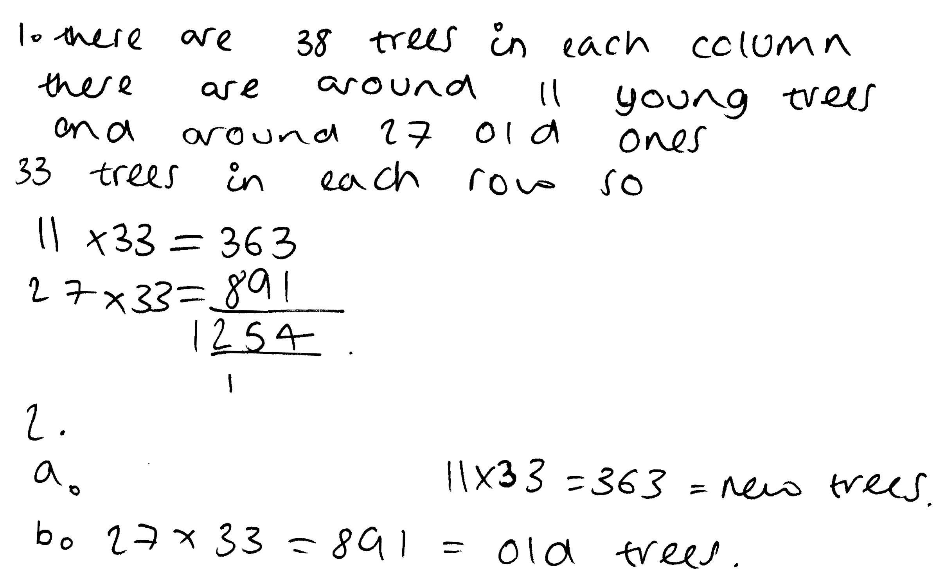

Comments
Pupil B recognizes that sampling is needed, but she multiplies the number of young trees and old trees in the left hand column by the number of trees in the bottom row. She ignores the columns that have no trees in the bottom row, so her method underestimates the total number of trees. However, she does take account of the different numbers of old and new trees.

Probing questions and feedback

- How many columns of trees are there?
- Which columns have you left out of your calculations?
- Using your first column as your sample, how many trees do you think there are altogether?
- What would happen if you used the number of trees in a different column for your sample?
- So how could you improve your estimates?

Pupil C

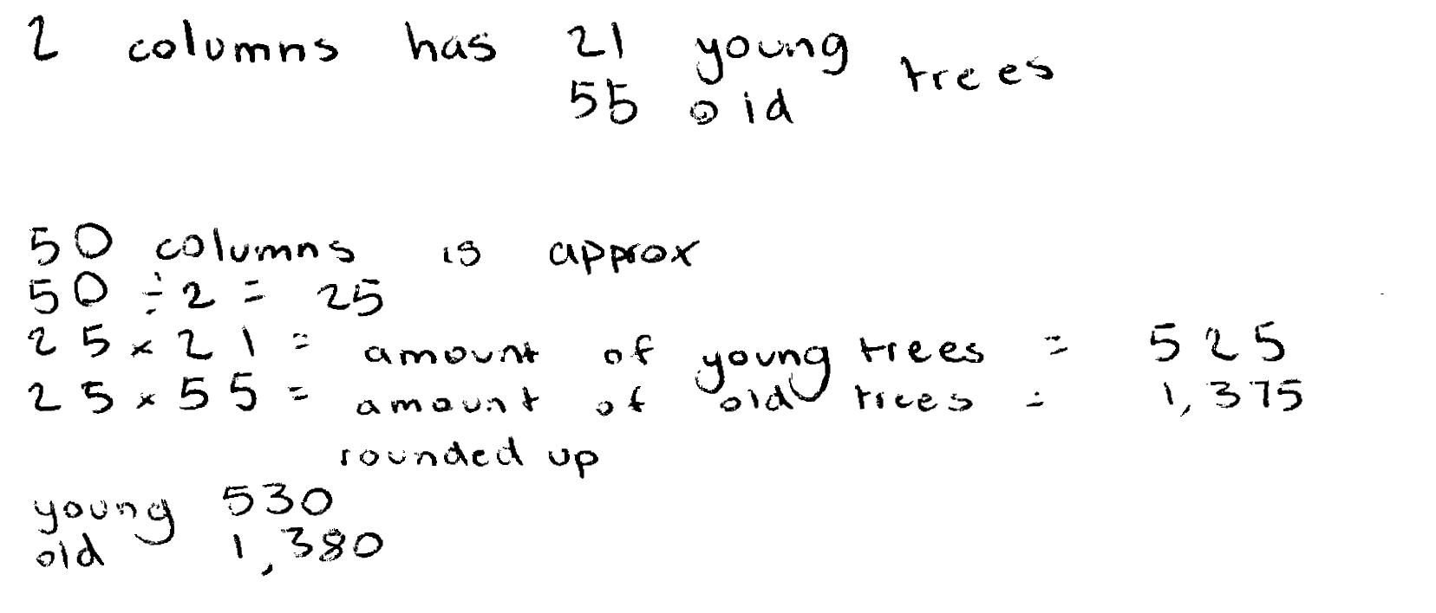

Comments
Pupil C uses a sample of two columns and counts the number of old and young trees. He then multiplies by 25 (half of 50 columns) to find an estimate of the total number.

Probing questions and feedback
- How could you test the accuracy of your estimate?
- What would happen to your estimate if you chose a larger number of columns for the sample?
- What other sample could you have chosen?

Pupil D

Comments
Pupil D chooses a representative sample and carries through her work to get a reasonable answer. She correctly uses proportional reasoning. She checks her work as she goes along by counting the gaps in the trees. Her work is clear and easy to follow.

Probing questions and feedback
- How accurate do you think your answer is?
- If you miscount your sample by 1, how does that affect your overall estimate?
- How many samples would you need to choose to get an estimate within about 10% of the true answer?

