 | Cats and Kittens

Task description

Pupils work out how many descendents one female cat could produce in 18 months.

Suitability National Curriculum levels 5 to 8

Time 45 minutes to 1 hour

Resources Paper and calculator

Key Processes involved

- Representing: Simplify the problem and choose a method.
- Analysing: Use given facts and make informed assumptions.
- Interpreting and evaluating: Relate their findings to the problem.
- Communicating and reflecting: Present their arguments and reflect on their findings, building towards a credible solution.

Teacher guidance

Check that pupils fully understand the context. You might use a short (funny, but informed) video on the need to neuter cats http://www.youtube.com/watch?v=CMzW3LIkNLA and questions such as:

- The task is about what might happen if you don’t have your cat neutered
- Do you think that 2,000 descendants is a reasonable number in 18 months?
- Use the facts given about cats and kittens to help you decide.

The task requires multiplicative calculations to represent changes over time.

During the work, the following probing questions may be useful

- What are the most important facts, and why?
- What assumptions have you made?
- What did you assume about the average number of female kittens in each litter?
- What does your solution tell you about the statement made in the poster?

More able pupils might question more detailed assumptions, such as:
- How quickly a cat becomes pregnant
- How soon after the start of the 18 months is the first litter born
- Some cats/kittens may die during this period

Cats and kittens

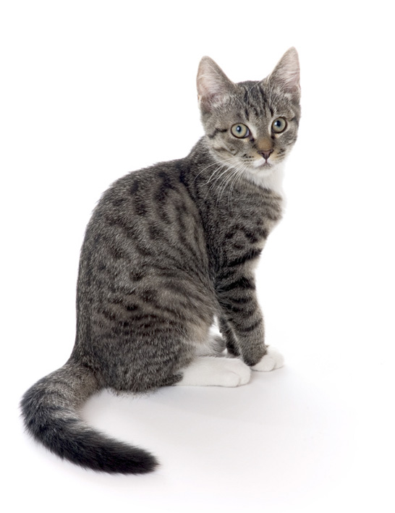

Make sure your cat cannot have kittens.

Cats can’t add but they do multiply!

In just 18 months, this female cat
can have 2000 descendants.

This is a poster produced by an organisation that looks after stray cats.
Before they publish it, they have asked you to check if this number of descendants is realistic.

You will need some of these facts about cats:
Age at which a female cat no longer has kittens

About
10 years
Average
number of litters a female cat can have in one year

3
Number of kittens in a litter

Usually
4 to 6
Length of pregnancy

About
2 months
Age at which a female cat can first get pregnant

About
4 months

Assessment guidance
Cats and kittens

Progression in Key Processes

Representing | Analysing | Interpreting & Evaluating | Communicating & Reflecting
Choice of diagrams and timelines | Counting, calculation and accuracy | Relating to the problem, including making assumptions | Clarity of method, reasoning and conclusion
Draws a simple diagram or  draws a timeline with some key events shown sequentially  PROGRE  S  S  I  ON  Pupils A and B | Finds the number of kittens that would exist if each cat had only one litter  Pupils A and B | Relates their findings to the original problem, i.e. whether 2000 descendants is or is not realistic  Pupils A and B | Presents work in a way that it is possible to tell which is the original cat, and how many kittens are within each litter  Pupils A, B and C
Draws a simple diagram and shows that multiplication is an appropriate tool  or draws a timeline with events shown sequentially; considers more than the offspring of the first cat  Pupil C | Uses multiplication to find the number of kittens that would exist if each cat had only one litter and recognises the need to count all those descendants  Pupil C | Makes explicit the assumption about the number of kittens per litter, e.g. ‘Each litter is 6 kittens’ | Shows their methods such that someone else can follow their reasoning
Method represents both multiplication and time for the original kitten, even if not all her descendants are represented | Recognises that most cats, in the time available, can have more than one litter | Qualifies their assumption about the number of kittens per litter, e.g. ‘I used 6 – that gives the biggest number of cats’ | Communicates clearly, effectively and concisely throughout and builds to a (partial) solution
Chooses an effective method that represents both multiplication and time for the original kitten and all her descendants  Pupil D | Uses an effective method to work towards a credible solution that takes into account the wide range of factors  Pupil D | Makes explicit further assumptions, e.g. that no cats die or that cats become pregnant as soon as physically possible  Pupil D | Communicates clearly, effectively and concisely with evidence of reflection, e.g. that number of kittens per litter significantly affects the outcome  Pupil D

Sample responses
Cats and kittens

Pupil A and pupil B – working separately

Pupil A
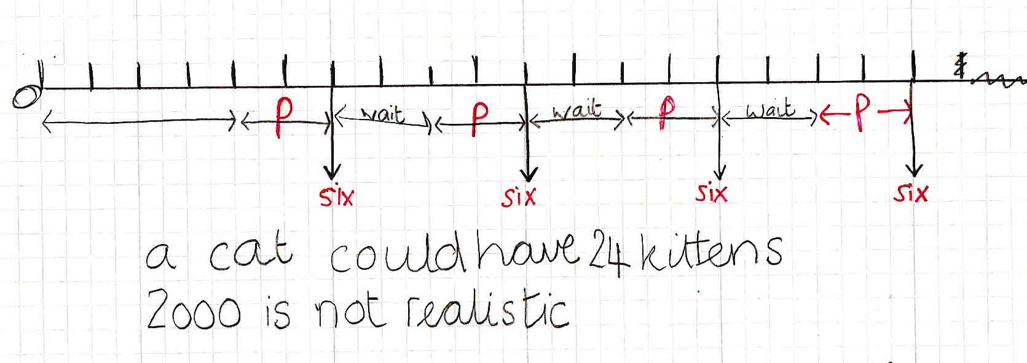

Pupil B

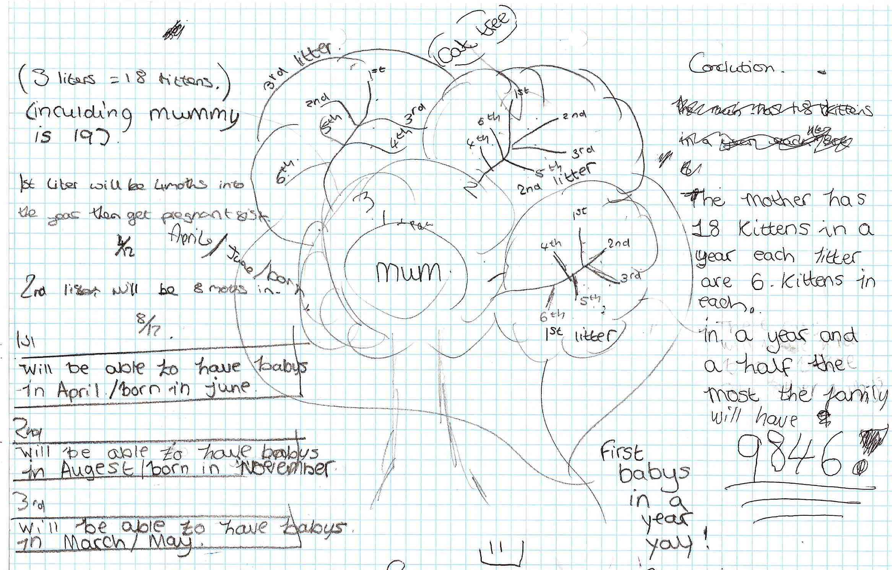

Comments

Pupil A

Pupil A shows no months on the simple timeline, but the 18 divisions and events show understanding, albeit only for the kittens from the original cat. She has worked out that the cat would have 24 kittens one year on, so recognised and applied the pattern of ‘add 6 every 4 months’.

Pupil B

Pupil B uses a ‘cat tree’ (multiplicative method) and tries to control for time (with errors). She does not explain the value of 9846 and it does not follow from the reasoning. She is explicit about the number of kittens per litter is explicit. Her communication is reasonably clear.

Probing questions and feedback (A and B)

- When you work on a problem, remember to go back and check that you have considered all the different aspects.
- Suppose the 6 kittens in the first litter also had kittens themselves......

Both pupils need more opportunities to apply maths in a real-life scenario, with a range of solutions, some effective, some less so; then ask them to say which is best and why.
This should also help develop their understanding of how to approach complex problems.

Pupil C

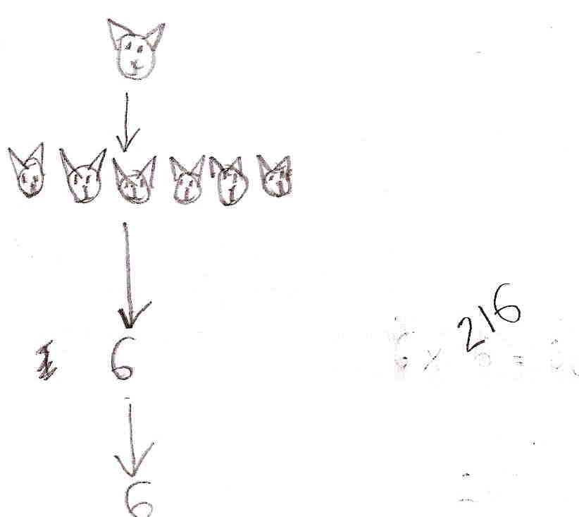

Comment

Pupil C abandons a time consuming pictorial representation for a numerical representation. The value 216 implies a multiplication if each cat had only one litter; the total number of descendants is not found. The correct use of time is implied by three litters, but this is not explicit. There is no interpretation or evaluation, and communication is minimal.

Probing questions and feedback

- Think about what would help other people understand what you are doing
- Think about what the task is asking – do you think 2000 kittens is realistic or not, and why?

Pupil C should be given more opportunities to present his work to others; this would encourage an understanding of the importance of recording his work and findings.

Pupil pair D
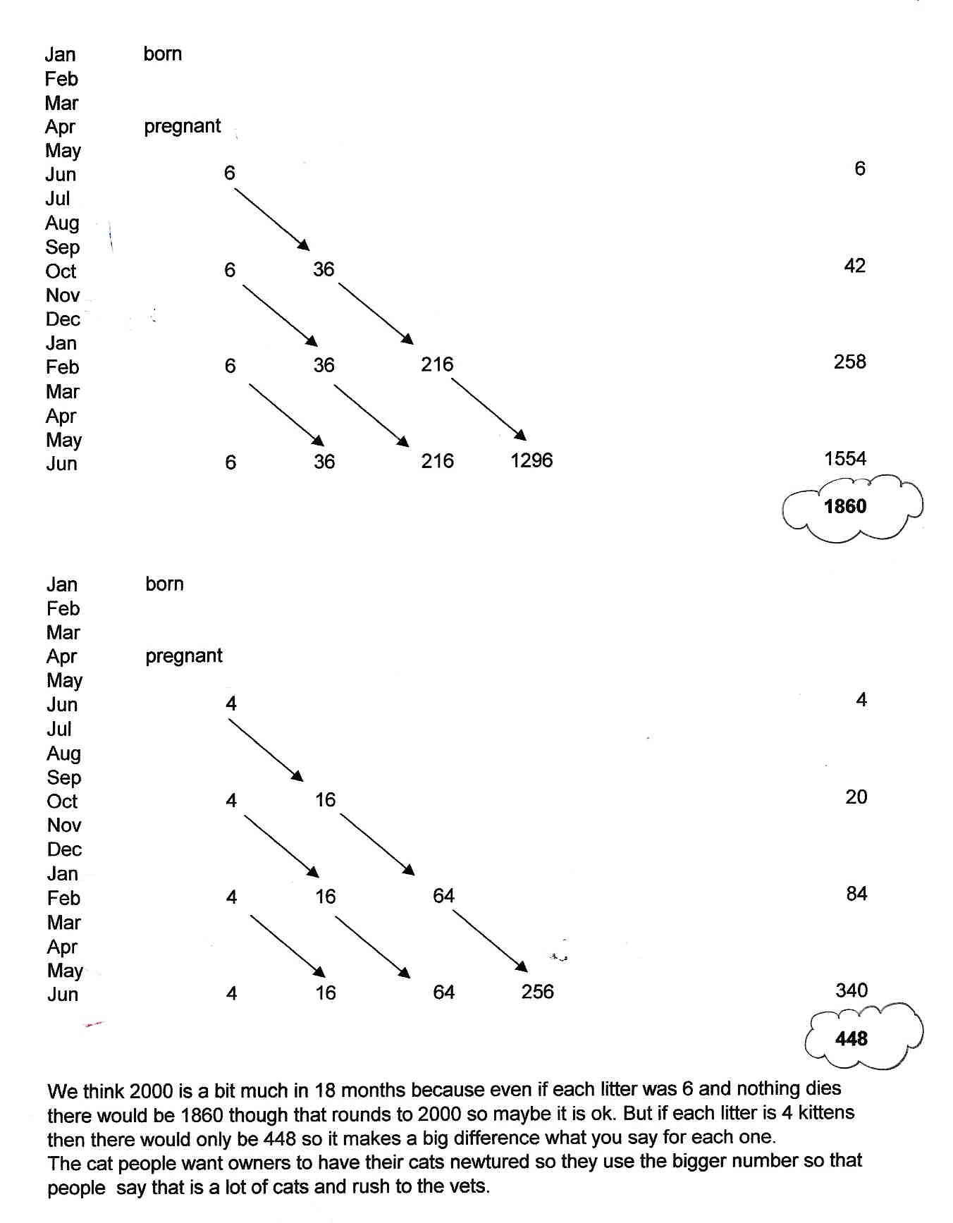

Comment

Pupil pair D use a spreadsheet to provide an effective way of controlling for time and multiplication; their method is clear and effective; they clearly show understanding of the process skills. The teacher discussed their choice of 6 kittens per litter – they chose the ‘worst case scenario’ but decided to investigate what would happen for 4. The difference is a good example of how changing variables makes a significant difference in multiplicative circumstances. This provides opportunities for cross-curricular discussions, eg birth rates across the world.

Probing questions and feedback

- When recording numbers, try to think how you could see the underlying structure, for example: 4, 16, 64, 256 … is a sequence – so how could that help you generalise?

The pupils would benefit from working on other complex tasks where variables need to be controlled, for example the Bowland cases of Speed cameras or Crash test.

