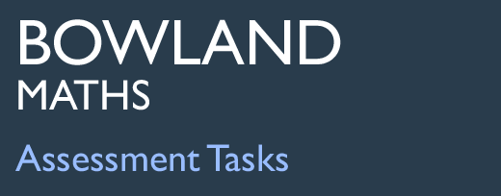 | Candle Box

Task description

Pupils design a 2D net for a box, given a 3D picture of the box.
Suitability National Curriculum levels 4 to 6

Time 30 minutes to 1 hour

Resources Ruler and pencil; it may be useful to have spare copies of the worksheet available; scissors available but provide only on request

Key Processes involved

- Representing: Represent a 3D object in 2D.
- Analysing: Visualise how the box will look when opened flat; draw their net accurately, joining faces appropriately and keeping the correct orientation of the pictures on the faces.
- Interpreting: Imagine the net folded up again (after drawing it) and locate a sufficient number of flaps so that faces may be joined together; ensure that glue flaps do not interfere with one another.
- Communicating and reflecting: Draw the box design clearly and labelled.

Teacher guidance

Check that pupils fully understand the task context before they begin, with points such as:
- You are asked to draw a net, in one piece, for a candle box.
- What will the box look like when it is assembled?
- What types of flaps will you need to include? Some are to be glued and some not; how will you tell which ones are which?
- What is important about the candle designs on the sides and top of the box?

Pupils may tackle this task in different ways, but they might be expected to:

- make 3D mathematical models by linking given faces or edges, and draw common 2D shapes in different orientations on grids
- recognise and use common 2D representations of 3D objects

Candle Box

Tom is making a little gift box to hold a big candle.



Please help Tom by drawing an accurate plan for making his box using the dotted paper.
It should be drawn so that when it is cut out it will all be in one piece.

One of the sides has been drawn to start you off.

Remember:

- flaps are needed for gluing the box together; shade these in
- flaps are needed for fastening the lid, but these will not be glued! – so don’t shade them
- draw the candle on the lid and the thumb hole
- draw a picture of the Birthday Candle on each side – get it right way up!

Draw your design below:

Assessment Guidance

Progression in Key Processes

Representing | Analysing | Interpreting and evaluating | Communicating and reflecting
Representation of a 3D object in 2D  PROGRE  S  S  I  ON | Geometric accuracy and completeness of net | Interpretation of net in relation to the problem; placing of glue flaps and drawings of candle | Accuracy and completeness of final design
Represents part of the box on the isometric paper.  Pupil A | Draws some faces correctly, but does not join them up appropriately.  Pupil A | Cannot interpret own drawing in terms of 3D box.  The picture on the box is not considered or is incorrectly placed.  Pupil A | Clearly draws some faces of the box, with inaccuracies and/or omissions.
Represents most of the box on the isometric paper.  Pupil B | Draws most faces correctly; joins some up correctly, but with several omissions and inaccuracies.  Pupil B | After drawing the net, tries to imagine it folded up again. Draws candles and glue flaps but in wrong orientations/ positions.  Pupil B | Clearly draws most faces of the box, but with inaccuracies and/or omissions.  Pupils A and B
Represents all faces of the box on the isometric paper.  Pupil C | Draws a net accurately, including the correct number of faces, joined appropriately.  Pupil C | Locates some glue flaps and lid flaps, but may not distinguish them.  Candle picture omitted or in wrong orientation on some faces.  Pupils C and D | Clearly draws and labels the box design.  Pupils C and D
Represents all faces and glue flaps of the box on the isometric paper.  Pupil D | Draws a net accurately, including the correct number of faces, joined appropriately.  Pupil D | Locates glue flaps and lid flaps, and distinguishes between them. Ensures that these do not interfere with one another.  Candle picture in correct orientation on all faces. | Clearly draws and labels the box design.  Pupils C and D

Sample responses

Pupil A
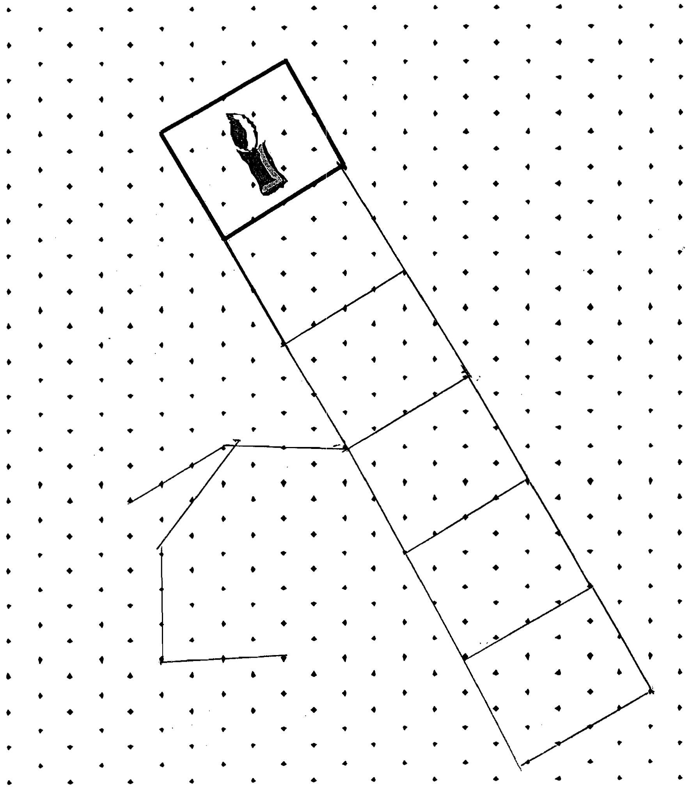

Comments

Pupil A appears to understand what he has to do, and has tried to draw the 6 sides of the box so that they will fold into a ring. These are in the wrong positions, however. He appears to have given up when trying to draw a hexagonal top.

Probing questions and feedback

- What would your box look like with the faces you have drawn?
- Which side of the rectangle should the hexagon base be connected to?
- How can you reorganise your design to more closely match the box required?
Pupil B
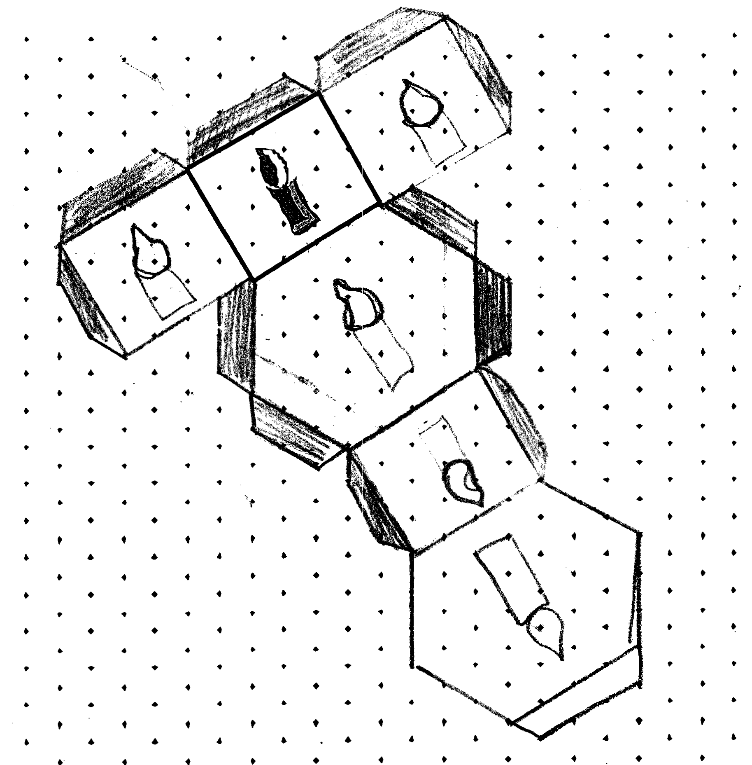

Comments

Pupil B has drawn only four of the rectangular sides, but these are the correct size and position. She has also tried to draw the hexagonal base and top in their correct positions, but these are not regular. She has drawn most of the candles in their correct orientations (although not on the lid!). Most of her flaps are correct, but the shading is not and there is no thumb hole.

Probing questions and feedback

- The hexagon that forms the base should be regular. How can you adjust the shape of your hexagons to achieve this?
- How many rectangular sides must the box have?
- You have been asked to provide a thumb hole. Where would this go?
Pupil C
Comments

Pupil C has correctly drawn the base and lid hexagons, and all the rectangular sides of the box in their correct orientations. The candles have not been shown. All but one of the flaps are in the correct place, but he has shaded them all for gluing.

Probing questions and feedback

- In which direction would you draw the candles to ensure they will be pointing in the right direction on the sides of the box?
- You have drawn some flaps, but what are they all for – and which are to be glued?
- Can you complete the box to satisfy all the specifications?
Pupil D

Comments

This is an almost completely correct solution, showing the faces and flaps the correct size and orientation. The only error is that the flame on the candle on the lid is upside down.

Probing questions and feedback

- Can you imagine the box assembled from your net? Are all the sides present and the candles pointing in the correct direction?

