 | Bunting

Task description

Pupils work out how much material is needed to make bunting to go round a garden.

Suitability National Curriculum levels 5 to 8

Time 45 minutes to 1 hour

Resources Paper, ruler and calculator

Key Processes involved

- Representing: Choose a method to determine the amount of material.
- Analysing: Work out how many flags should be made and how much material is required.
- Communicating and reflecting: Communicate their findings effectively and check that the solution fits the problem.

Teacher guidance

You can help pupils to understand the task, for example, with a short video on bunting at a street party (eg: http://www.youtube.com/watch?v=wVYjCa77CAw ) with comments:

- Bunting is the word for a series of flags, usually triangular, that you often see on occasions like street parties.
- You are asked to work out how much material is needed to make bunting to go round someone’s garden. You are given some facts and two steps to follow.
The task requires percentages, tessellations and areas and perimeters.
During the work, the following probing questions may be helpful:
- Are you confident that your method will work out how much material Kim needs?
- Are there different ways you could plan your lay-out to get the most flags out of each metre of material? Is yours the best way? How do you know?
- Is there any other information that Kim needs from you?

Teacher notes about possible tessellations are given in the Annex at the end.

Bunting

Kim runs her own business; she uses fabric to make hanging decorations called bunting.
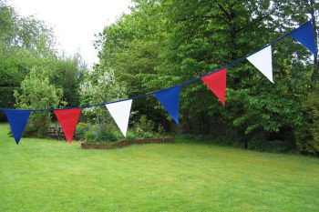
A customer orders purple bunting to go round his garden.
His garden is a rectangle of 24m by 18m.

Kim asks you to advise her about how much material she should buy.

Follow these two steps that Kim normally uses to work out how much fabric to buy.

Step 1.
First I work out how many triangular flags to make.

    - I work out the total length the customer wants.
    - Then I add about 10% so that it hangs properly.
    - I put 4 triangular flags on each metre of tape.
1m

Step 2.
12cm
20cm
Then I work out how much fabric to buy.

    - Each isosceles triangular flag is cut to these dimensions.
    - Fabric is expensive, so I arrange the triangles carefully.
    - The fabric is sold in widths of 120cm.
    - Then I work out the length I need to buy.

Assessment guidance

Progression in Key Processes
Analysing (i) | Representing | Analysing (ii) | Communicating and reflecting
The number of flags to be made  PROGRE  S  S  I  ON | Methods to work towards finding the amount of material required | The amount of material required | Effective communication of findings; some check that the solution fits the problem
Finds the perimeter but omits to add 10%, then × 4, ie 336 flags | Shows evidence of tessellating triangles | Shows some insight, eg attempts to use area | Shows sufficient working to justify the number of flags, even if the number is incorrect  Pupil D
Finds the perimeter, adds 10%, then × 4, ie shows the value 369.6  Pupils C and D | Uses tessellation to find how many flags fit within one width of material, eg 19 flags fit within one 20cm length of material (see first diagram)  Pupils A+B, C and D | Divides the number of flags by the number for one 20cm length of material, then multiplies by the length, eg  370 ÷ 19 × 20 = 390cm  Pupil D | Explains the work clearly, probably using diagrams, to explain the approach  Pupils A+B and C
Recognises that the number of flags must be rounded up to the next integer | Shows an alternative way of cutting the flags from the fabric | Divides the number. of flags by the number for 20cm length, rounding up to the nearest integer, then × the length, eg 370 ÷ 19, so 20 needed, × 20 = 400cm  Pupil C | Uses diagrams and text concisely to represent the situation accurately
Recognises that in real life a few extra should be made as contingency  Pupils A+B | Gives reasons why one way of cutting flags is better than another | Works out the amount of material for a different orientation | Uses diagrams and text concisely and accurately and shows further insight, eg to find max/min quantities of material

The first column on analysing relates to the first step in the task (routine calculations); the second relates to the more complex part, determining the amount of material.

Sample responses

Pupils A and B – working together
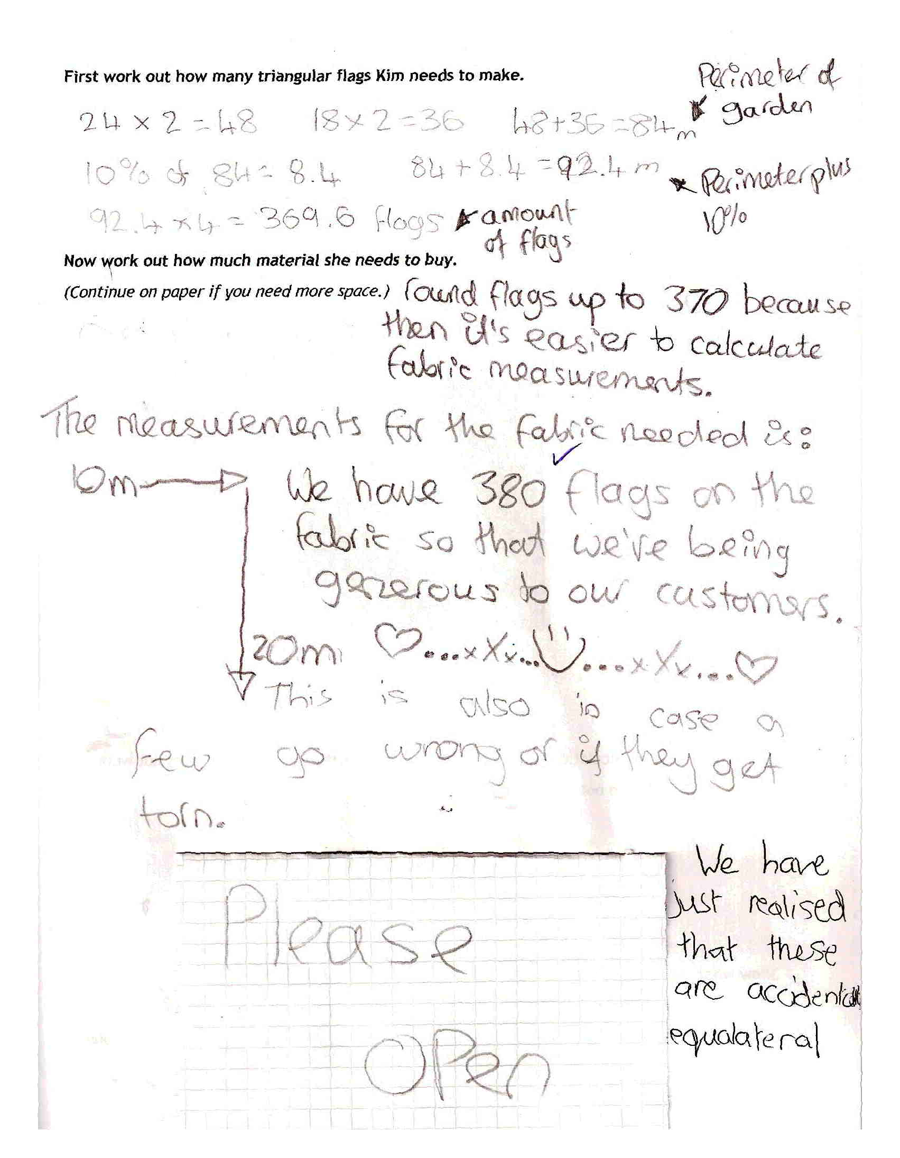

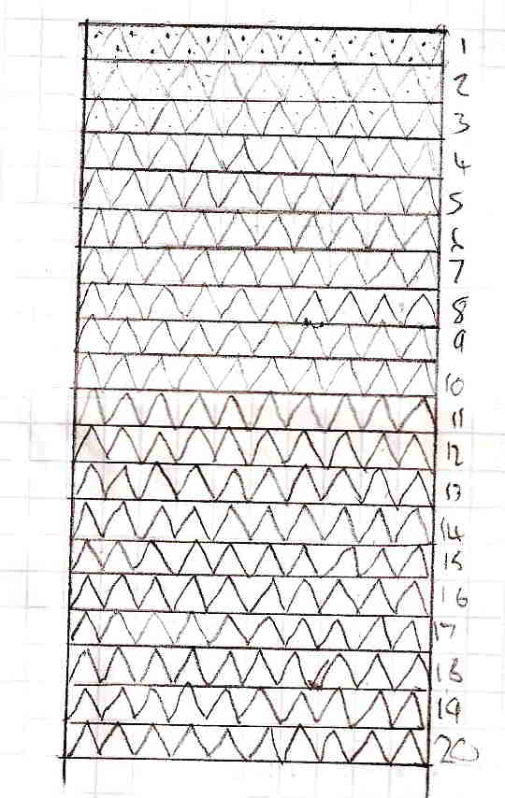

Comments

Their communication is clear at the start of the task; they round to make calculation easier, rather than recognising they cannot have part of a flag. They worked on squared paper to draw the flags – thorough but inefficient; in discussion, it was clear that they thought they had produced a scale drawing. They justify making more than 370 flags but were confused over the final measurements of the material, using 20m depth rather than 20 × 20cm. The width of 10m is also confused.

Probing questions and feedback

- Be careful when you are working that you don’t lose sight of the problem – did you actually give an answer to the question asked?
- Think about the methods you are using and whether you could save effort by using better ones. Did you really need to draw all the triangles?

These pupils would benefit from more work on extended tasks where they choose their own methods of working, but also where they are required (and have time) to reflect on and justify their choices. The Bowland case study Save a Baby Kangaroo may provide an appropriate and engaging vehicle for this learning.
Pupil C

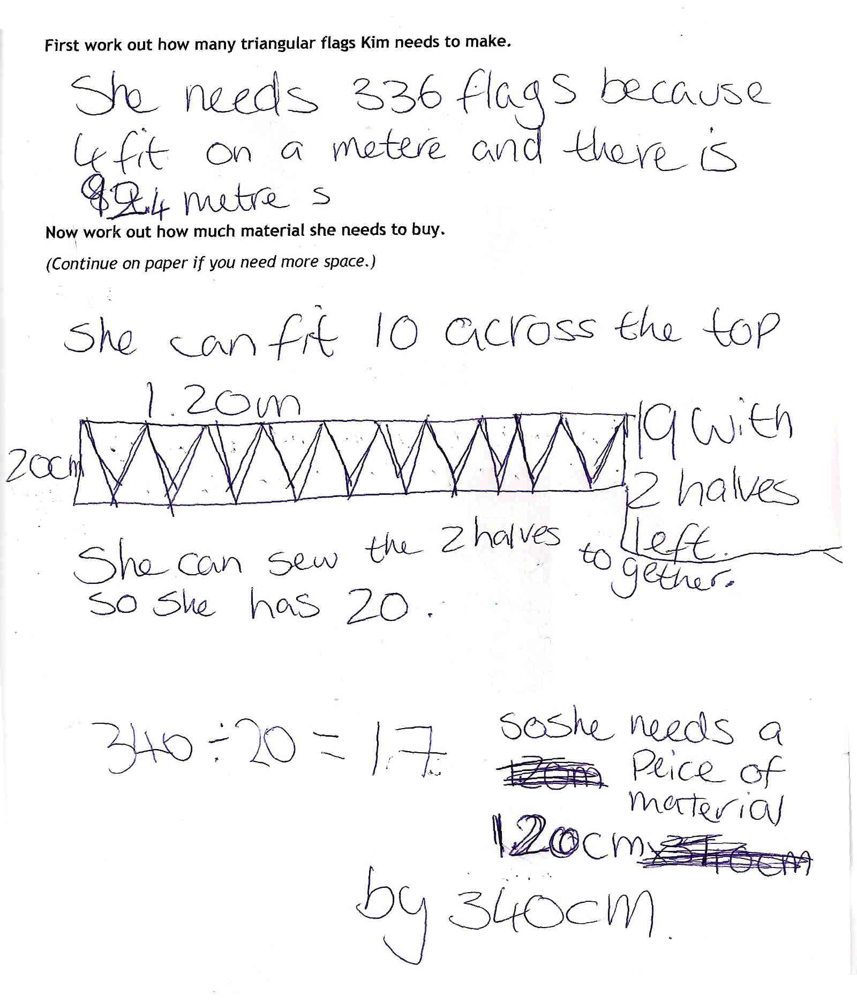

Comments

Pupil C worked originally without adding 10%; realising her error, she changed 84m to 92.4m, but did not change the number of flags to match. She rounded up her original number of 336 flags, but without explaining why. The tessellation is correct; although sewing two halves together may not be very practical, it is clearly explained. The working throughout is sufficiently clear to follow her reasoning and she follows through correctly to find the total length.

Probing questions and feedback

- When you have solved a problem, try and look at it in a different way – explore to see if there is another way of answering it which might give a better answer.

Providing a task similar to this, with is a range of possible methods and asking her to identify as many methods as she can, should encourage her understanding of the need to consider more than one way of approaching a problem. She would be likely to benefit from another of the Bowland assessment tasks, eg Fruit Pies.

Pupil D

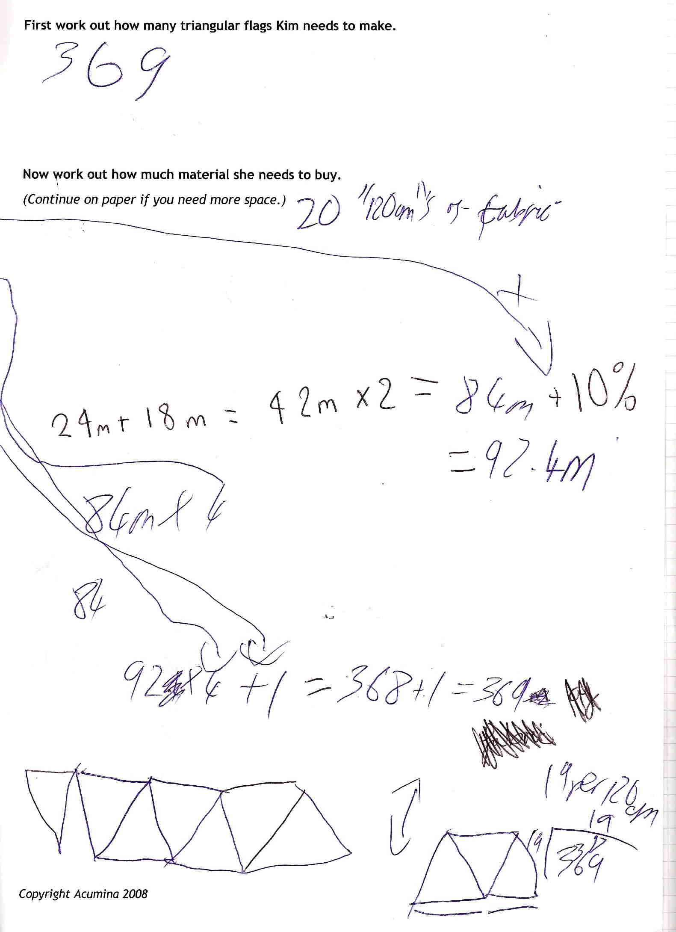

Comments

This work is from an able pupil whom the teacher considered to be working at level 8. He clearly understood the task and worked quickly towards a solution, rounding down, which is acceptable - but without any explanation. The arrows link back to the problem, but his communication is so poor that he fails to reach an amount of material – 20 ‘120cms’ of fabric is insufficiently accurate or explained. He has sacrificed clarity and accuracy, seemingly for the sake of speed. His communication is minimal, which prevents following his reasoning and stops him from seeing his own mistakes.

Probing questions and feedback

- Why do you think Kim might have difficulty in accepting your work as correct? Think about the need for others to follow your methods, not just your answer. How can you work quickly but give clearer evidence of your thinking?
- What about alternative solutions … could you save Kim money by laying out the triangles differently?

A positive way forward would be for him to do an extended task that includes a range of appropriate methods of working and an explicit need for effective communication. This should encourage his understanding of the importance of thinking as well as doing. The Bowland case study Product Wars would be a good next step.

Annex: Possible tessellations

The following may be helpful for the second step – to get the most flags from the material.
Perimeter + 10% = 92.4m.  Number of flags = 92×4 + 2 = 370  20cm  Area of one flag is 120cm²  If there were no wastage, area of material needed would be  120 × 370 = 44400cm² ,so a length of 44400 ÷ 120 = 370cm | Two possible tessellations (there are others):  12cm  18cm  This fits 6 flags in the first 12 cm of fabric, then another 6 for each additional 6cm. It wastes the equivalent of 3 flags at each end of the roll. 370 (flags) is not a multiple of 6; to make 372 flags needs 6 + 372 = 378cm.  This fits 19 flags on 20 cm of fabric, wasting the equivalent of 1 flag for each 20 cm length. 370 flags would require 19.5 (370/19) strips of material, ie 20 strips, each of 20cm, so a total of 4m.  120cm = 6 flags  120cm = 10 flags

