 | 110 years on

Task description

Pupils use mathematical reasoning to estimate the number of descendants a girl who lived 110 years ago might have today.

Suitability National Curriculum levels 5 to 8

Time About 45 minutes

Resources Additional paper plus access to a calculator if requested

Key Processes involved

- Representing: Simplify the information given, choose a model, then make assumptions to complete the model.
- Analysing: Use their model to calculate the potential number of descendants.
- Communicating and reflecting: Present arguments summarising their conclusions and reflect on the validity of their results.

Teacher guidance

You may wish to show the task on a whiteboard and talk about the concept of descendants
- In this task, there is a photograph of a girl, about your age, who lived 110 years ago. She grew up, had children, who had their own children and so on.
- A family party is being planned for all her descendants. Your task is to make a good estimate of how many descendants you might expect her to have.
- You are given some facts – think about why there are there, and use them!
- Show your working so I can know what you did and how you reached your answer.

The task requires multiplicative calculations to represent changes over time.

The following probing questions may be helpful:
- What assumptions have you made?
- When you are thinking about all her descendants over the 110 years, are there any other factors you need to consider?
- Have you made sure you have thought of all her descendants?

There are several assumptions needed for the task:
- How many children the girl had and when.
- The average age of giving birth and whether this changes over time.
- When and how, during the 20th century, the birth rate changed.
- The proportion of her descendants that conformed to the average birth rates.
- At what age people die, and so how many descendants are still alive for the party.

Note: If pupils use more than 25 years between generations, they are likely to work with only 3 generations so may consider just counting. If so, they should be encouraged to consider a smaller number of years between generations.

110 years on

This photograph was taken about 110 years ago.
The girl on the left was about the same age as you.
As she got older, she had children, grandchildren, great grandchildren and so on.

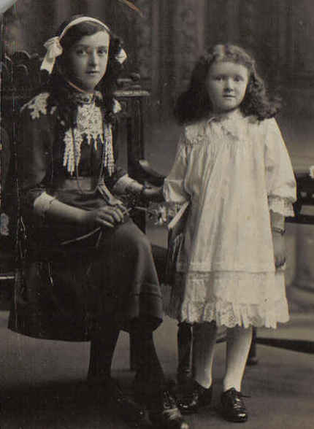
Time guide: minute

Now, 110 years later, all this girl’s descendants are meeting for a family party.

How many descendants would you expect there to be altogether?

Twentieth Century facts

At the beginning of the 20th century the average number of children per family was 3.5
By the end of the century this number had fallen to 1.7

In 1900, life expectancy of new born children was
45 years for boys and 49 years for girls. By the end of the century it was 75 years for boys and 80 years for girls.

Assessment guidance

Progression in Key Processes

Representing | Analysing | Communicating and reflecting
Simplification of the information and assumptions to complete the model. A method to represent multiplication and/or time  PROGRE  S  S  I  ON | Accurate calculations and logical working | Clear communication throughout
Draws a simple diagram or  lists some key events sequentially. Uses given facts, eg uses 4 (or 3) for the number of children born to the girl but 2 for their final generation  Pupil A | Uses a counting method to find the number of great and great, great grandchildren. | Shows which generation is which, and the number of children born in each generation  Pupil A
Draws a diagram showing at least 3 generations or a timeline with some key events shown  Pupil A  Even if not explicit, the number of years between generations is clearly implied  Pupils B+C | Uses a counting method to find the total number of descendants  Pupil A | Show their methods such that someone else can follow their reasoning reasonably well  Pupils B+C
Chooses a method to represent both multiplication and time  Pupils B and C. Even if not explicit, the years between generations and at what age people died are clearly implied  Pupil D | Uses a multiplicative method to find the number of great or  great, great grandchildren  Pupils B+C | Uses methods that are explicit and ‘flow’
Chooses an effective method to represent both multiplication and time. Assumptions are explicit and detailed, eg as previously and all descendants have children, and premature deaths are to be ignored  Pupil D | Uses a multiplicative method to find the total number of descendants  Pupil D | Communicates clearly, effectively and concisely throughout, using a method that could extend to further generations  Pupil D

Sample responses

Pupil A

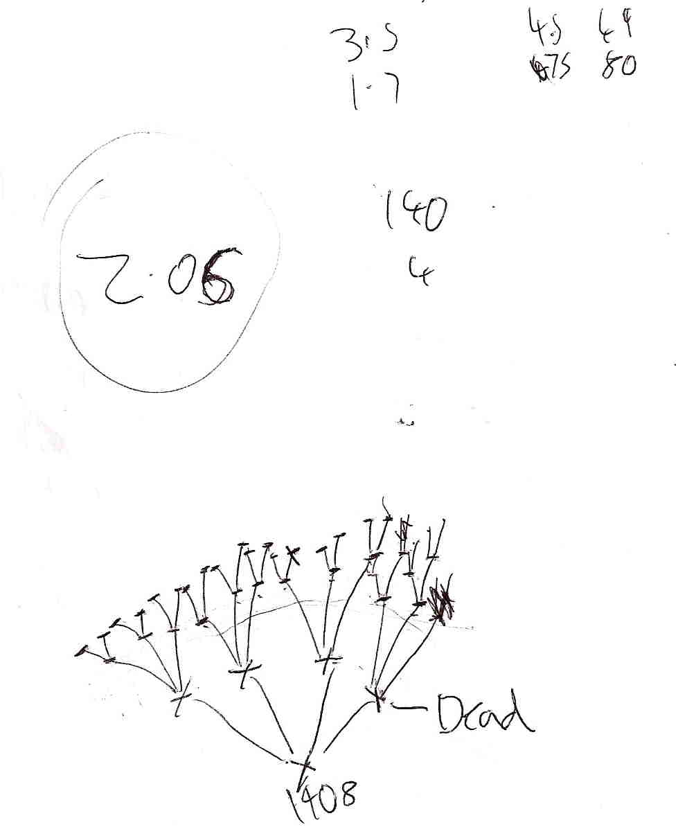

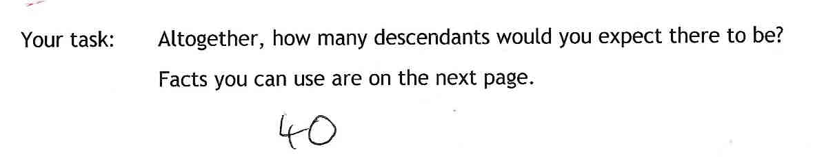

Comments

The teacher judges Pupil A to be working at level 6 or 7 for range and content. His understanding of the process skills is less well developed and needs to see the importance of method and a logical approach rather than focusing on an answer. He makes an attempt to justify the number of children per generation (by finding the mean of 3.5 and 1.7). He gives no justification for the numbers of children nor for stopping after 3 generations. He has included all the descendants still alive, but included the girl who would now be over 120).

Probing questions and feedback

- When you are working on a task, really think about the method you are using and how you should present it so that others can understand your thinking.
- Think too about checking whether your arithmetic is reasonable - can 2.06 be the mean of 1.7 and 3.5?

Practice in completing tasks that focus on process skills would help increase this pupil’s awareness of the importance of method and a logical approach, and not just answers. Extended tasks, such as the Bowland case studies, would provide an excellent context.

Pupils B and C

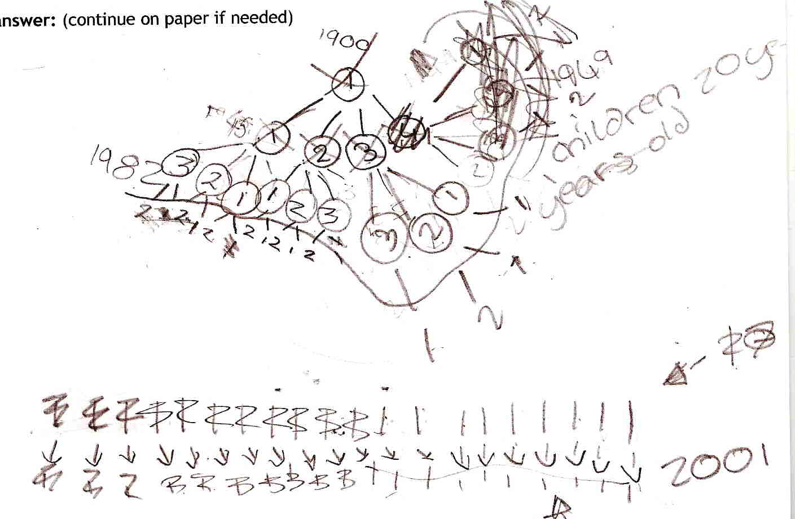

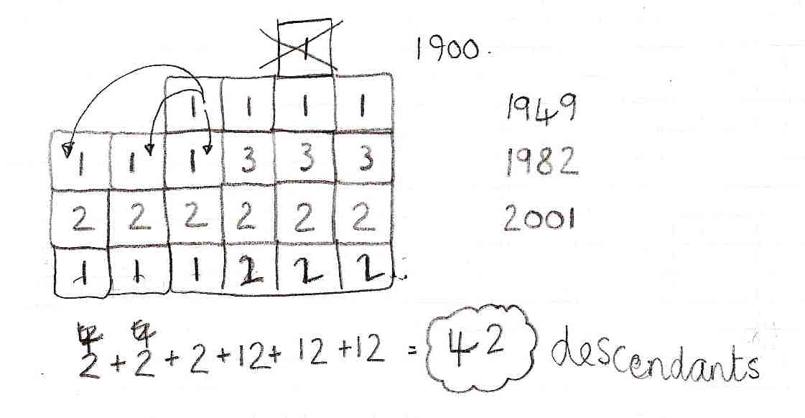

Comments
Their first approach tries to control for time, but they become confused and start again. Their second approach is an original method that would be effective if explained and followed correctly: the number of children per generation is shown varying over time. But they make no attempt to explain the dates - the gap from 1900 to 1949 may be confusion with life expectancy. Multiplication is implied, since the row showing addition is found by multiplying the numbers in the column above. The number of great, great-grandchildren is incorrectly thought to be the total number of descendants.

Probing questions and feedback

- You are clearly thinking about your method. But also think how you could help the reader: for example why did you choose the dates you did?

Exposing these pupils to open-ended activities, with decreasing scaffolding, would help develop the mathematical ability suggested by the method they chose. Participation in the programme of tasks within the Bowland case study You Reckon would provide a good framework for them to explore their mathematical skills.

Pupil D

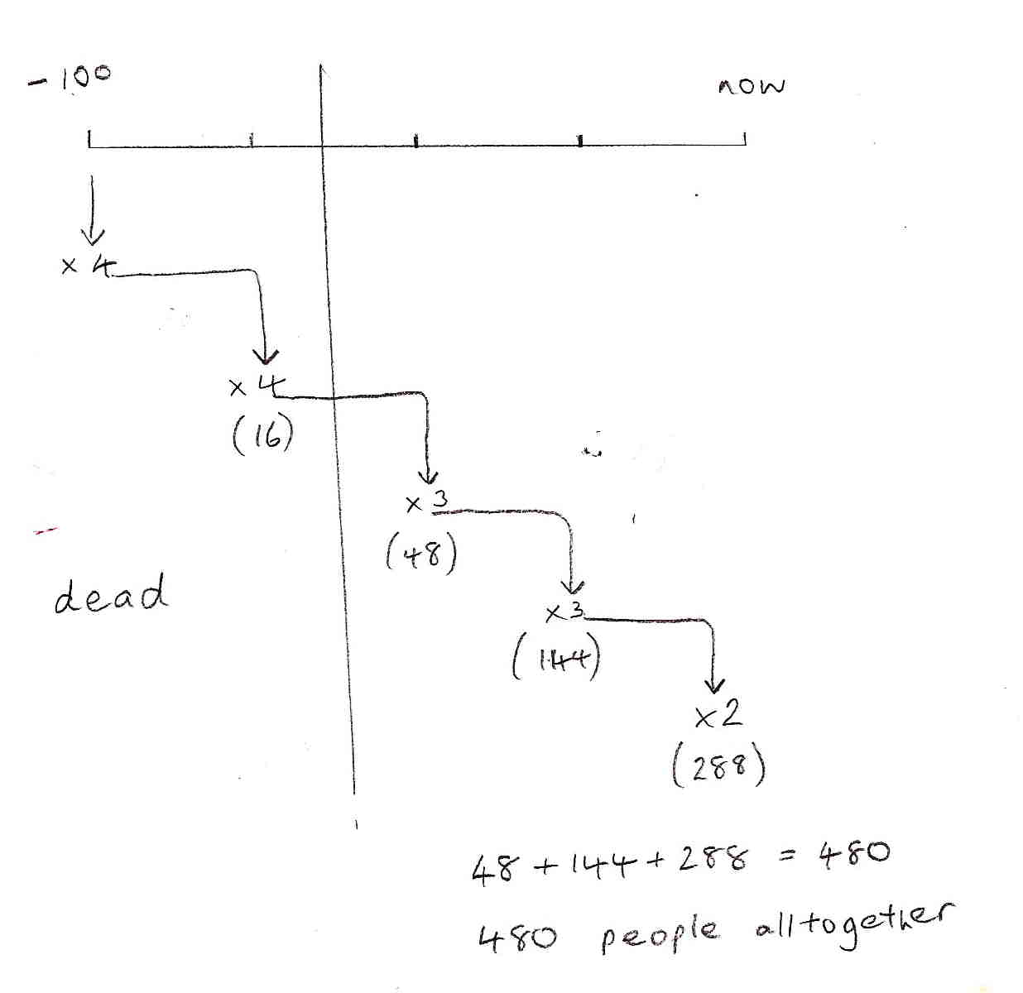

Comments

Pupil D made the (implicit) assumptions that each generation is 25 years apart and that the ‘final’ generation was born in time for the party. The number of descendants born at each stage is shown clearly, and the method controls effectively for time and multiplication. All people over the age of about 75 are shown as dead, but without explanation. She has clearly engaged with the context and produced an effective and concise solution.

Probing questions and feedback

- When you are working on a complex problem, think about the assumptions you are making and how they affect the results. What difference would it make if you varied the number of years between generations eg 20 or 30 years rather than 25?

Encouraging this pupil to assess critically real life information (eg from newspapers) in terms of assumptions made, would extend her analytical thinking both about her own work and about other people’s.

