|  |  |
| --- | --- |
| bpdlogo_bowlandb | Keeping the pizza hot  Assessing the learning |

|  |
| --- |
| Case Study description |

Pupils explore the real-world scenario of delivery of pizzas

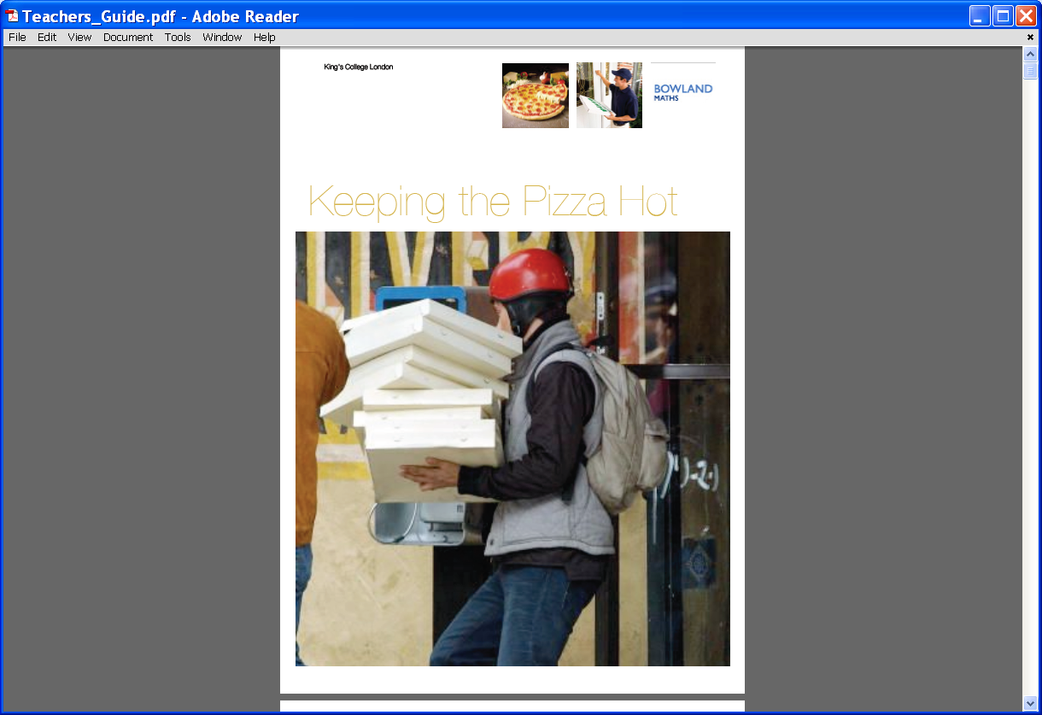

**Suitability** National Curriculum Levels 6 to 8

**Time** The assessment activities can be completed within the times for the case study

**Resources** All the resources required are listed within the case study

**Opportunities to assess Key Processes**

The lesson phases are inter-related, so evidence of various Key Processes may be seen at any time. The following reflects evidence gathered during trials.

* **Representing**: during phases 1 and 2
* **Analysing**: during phases 1 and 2
* **Interpreting and evaluating:** during phases 1 and 2
* **Communicating and reflecting**: during phase 3.

In addition to assessment of Key Processes, there are opportunities to assess Range and Content (detail is included within the case study), as well as some of the personal, learning and thinking skills, particularly those for ‘team working’.

|  |
| --- |
| Phase 1: Creating a mathematical model |

Pupils review data, preferably generated by themselves, and compare cooling rates for pizzas. Then they create a mathematical model to fit.

**Teacher guidance**

|  |
| --- |
| Observe how well pupils:   * Obtain and interpret data * Decide which types of graph are appropriate * Vary values to find the best fit * Link their findings to the real world scenario of pizza cooling |

Questions to ask:

* *What equations did you try?*
* *How did you decide what to change and how to change it?*
* *What are the advantages/disadvantages of using a straight line? Or a quadratic?*
* *How well does … predict what will happen?*
* *What assumptions did you make?*

**Assessment guidance: Progression in Key Processes**

|  |  |  |  |
| --- | --- | --- | --- |
|  | **Representing** | **Analysing** | **Interpreting and evaluating** |
| PROGRESSION | Understands the link between graphical representation and the pizza cooling | Improves the fit of an equation to the data | Recognises that a straight line implies the pizza cools at a constant rate |
| Compares linear equations to find the best fit | As above and shows understanding of the effect of varying intercept and gradient | As above, and uses their knowledge of intercept and/or gradient to apply to the real life situation  Pupil pair A |
| Tries out and compares different representations, eg quadratic curves Pupil pair A | Shows understanding of the effect of varying values for quadratics or exponentials Pupil pair A | Explains why both linear and quadratics are not appropriate representations, |
| Tries out and compares different representations, eg quadratic and exponential curves  Pupil pair B; Pupil pair D (p8) | Gives an exponential equation that fits the data reasonably well Pupil pair B; Pupil pair D (p8) | Explains why an exponential function is the most appropriate function for the given context Pupil pair B; Pupil pair D (p8) |

**Sample response: Pupil pair A**

**Comments**



We wanted the line to be like the red one (the line of best fit). We knew it would have 78 in it as it is 78 on the y axis so we tried different gradients and got y=2.8x+78

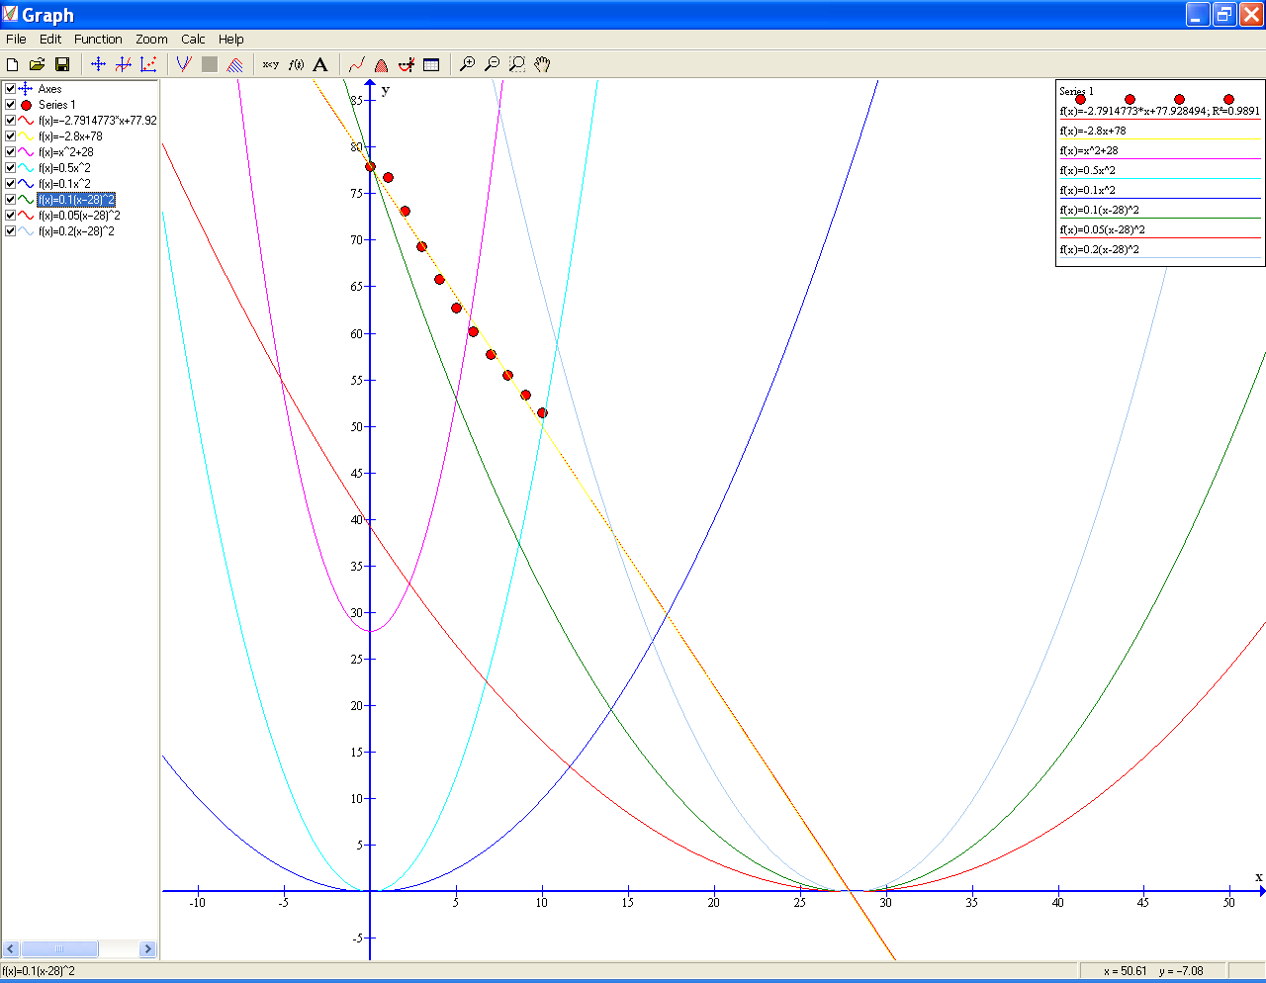

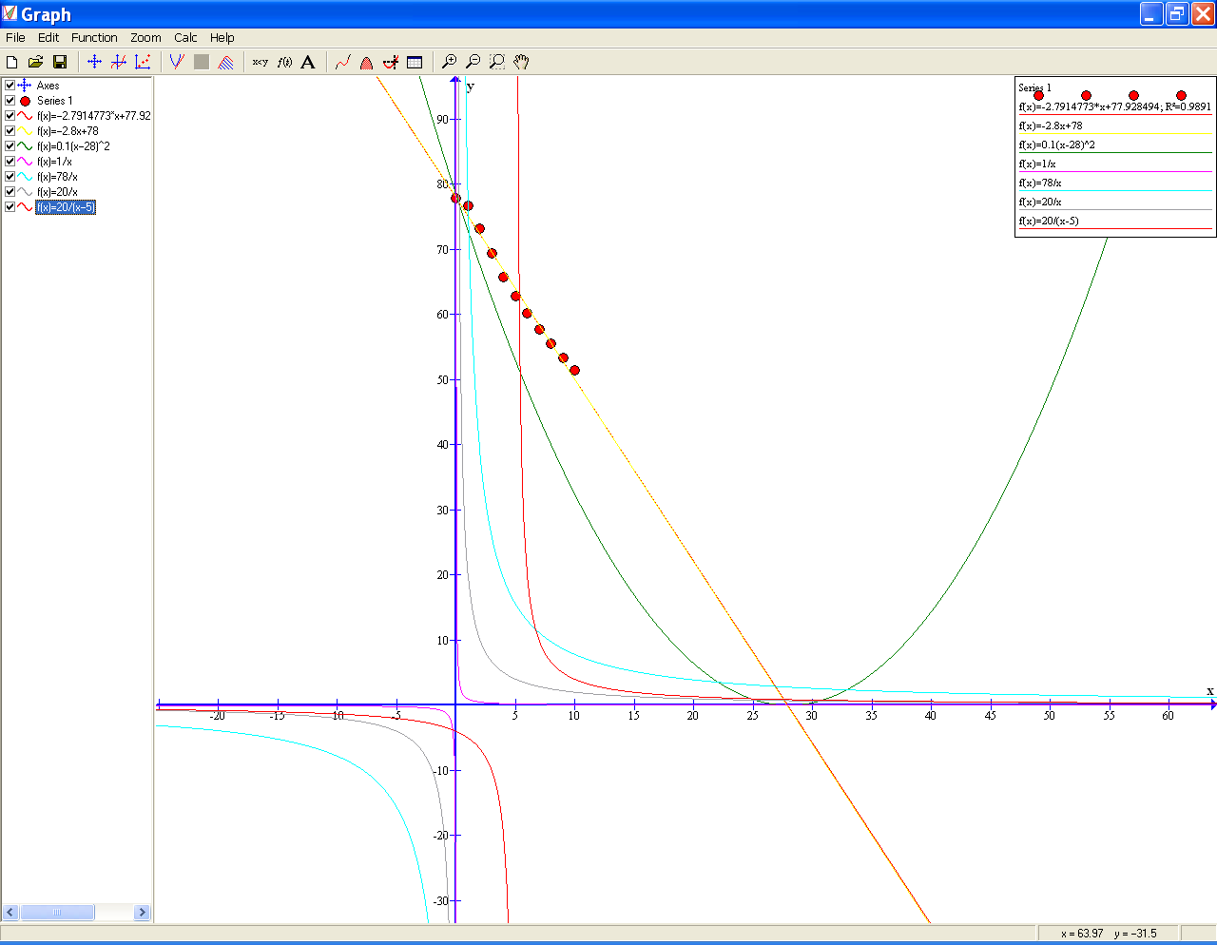

Our teacher said to try graphs like y = 1/x but we tried and they were not very good and we couldn’t make them fit well so we decided the best fit was the line 2.8x+78 because we want to deliver before it is colder than 62 degrees so this one fits ok in the temperature that we need.

We tried graphs of x^2 because they curve down. We got one that went through (0,78) and (28,0) but it wasn’t a good fit so we tried more. Our teacher asked if the x^2 was right and what it meant when the graph went back up.

MCj04406510000[1]

**Amazing !!! My pizza is hot again!!!**

The pupils vary values within linear equations systematically, recognising the need to keep the y-intercept constant. Their trials for quadratics show an increasing awareness of the effect of varying values, but they make little progress with the exponential function.

**Probing questions   
and feedback**

* *How did you know  
  to try a negative  
  gradient when you  
  were working with  
  straight lines?*
* *What was the effect  
  of the changes you  
  made when you  
  were working with  
  quadratics?  
  Can you predict   
  what would   
  happen if …. ?*

The pupils would   
benefit from further discussion to find answers to their questions, ie what would the up slope of the quadratic mean, and so why might that not be a good fit?

**Sample response: Pupil pair B**

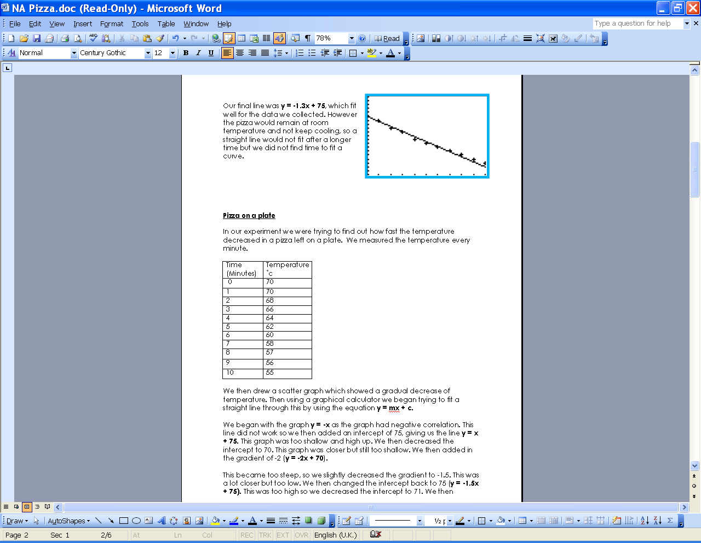

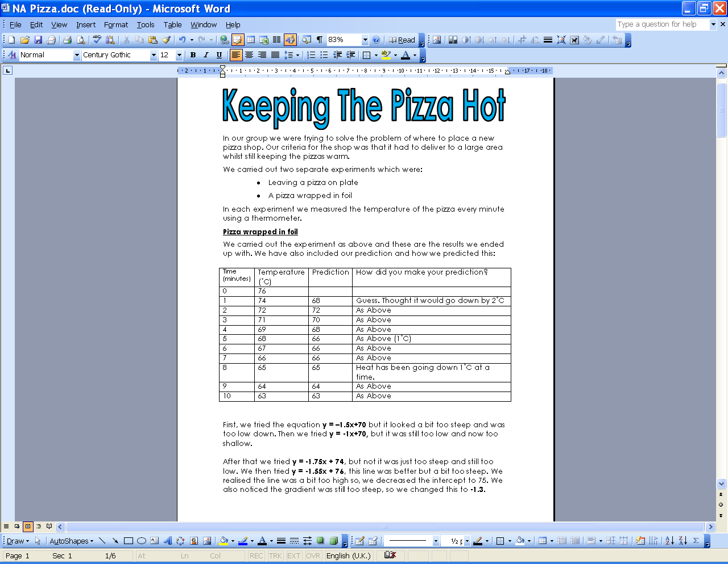



**Comments**

The pupils gathered data. They varied values within linear equations, comparing and interpreting them. They chose to use an exponential function, using mathematical insight when varying values.

**Probing questions and feedback**

* *If you add a constant to the equation,   
  what happens to its graph?*
* *Does it matter if the equation is linear,  
  or quadratic, or exponential?*

This pair would benefit from working on other activities that help them to link their knowledge of equations to the real world.

|  |
| --- |
| Phase 2: Deciding where deliveries can be made |

Pupils choose the packaging and use their model to find for how many minutes the pizza stays ‘hot’. They then establish where, within an area, they can deliver in that time.

**Teacher guidance**

|  |
| --- |
| Observe how well pupils:     * Use their model to find the time available * Find the maximum distance that can be travelled within this time * Link their findings to the real world scenario of pizza delivery |

Questions to ask:

* *How confident are you that the maximum time for delivery is about right?*
* *How did you decide where you can and can’t deliver?*
* *What assumptions have you made?*
* *What else do you need to think about to improve your estimate of the delivery area?*

**Assessment guidance: Progression in Key Processes**

|  |  |  |  |
| --- | --- | --- | --- |
|  | **Representing** | **Analysing** | **Interpreting and evaluating** |
| PROGRESSION | Needs teacher support to select appropriate tools | Shows understanding of scale  Pupil C | Interprets findings within the context, eg shows distances on a map  Pupil C |
| Selects appropriate tools for some of the steps  Pupil C | Shows understanding of speed and scale | Uses their previous work to determine the time available |
| Selects appropriate tools for all of the steps Pupil pair D (p8) | Uses speed and scale efficiently and effectively | Gives a clear solution that takes the major factors into account Pupil pair D (p8) |
| Selects appropriate tools for all the steps and shows insight into the problem, eg by varying speed according to type of road | Uses speed, scale and locus efficiently and effectively Pupil pair D (p8) | Recognises that their model is a simplification, ie that other factors impact |

**Sample response: Pupil C**



**Comments**

Although pupil C recognised the complexity of the problem, her solution lacked detail.

**Probing questions and feedback**

* *What other information would the pizza shop owner need to decide how far she could get?*
* *If you were travelling at 30mph, say, where could you get to before the pizza cools? How do you know? If you were travelling at 60mph, would you go twice as far? What about 45mph? Or 40mph? Or … ?*

Pupil C would benefit from reviewing work done by other pupils. This should support her in identifying and explaining key information.

|  |
| --- |
| Phase 3: Producing a report |

Pupils produce a report for a given audience, eg the pizza shop owner.

**Teacher guidance**

|  |
| --- |
| Observe how well pupils:   * Summarise their findings, giving key information * Tailor their report to the relevant audience |

Questions to ask:

* *When you listen to (or see) other groups’ presentations (or reports), what will you be looking for and why?*
* *What is the difference between a report for a scientific journal, say, and a report  
  for the pizza shop owner?*
* *Is there anything else the person reading your report needs to know? Is there any detail that they are unlikely to want to know?*

**Assessment guidance: Progression in Key Processes**

This phase may also give evidence of representing, analysing, interpreting and evaluating. The tables shown above can be used to evaluate progression in these areas.

|  |  |
| --- | --- |
|  | **Communicating and reflecting** |
| PROGRESSION | Creates a simple report that explains what they have done and why; gives simple feedback to others |
| Creates a report that identifies clear conclusions; gives helpful feedback to others  Pupil pair D |
| Communicates effectively; gives effective feedback and reflects on own approach |
| Communicates effectively and concisely; gives insightful feedback and reflects on a range of approaches Pupil pair E |

**Sample response: Pupil pair D**

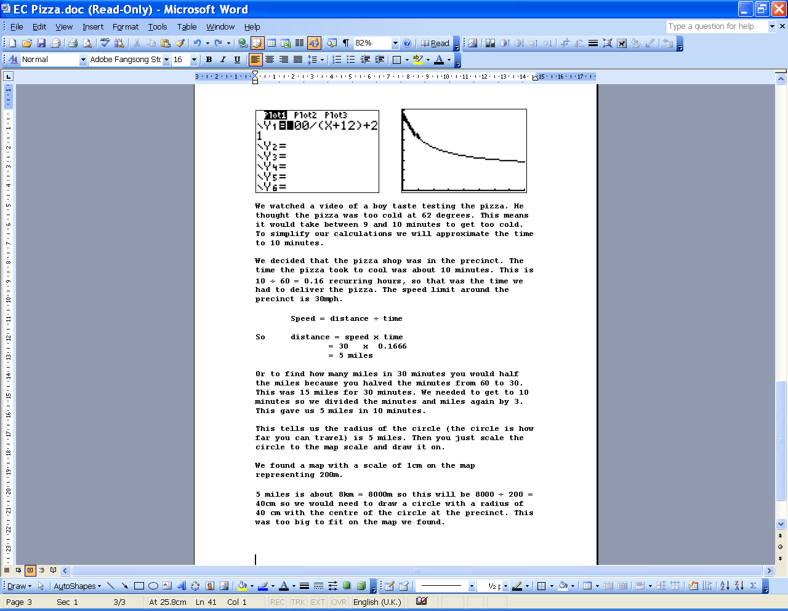

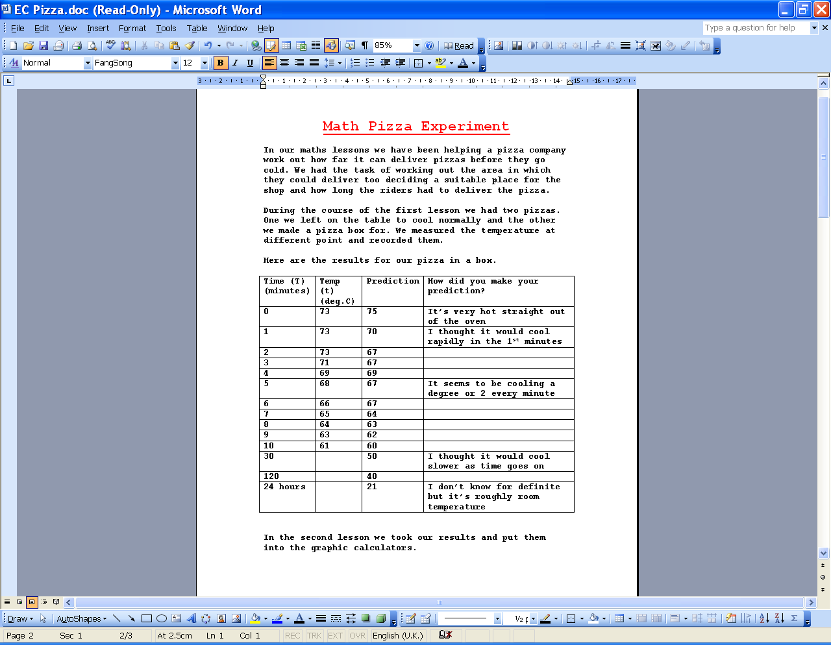

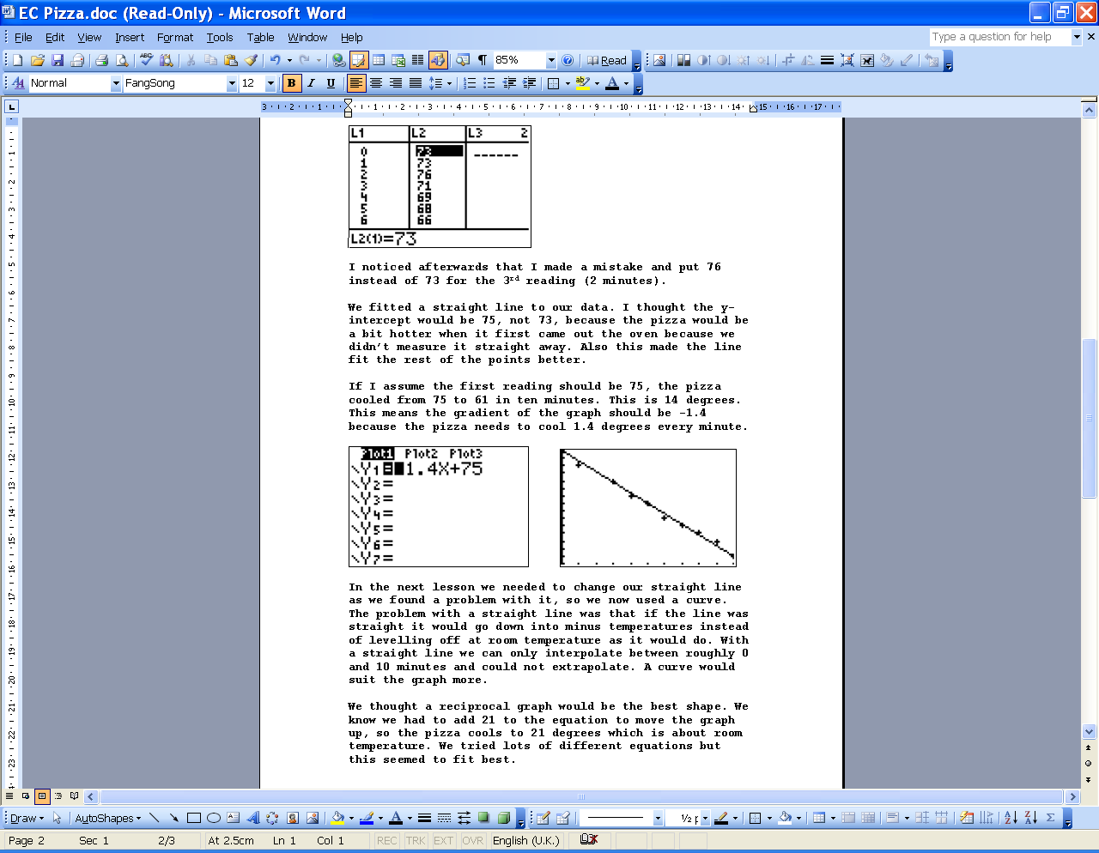

**Comments**

The pupils gave a detailed account of their work but did not summarise it for their chosen audience (a scientific magazine). However, their feedback showed a growing awareness of the purpose of their report.

**Probing questions and feedback**

* *What are the main differences between these articles (in a scientific magazine) and your report?*
* *If you were sending your report to be published, what would you change and why?*

The pupils would benefit from group discussion about how to create a report that includes key findings and methods, yet is concise.

**Sample response: Pupil pair E**

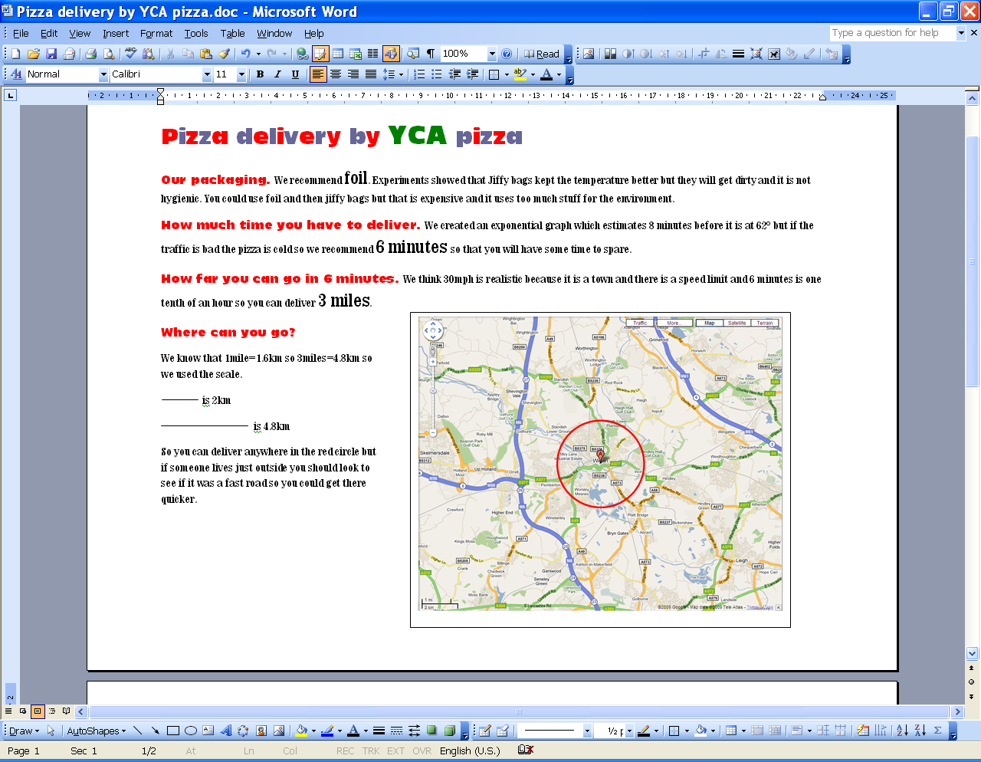

**Comments**

The pupils summarised their findings when writing a report for the pizza shop owner. They identified the key features and offerred clear and concise conclusions. They also gave oral feedback which was helpful to others and identified features that could be improved in order to communicate more effectively for the given audience.

**Probing questions and feedback**

* *If you were writing a report for a scientific journal, what would you change and why?*

The pupils would benefit from reviewing different types of report and discussing the key features of each.