|  |  |
| --- | --- |
| bpdlogo_bowlandb | Alien Invasion  Assessing the learning |

|  |
| --- |
| Case Study description |

Pupils solve non-routine mathematical problems arising from an alien invasion, using maps and data extracted from TV bulletins, radio reports and mobile phone messages.



**Suitability** National Curriculum levels 5 to 8

**Time** Most of the assessment activities are part of the case study and can be completed within the time for the case study.

**Resources** All activities are based on materials already within the Case Study.

An optional assessment activity is included (see page 10) which is linked to, but not part of, the case study; it might be more suited to pupils working at higher levels – and could be used for homework. The time required is flexible.

**Opportunities to assess Key Processes**

* **Representing**: during lessons 1, 2, 4 and the optional activity
* **Analysing**: during lessons 1, 2, 3, 4 and the optional activity
* **Interpreting and evaluating:** during lessons 1, 2, 3 and the optional activity
* **Communicating and reflecting**: during lesson 4 and the optional activity

In addition to assessment of the Key Processes, there are opportunities to assess Range and Content (detail is within the case study) and also some other personal, learning and thinking skills, particularly for ‘team working’.

|  |
| --- |
| Lesson 1: The Landing |

Pupils use a series of clues to identify places on a map where the aliens have landed.

**Teacher guidance**

|  |  |
| --- | --- |
| Observe how well pupils:   * Choose appropriate mathematics to use * Draw together the information provided * Explain where the spaceships are, and why | Resource Sheet 1.5 Clues |

Questions to ask:

* *How did you decide where the alien ships are?*
* *Can you convince me that this shape is a parallelogram?  
  Did you need to use all the clues?*
* *Are there any other places you considered for the fourth alien ship?*

**Assessment guidance: Progression in Key Processes**

|  |  |  |  |
| --- | --- | --- | --- |
|  | **Representing** | **Analysing** | **Interpreting and evaluating** |
| PROGRESSION | Chooses appropriate procedures, eg measures a distance on the map and states how many miles it represents | Needs support to complete resource 1.7 (conversion table), but uses it accurately for simple distances | Explains how the scale has been applied for simple distances |
| Develops own strategies to find the location of some of the spaceships | Completes resource 1.7 (conversion table) then uses it accurately to find the positions of some of the ships | Justifies why a spaceship is positioned as shown |
| Develops own strategies to find the location of the spaceships Pupil A | Works out the scale and uses it accurately for distances in both miles and kilometres  Pupil A | Shows mathematical insight, eg that the 3rd ship must be somewhere on St Andrew’s row Pupil A |
| Recognises a range of strategies is available, and chooses the most efficient | Recognises that without the final three statements, there is more than one position for the fourth spaceship | Explains the solution and justifies the positions of the spaceships recognising why the solution is unique |

**Sample response: Pupil A**

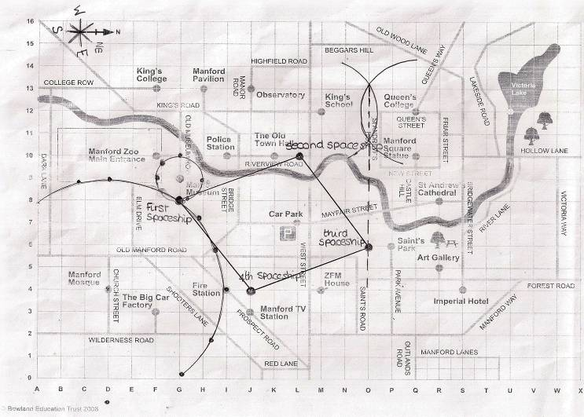

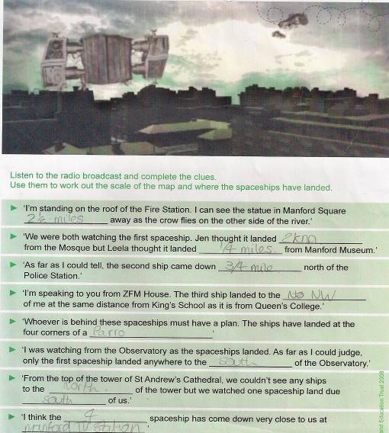

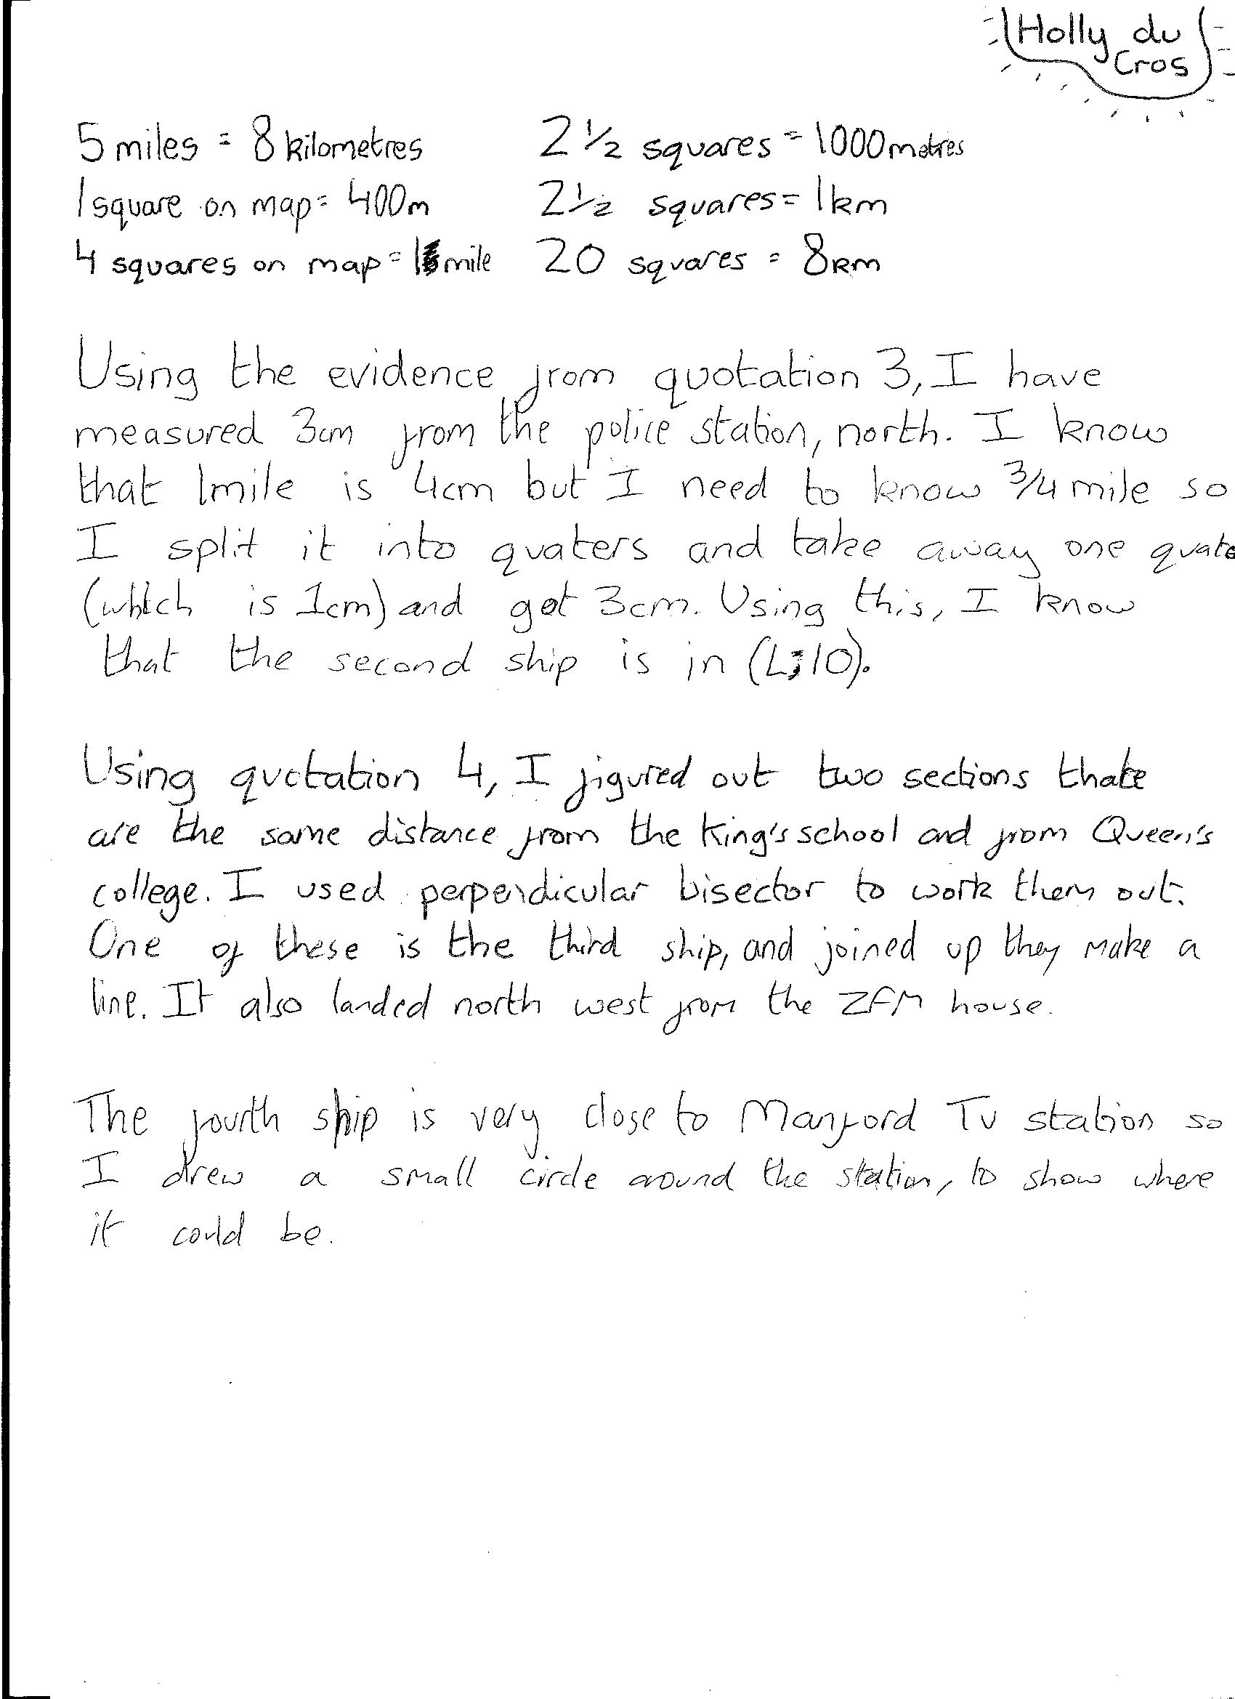

**Comments**

Having been reminded that 5 miles is approximately 8 km, pupil A worked systematically and independently to identify the position of the 3rd spaceship.

**Probing questions and feedback**

* *Why are the final three clues necessary? Without them, where else might the 4th spaceship have been?*
* *Is there a quicker way than using construction to find the position of some of the spaceships?*

Pupil A would benefit from working with other pupils to discuss which mathematical tools are most efficient for a problem and why.

|  |
| --- |
| Lesson 2: The Plan |

Pupils determine where the meeting point should be and calculate the time taken to reach it.

**Teacher guidance**

|  |  |
| --- | --- |
| Observe how well pupils:   * Bring all the information together to find a sensible meeting point * Justify the location of the meeting point and the time that will be needed to get there | Resource 2.3 Tourist Map |

Questions to ask:

* *Why did you choose this meeting point?*
* *What are the risks? What are the benefits?*
* *How long will it take your group to get there? How do you know?*
* *What assumptions did you make?*

**Assessment guidance: Progression in Key Processes**

|  |  |  |  |
| --- | --- | --- | --- |
|  | **Representing** | **Analysing** | **Interpreting and evaluating** |
| PROGRESSION | Chooses simple means of representation, eg uses shading to show where the fog is | Identifies some boundary points for the fog and chooses routes that avoid it | Gives a simple justification for the location of the meeting point; recognises the group that is furthest away will take the longest |
| Recognises that the locus of the boundary of the fog is a circle | Shows where the fog is, and chooses routes that avoid it, including boundary points | Justifies the location, quantifies the distances to be travelled and attempts to find the time taken by the furthest group  Pupil pair B |
| Chooses appropriate tools, ie a pair of compasses  Pupil pair B | Uses speed to find the time taken for one of the groups to reach the meeting point  Pupil pair B | As above, but with the method used to find time made explicit |
| Moves effectively between the diagrammatic representation and the real life situation to solve the problem | Works logically and clearly to solve the problem | Methods are explicit, efficient and concise |

**Sample response: Pupil pair B**

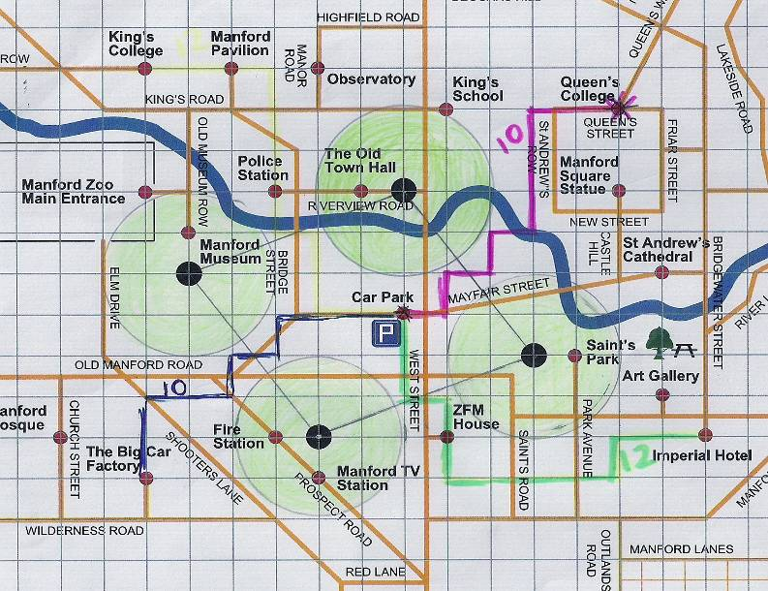

**Comments**

This pair accurately represented the areas of green fog on their map, using coloured pens to show routes that could be taken to avoid it. Distances, in centimetres, along these routes were also indicated.

The pupils presented their estimate of time to the class:  
‘*Lucy is slowest, she is 4km/hour, but if you were being chased by aliens you’d run so we thought 6km/hour. But that was too hard to work out so we decided to run faster at 8km/hour. 10 squares is 4km, so it would be half an hour to do 10 squares and the 12 would take a bit longer, about 35 minutes.*’

**Probing questions and feedback**

* *If it takes 60 minutes to run 6km, how many minutes will it take you to run 1km? Why? How will that help you to find how many minutes it will take you to run 4km?*
* *You said it takes 30 minutes to run 10 squares. Can you think of a way to work out how many minutes it takes to run 12 squares? Does the previous calculation help? How?*

Pupil pair B would benefit from working on other problems that require proportional reasoning.

|  |
| --- |
| Lesson 3: Alien Behaviour |

Pupils link different shaped graphs with information about the behaviour of the aliens.

**Teacher guidance**

|  |  |
| --- | --- |
| Observe how well pupils:   * Choose appropriate strategies when matching graphs and scenarios * Interpret features of graphs | Resource 3.4 Situation report |

Questions to ask:

* *How are you matching pairs? What is your strategy?*
* *How confident are you that you are correct?*
* *Does more than one story match any of the graphs?*
* *Does more than one graph match any of the stories?*

**Assessment guidance: Progression in Key Processes**

|  |  |  |
| --- | --- | --- |
|  | **Analysing** | **Interpreting and evaluating** |
| PROGRESSION | Finds one or more solutions, eg matches at least one of the graphs and scenarios | Explains solutions, eg ‘The graph is going down and so is the height of the flag’ |
| Works logically to find a number of solutions, eg compares linear graphs with different gradients, drawing valid conclusions Pupil C | Interprets some general features of the graphs within the given context, eg ‘A horizontal line means its speed is not changing’ Pupil C |
| Draws effective and complete solutions, eg finds a mostly correct solution for all cards, including the extension ones | Explains general features of linear and non-linear graphs |
| Gives a complete, correct solution, including the extension cards | Explains non-linear graphs in terms of rate of change and inverse proportionality |

**Sample response: Pupil C**

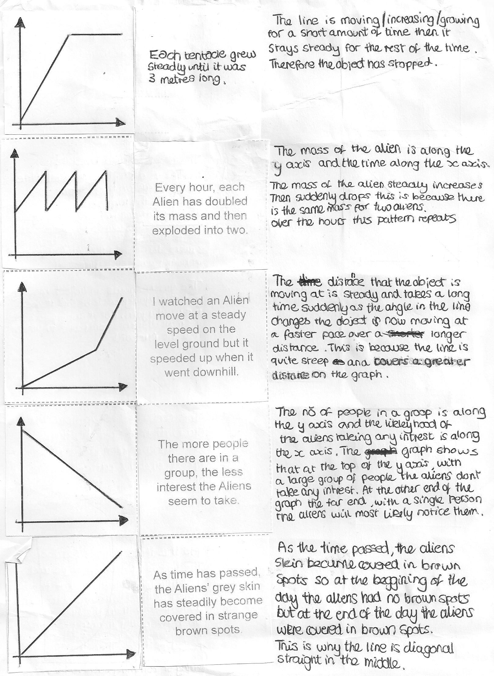



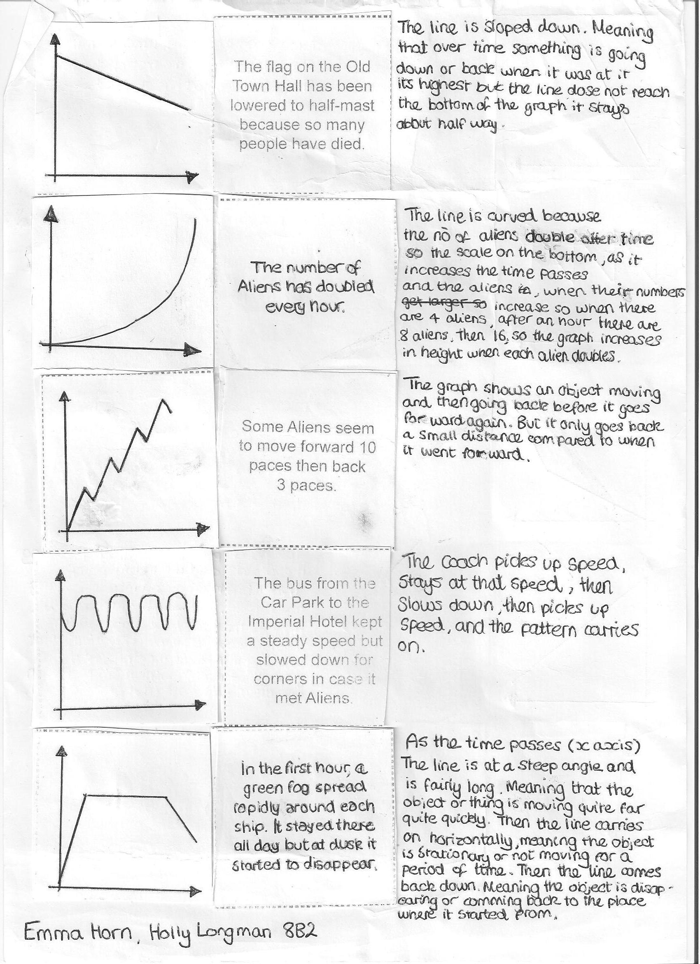

**Comments**

Pupil C’s explanations showed some understanding of graphical features, eg that for distance-time graphs, the gradient of the line determines relative speed. She gave some variables, defining the axes on which they lie.

**Probing questions and feedback**

* *For your 1st story, could the straight line graph have been at a different angle? How do you know?*
* *Can you create your own story* *about alien behaviour and draw its graph?*

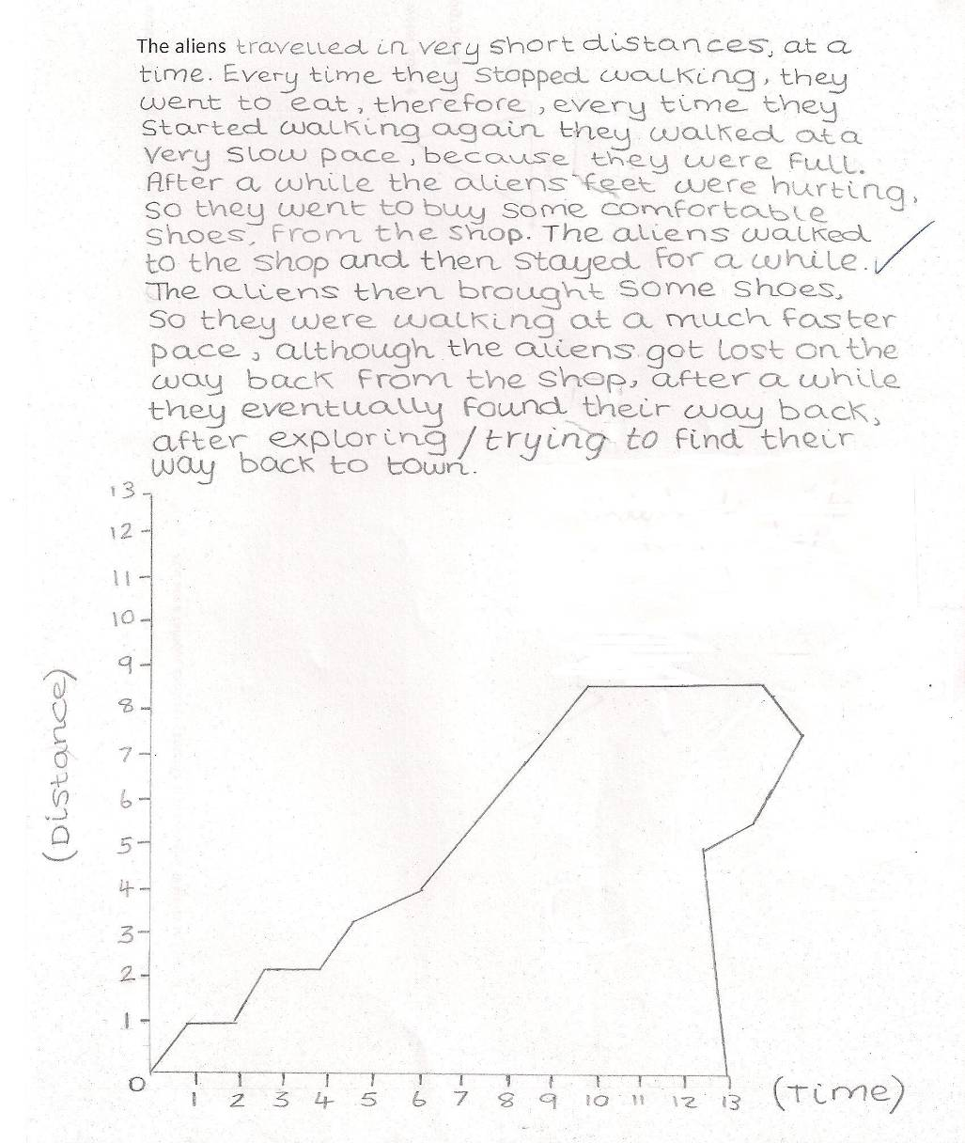

Pupil C’s response to the task and to the optional activity, shown right, illustrates that her understanding of distance-time graphs is not yet secure and reveals some misconceptions, including that it is possible to go back in time.

Pupil D gave thorough (albeit long) explanations, some of which are shown here.   
  
Her writing shows understanding of graphical features, eg that for distance-time graphs the angle of the line determines relative speed.

D uses inverse proportionality (sharing the food) and she attempts to explain non-linear graphs (‘the light would fade rapidly’) though her explanations could be improved by referring to rate of change.

She would benefit from other activities that allow her to interpret and explain graphical features. Allowing her to compare and discuss her answers with others in the group would also be beneficial.

|  |
| --- |
| Lesson 4: The Escape |

Pupils examine codes to help secure the teacher’s release.

**Teacher guidance**

|  |  |
| --- | --- |
| Observe how well pupils:   * Recognise and continue number patterns * Recognise that number patterns can be described using term-to-term rules and position-to-term rules - and that position-to-term rules are usually more powerful | Resource 4.3 Cracking the Code Situation report |

Questions to ask:

* *How did you decide what numbers to write in the 8th and 9th rows?*
* *Can you see any other patterns in the triangle?*
* *How certain are you that the number patterns will continue / your generalisation is correct?*
* *Have you seen a triangle like this before? Where?*

**Assessment guidance: Progression in Key Processes**

|  |  |  |  |
| --- | --- | --- | --- |
|  | **Representing** | **Analysing** | **Communicating and reflecting** |
| PROGRESSION | Needs support to connect the two variables | Shows understanding of simple patterns | Explains a simple pattern and suggests how it is likely to continue |
| Chooses a method of summarising information, eg labels the given diagram Pupil D | Shows understanding of more complex patterns, eg works out the numbers in the 8th and 9th rows | Explains a more complex pattern and how it is likely to continue |
| Summarises findings effectively, eg by using headings | Seeks generality Pupil D | Explains why a general rule is more efficient than building up a pattern term-by-term Pupil D |
| Moves between number and algebra | Uses algebra to express generality | Explains why the nth term is useful when expressing generality |

**Sample response: Pupil D**

**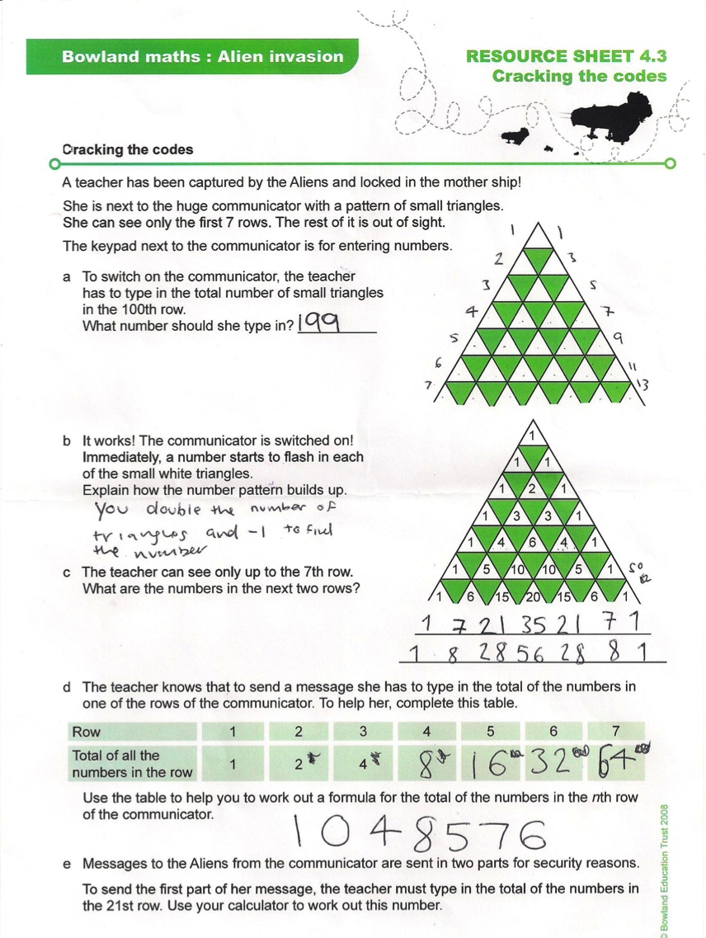**

**Comments**

Pupil D used words and numbers to explain how the patterns continue. In discussion, he explained that although he tried to find a general rule in part (e), his only strategy was to find the (correct) answer through repeated doubling.

**Probing questions and feedback**

* *How could you help someone else understand what is represented by the numbers on your first diagram?*
* *4 = 2 × 2, 8 = 2 × 2 × 2, 16 = 2 × 2 × 2 × 2, etc.*   
  *How can this help you to find a general rule for repeated doubling?*

Pupil D would benefit from working on problems that illustrate the benefits of using algebra to express generality.

|  |
| --- |
| Optional Assessment Activity: The Fog |

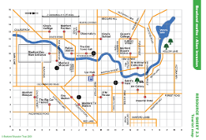

Resource 2.3 Tourist Map   
will be needed

The green fog spreads in each direction …..

Suppose it took one hour to spread the first half a mile.   
In the second hour it spread by half the distance that it spread in the first hour. In the third hour it spread by half the distance that it spread in the second hour. And so on, and so on, and so on …..

Would all of Manford eventually become enclosed in green fog?

**Assessment guidance: Progression in Key Processes**

|  |  |  |  |  |
| --- | --- | --- | --- | --- |
|  | **Representing** | **Analysing** | **Interpreting and evaluating** | **Communicating and reflecting** |
| PROGRESSION | Makes some inroad into the problem, eg uses numbers or a diagram to show how the fog spreads in the first two hours | Works with simple fractions, eg to show that in the second hour the fog has spread another 1/4 mile | Relates findings to the problem, eg in the second hour the fog has spread a total of 3/4 mile | Gives a simple account of the work |
| Uses numbers or diagrams to show how the fog spreads in the first 3 hours | Works with fractions, eg in the third hour the fog has spread a further 1/8 mile | Relates findings to the problem, eg in the third hour the fog has spread a total of 7/8 mile | Recognises that the distance the fog is spreading is decreasing each hour |
| Makes effective use of numbers and/or diagrams to support thinking | Creates a number sequence, eg 1/2 + 1/4 + 1/8 + 1/16 …  or 1/2, 3/4, 7/8, 15/16 … Pupil E | Recognises that the fog has a limited reach | Communicates effectively, and explains why the fog has a limited reach Pupil E |
| Makes effective use of a range of mathematical tools, eg symbols, words, diagrams and tables  Pupil E | Generalises, eg gives the nth term of the number sequence | Recognises that the fog has a limited reach of one mile Pupil E | Communicates effectively, and gives a clear justification as to why the fog has a limited reach of one mile |

**Sample response: Pupil E**

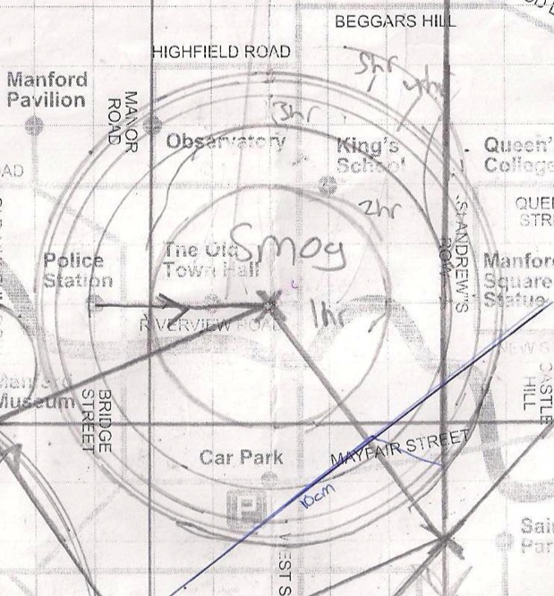

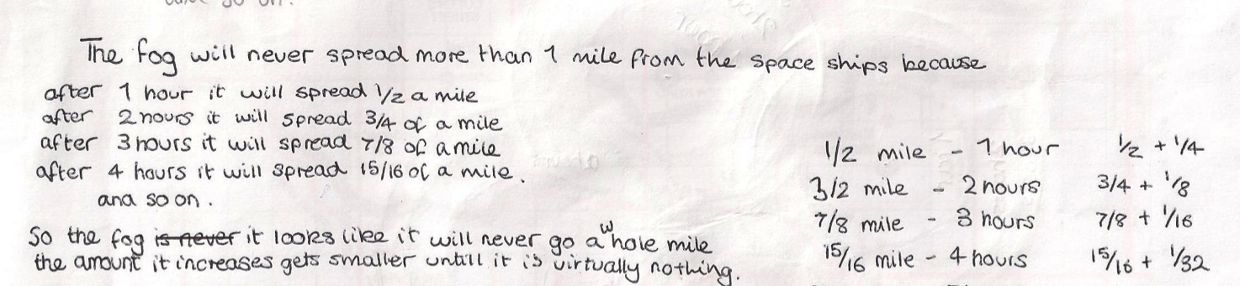

**Comments**

Pupil E showed mathematical insight into the nature of a converging series

**Probing questions and feedback**

* *Can you give a little more explanation about why the fog will never go a whole mile? Would it help to use an nth term?*
* *How is the maximum distance that the fog spreads related to the distance it spreads in the first hour? For example, what if the fog spread 2 miles in the first hour …, or a quarter of a mile in the first hour, or … ?*

Pupil E would benefit from working on a range of problems that involve proof